**[ST10315122] – [Nikhil Rajkumar] – WEDE5020 – POE – Part 1.**

|  |  |
| --- | --- |
| **Cover page:** | **Cover page** |
| **Table of contents:** | **Pg1** |
| **Website choice:** | **Pg2-3** |
| **Website assets:** | **Pg4-9** |
| **Website pages and content:** | **Pg10-15** |
| **List of references:** | **Pg16-17** |
| **Part 2: Improvements to part 1:** | **Pg18 onwards** |
| **New website assets:** | **Pg18-20** |
| **Improved webpages and content:** | **Pg21-33** |
| **Improvements in code:** | **Pg34-36** |
| **Reference list for new website assets:** | **Pg37** |
| **Part 3: Improvements to part 2:** | **Pg38 onwards** |
| **New website assets:** | **Pg38-39** |
| **Improved webpages and content:** | **Pg39-58** |
| **Functionality:** | **Pg59-63** |
| **SEO:** | **Pg64** |
| **Improvements in code:** | **Pg64-68** |
| **Reference list for new website assets part 3:** | **Pg69** |

**Table of contents:**

**Website Choice:**

The Digital divide

The digital divide is the gap that exists between people who have access and know how to use and take advantage of modern technology and those who are simple too old to understand how this technology works or they just can’t afford access to the internet. This creates an inequality between people living around the world, giving some people an advantage over others. The “Everyone online” Non-profit organization plans on closing the gap of the digital divide enabling everyone to gain access to the internet which would potentially make a lot of people’s lives much easier. To help people who are less fortunate and do not have the money to be able to afford an electronic device we will be seeking donations of old cell phones and computing devices from the public which would help those in need and address another world issue called pollution. When old electronic devices are disposed improperly, the batteries from these devices contain harmful substances that damage the environment causing air and water pollution. These substances are toxic to plants, animals and people. We will also be hosting fund raising events to help raise the funds needed to support our mission as well as this would help raise awareness to the public about the problem. We will seek help from volunteers in the public who are passionate about closing the gap of the digital divide so that they can help educate people on how to use modern technology and gain access to the internet. Volunteers will help people in need to understand how modern technology works and will help train people. In some areas people do not have access to the internet because they lack access to proper hardware that would allow them to access the internet, so we have secured partnerships with big internet service providers in various areas to sponsor people with the equipment then need to access the online world. Peaceful events such as educational and sports events will be done to help various ISPs to understand what our mission is so that they can reduce the prices of technological devices and internet services. All this would contribute to getting everyone the ability to benefit from the advantages of modern technology.

**Website assets:**

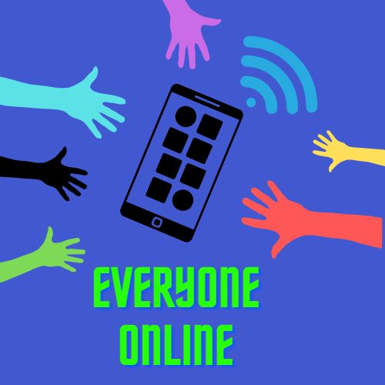

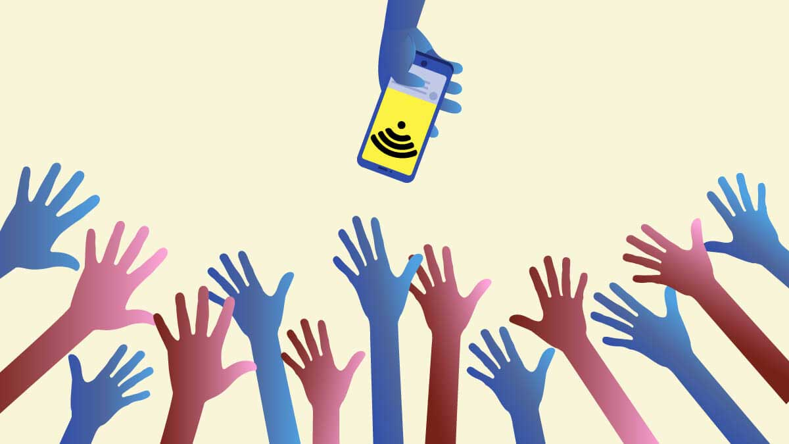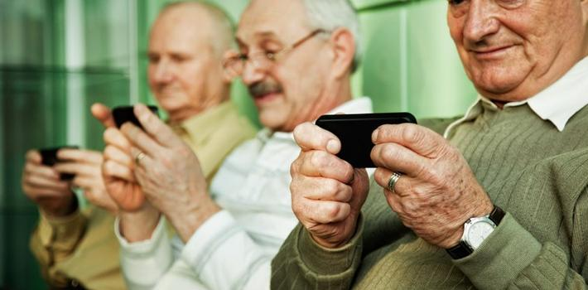

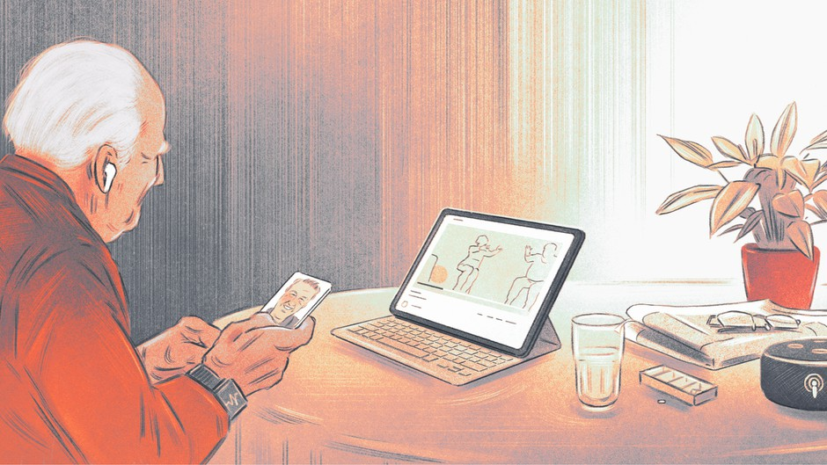

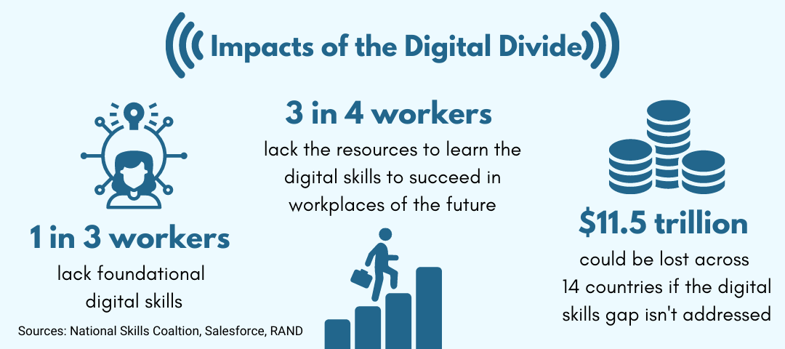

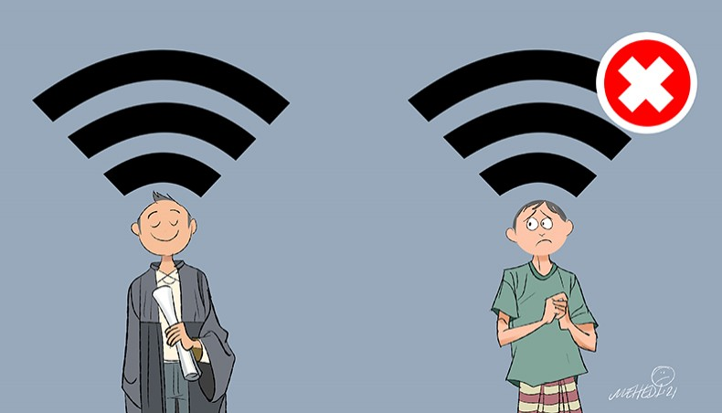

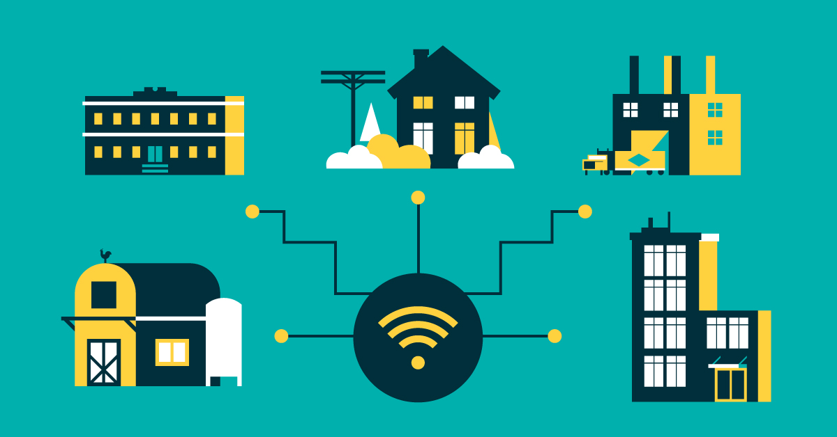

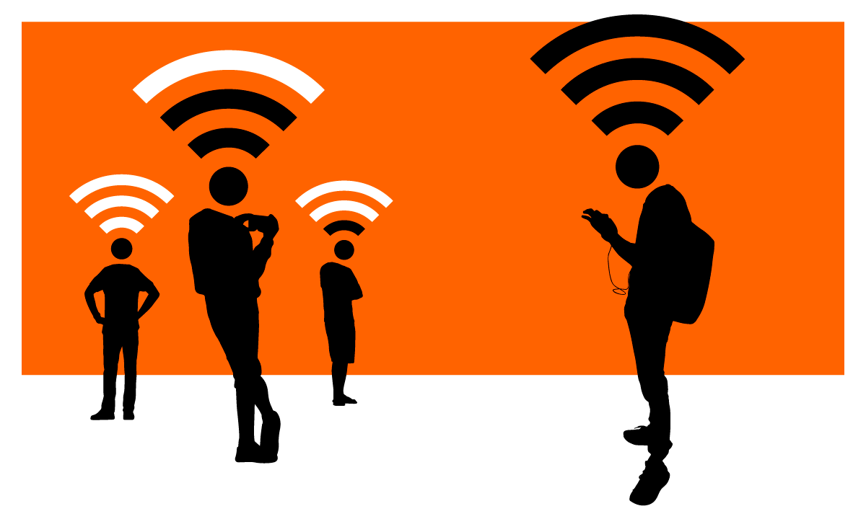

**Webpages and content:**

**Home page:**

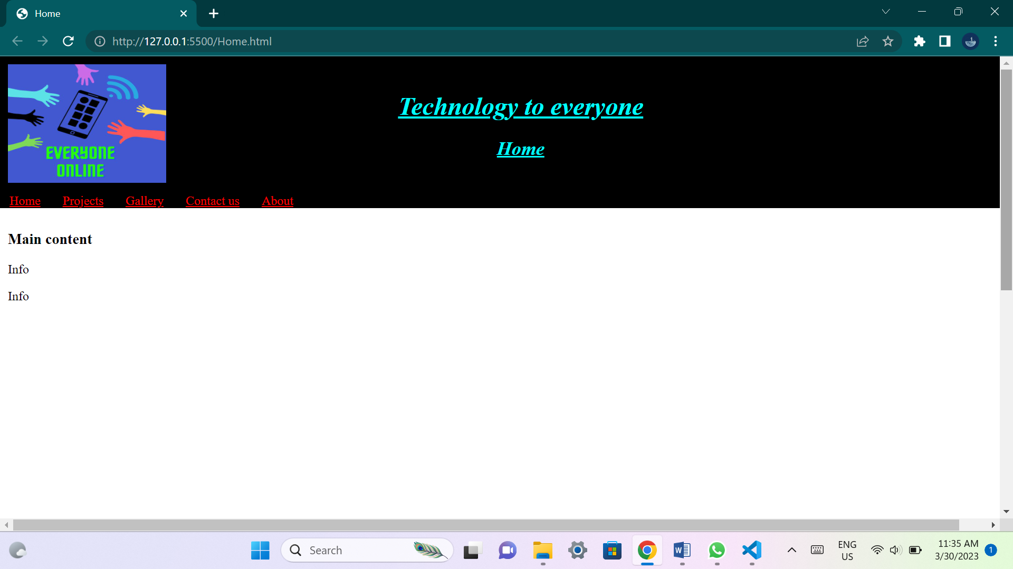

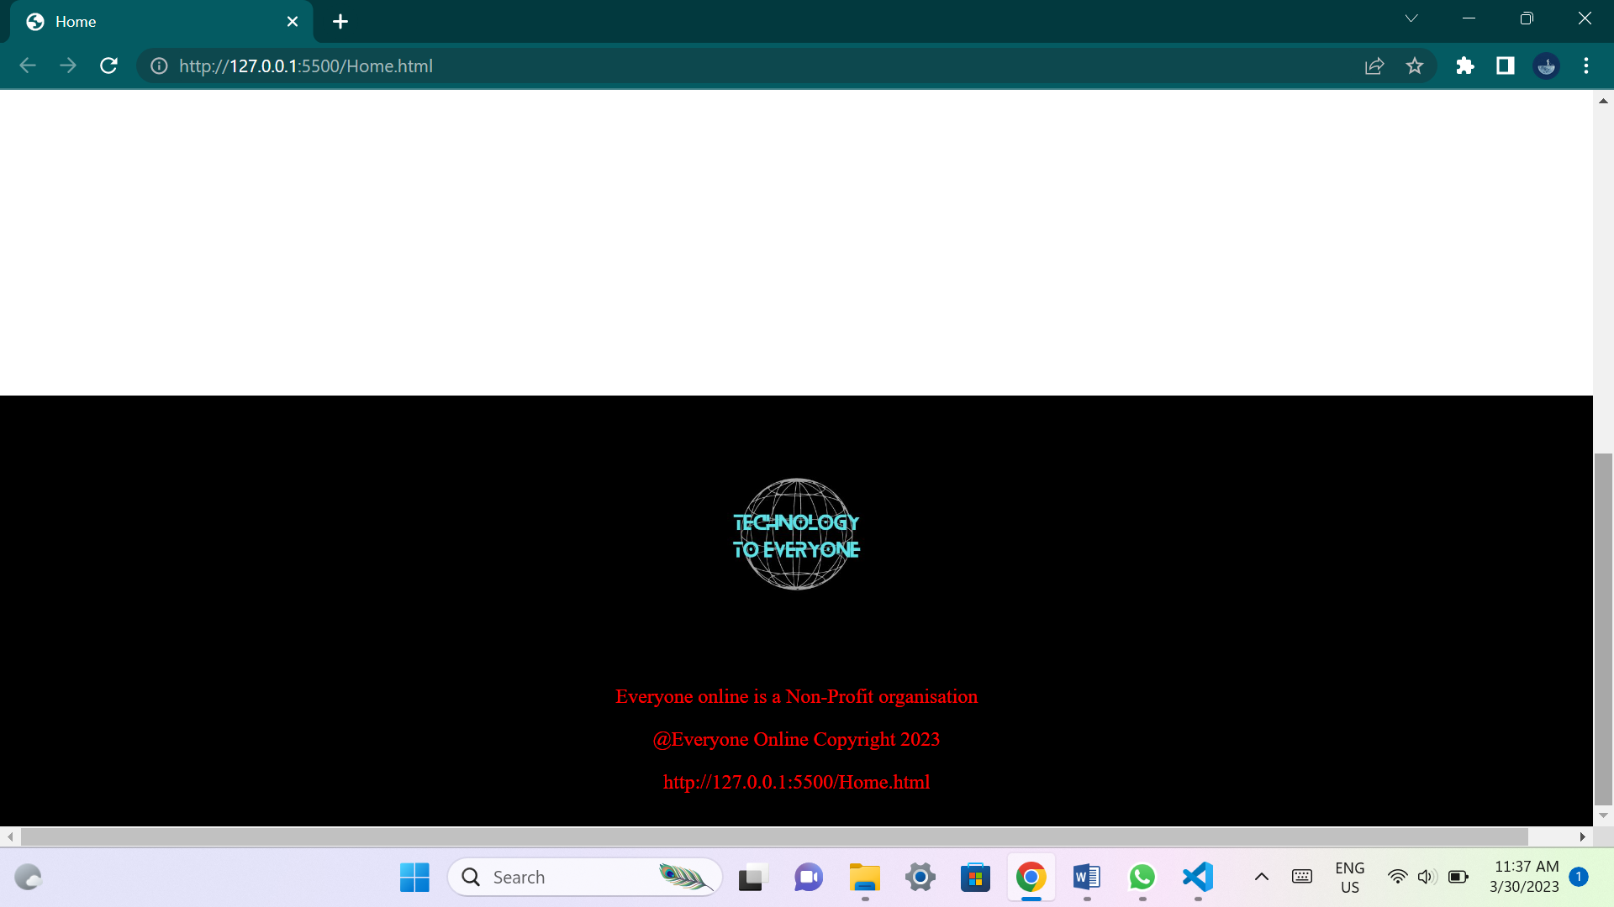

**This page will outline brief details about the organization and its plans. It will include summarized details about all the other web pages.**

**Projects page:**

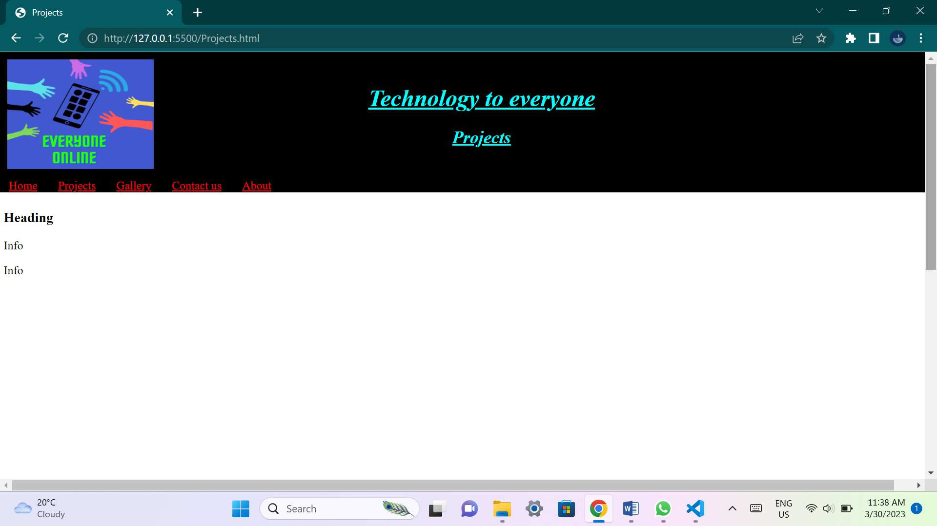

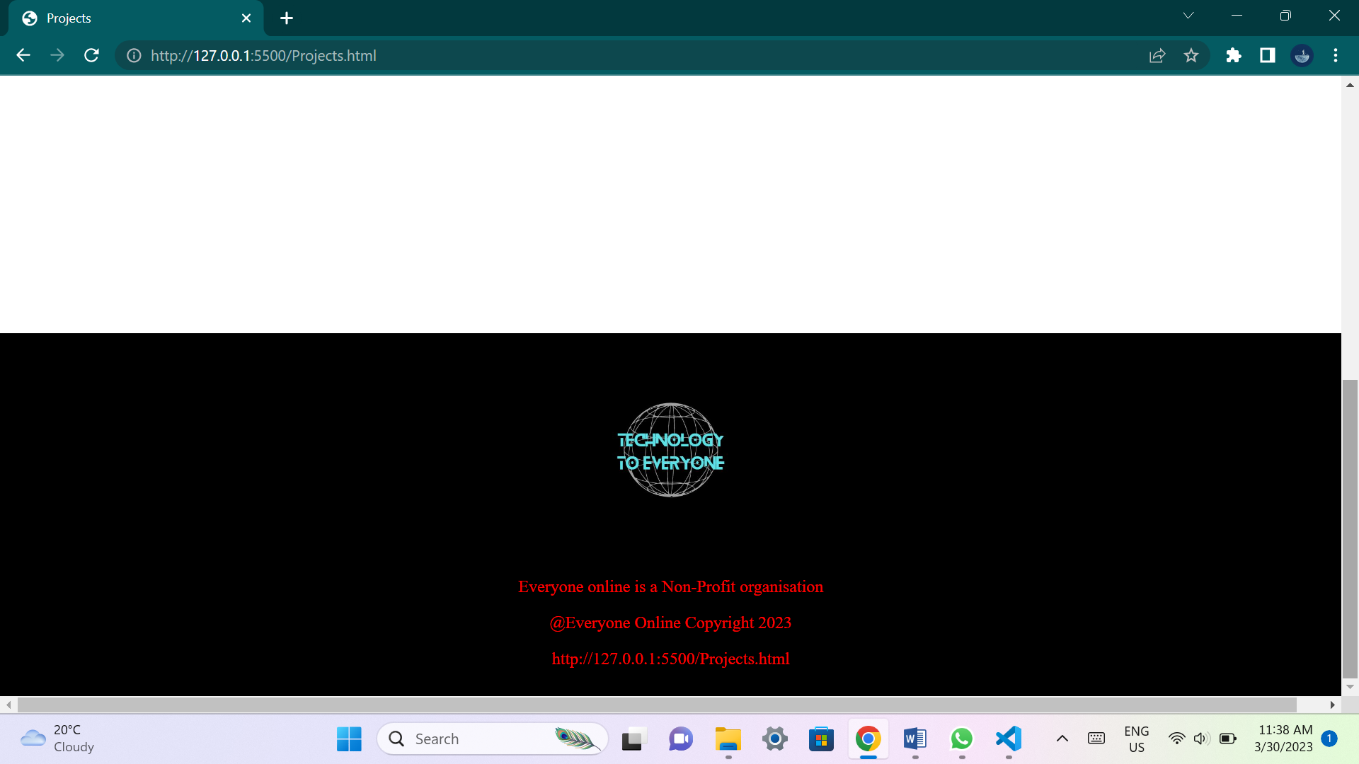

**This page will have images and details about projects that the organization is currently pursuing and wishes to accomplish.**

**Gallery page:**

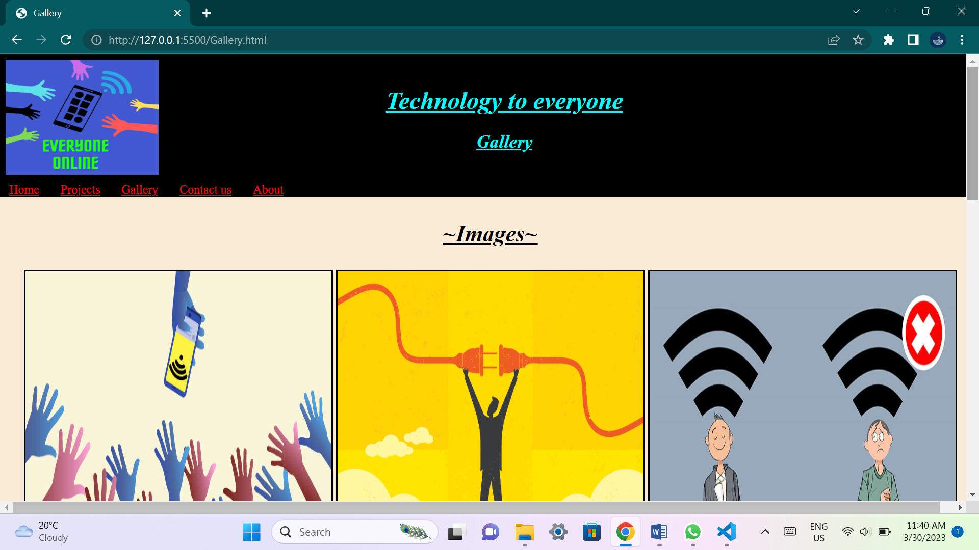

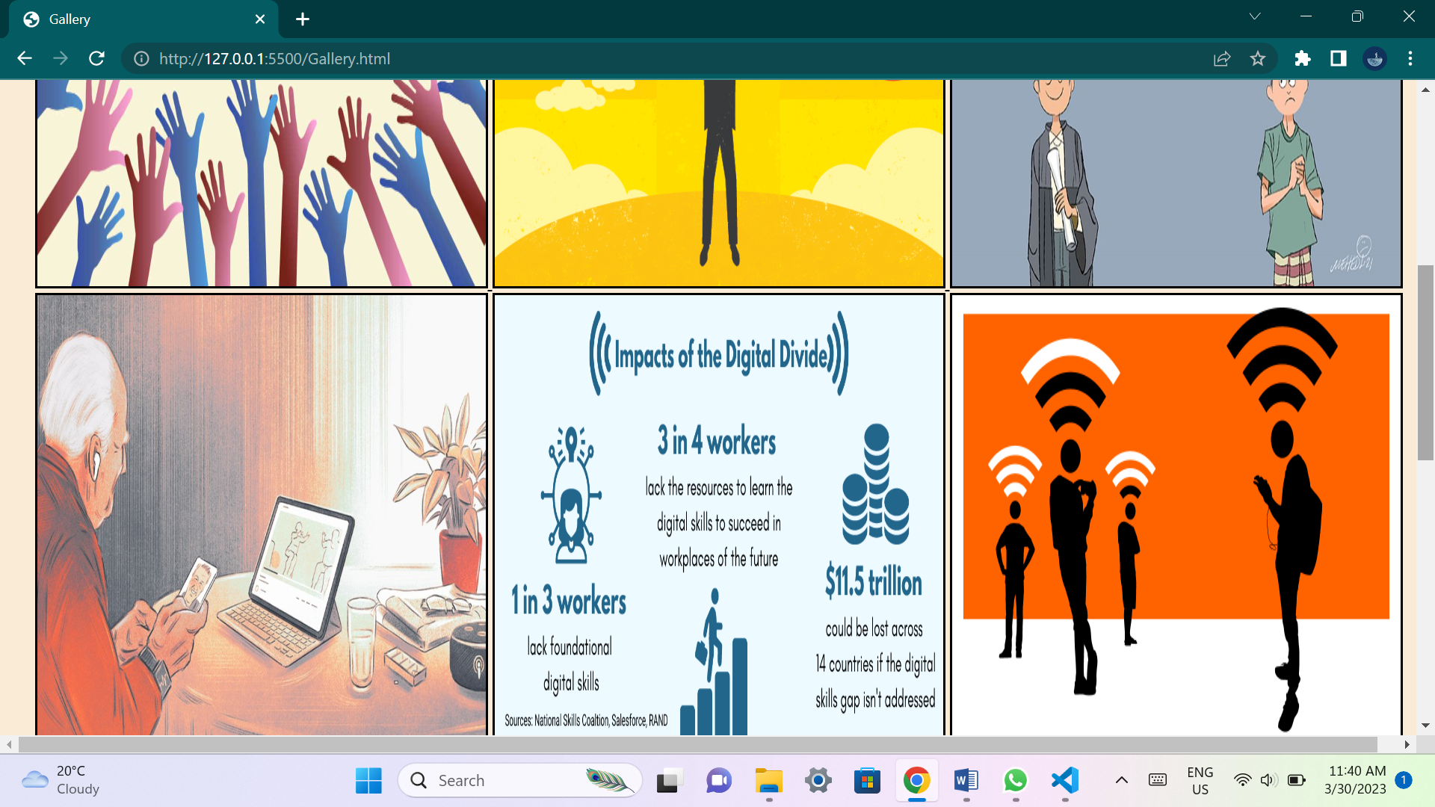

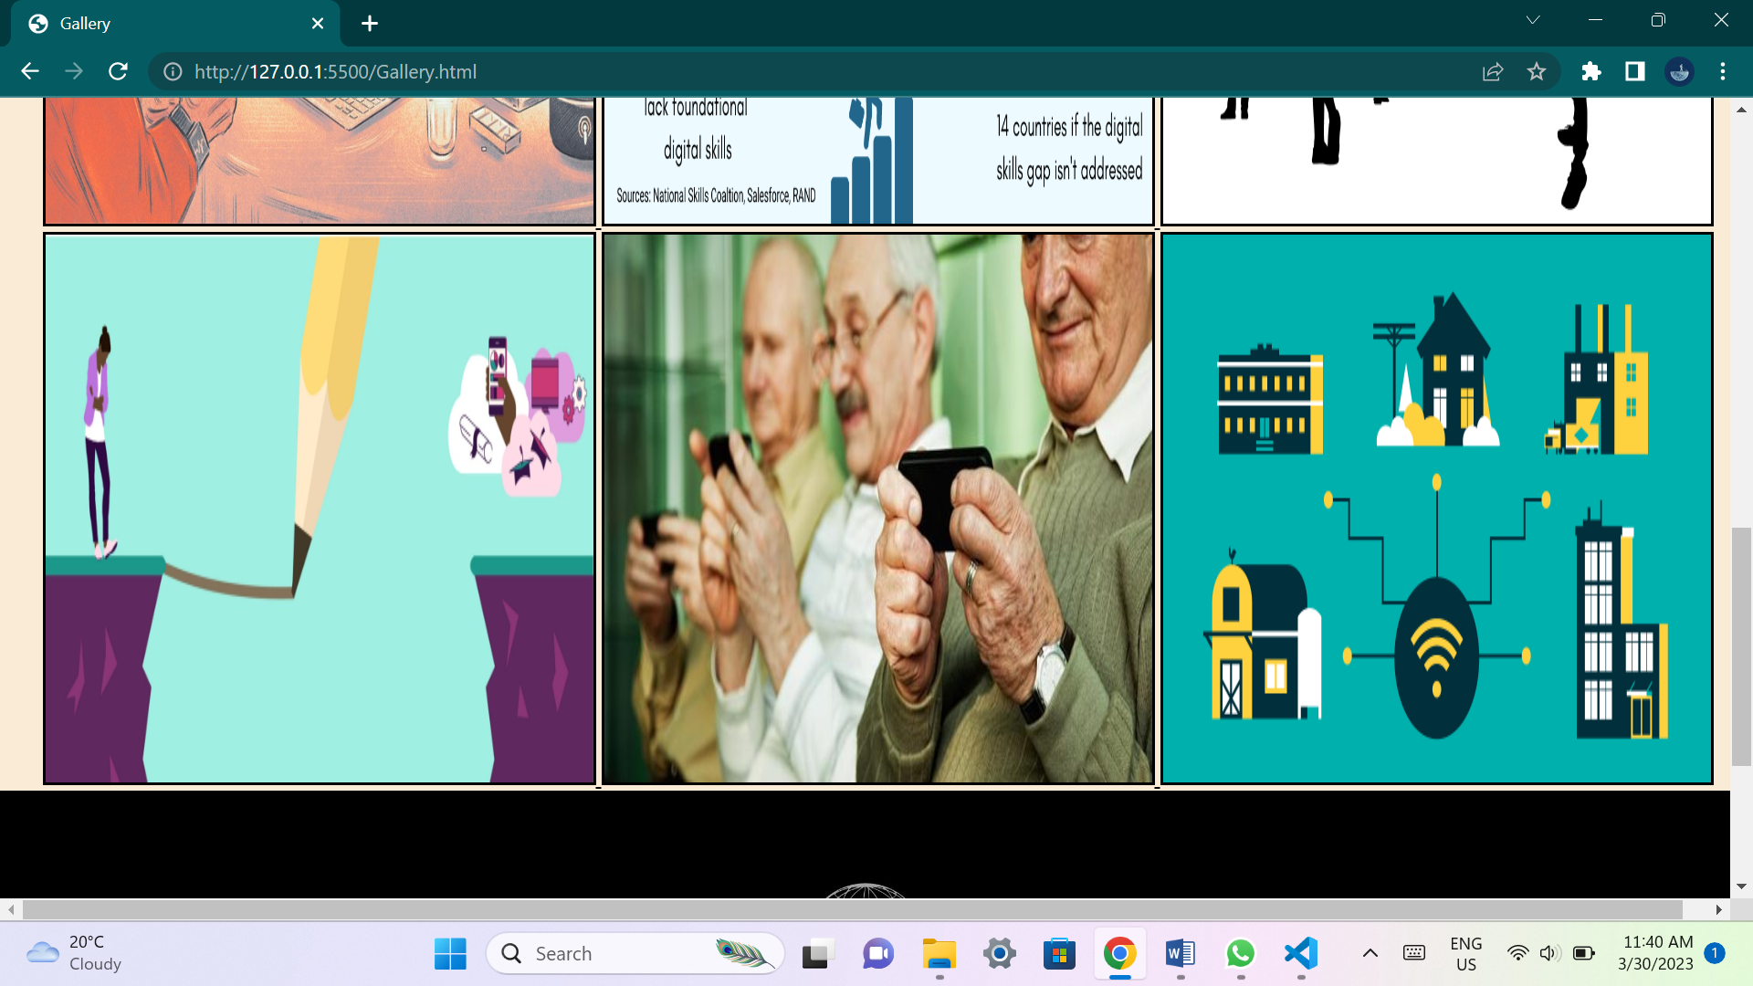

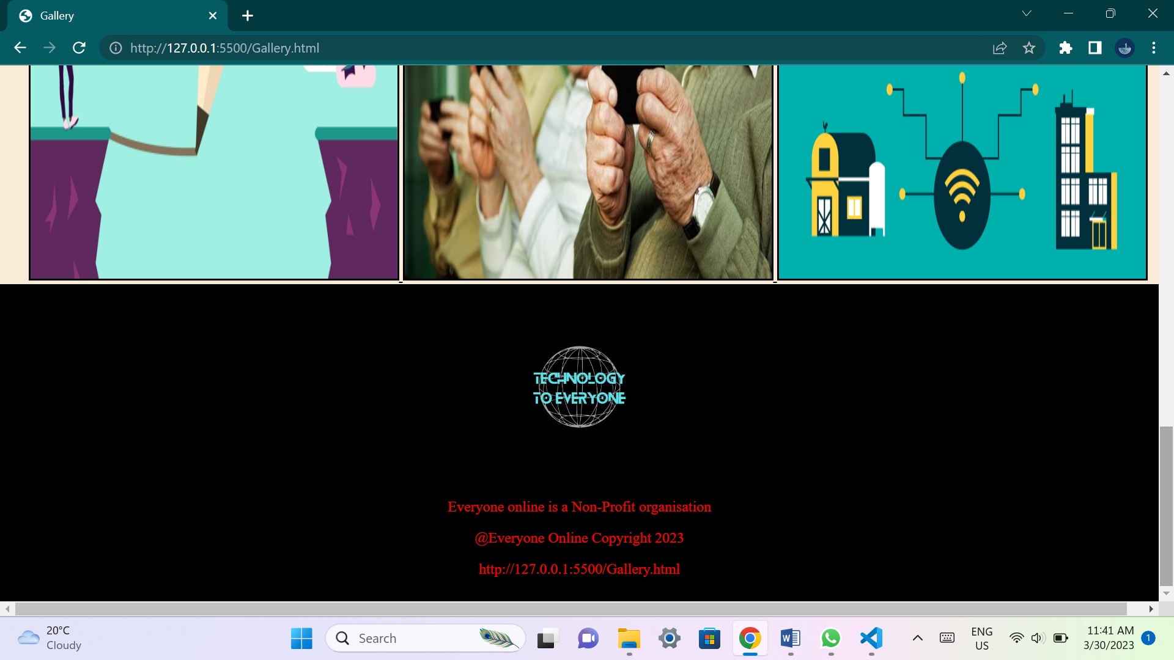

**This page will contain multiple images that would help the user understand what the organization wishes to achieve and its idea's.**

**Contact page:**

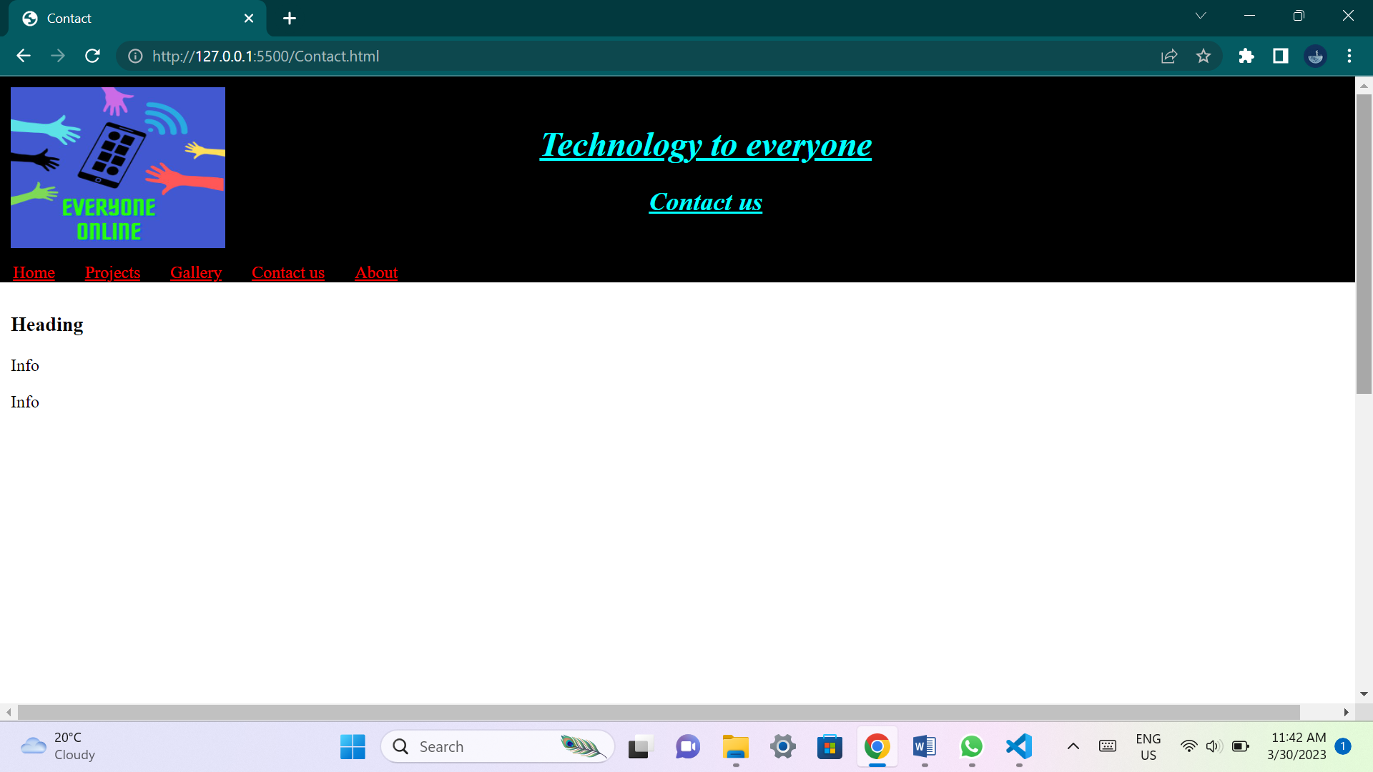

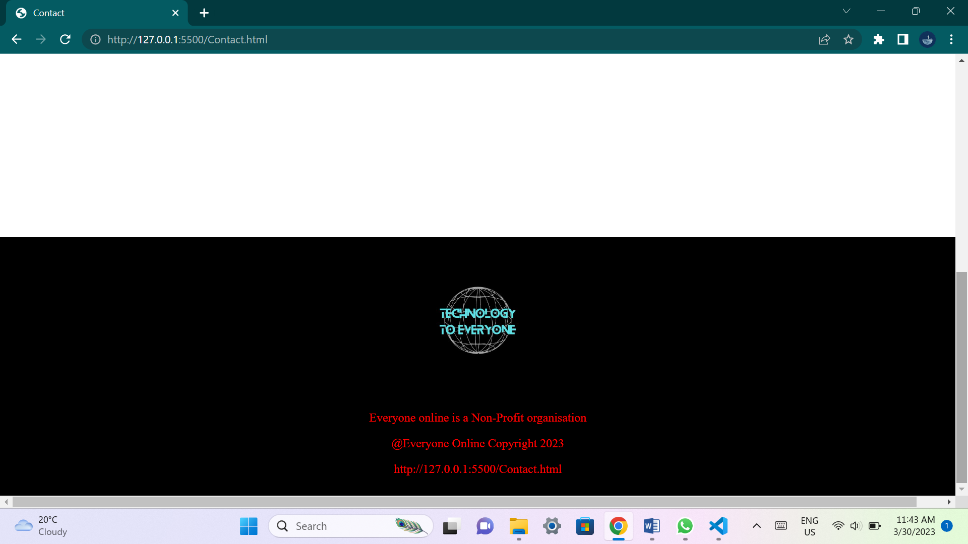

**This page will have contact details that will be available to the user if they have any questions or queries dealing with the organization.**

**About page:**

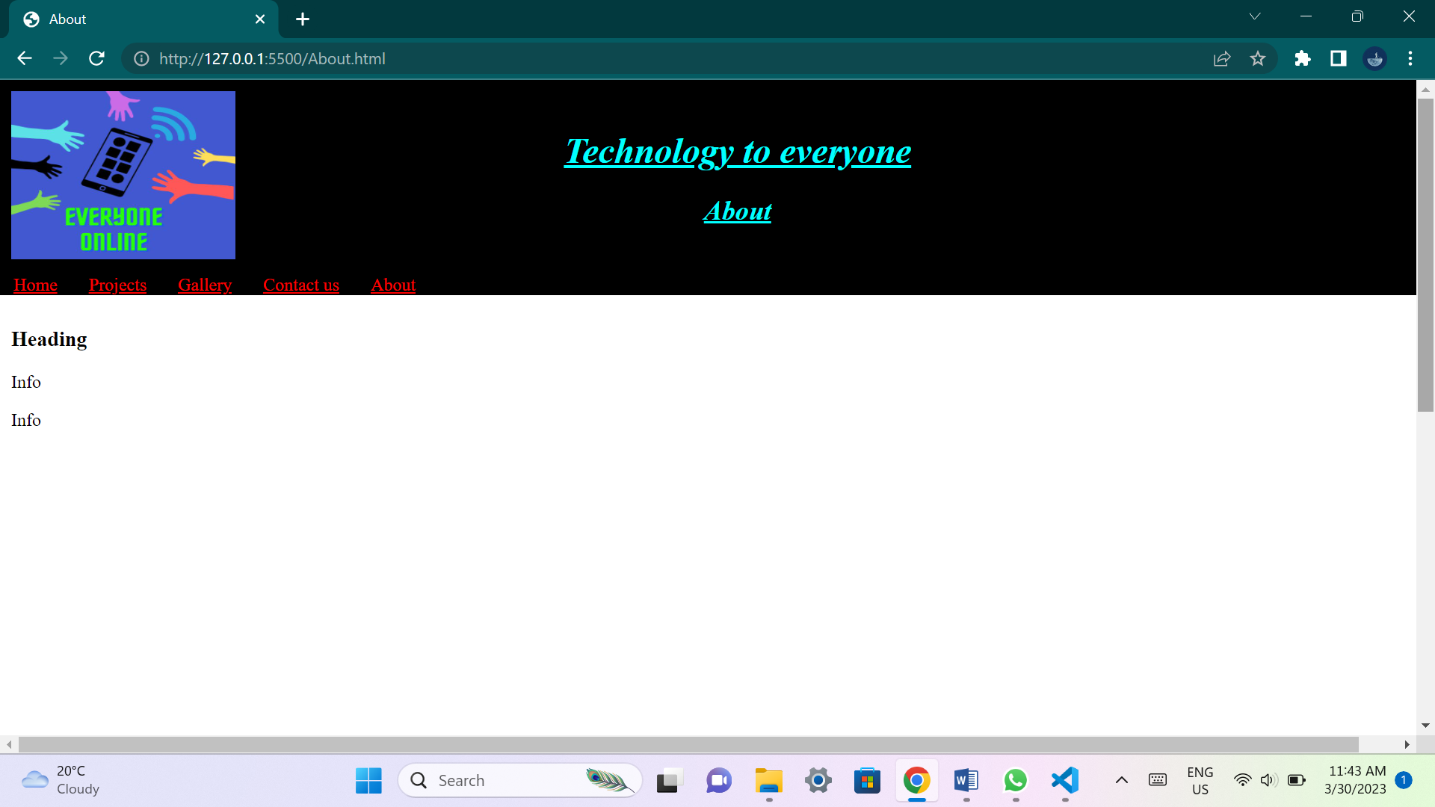

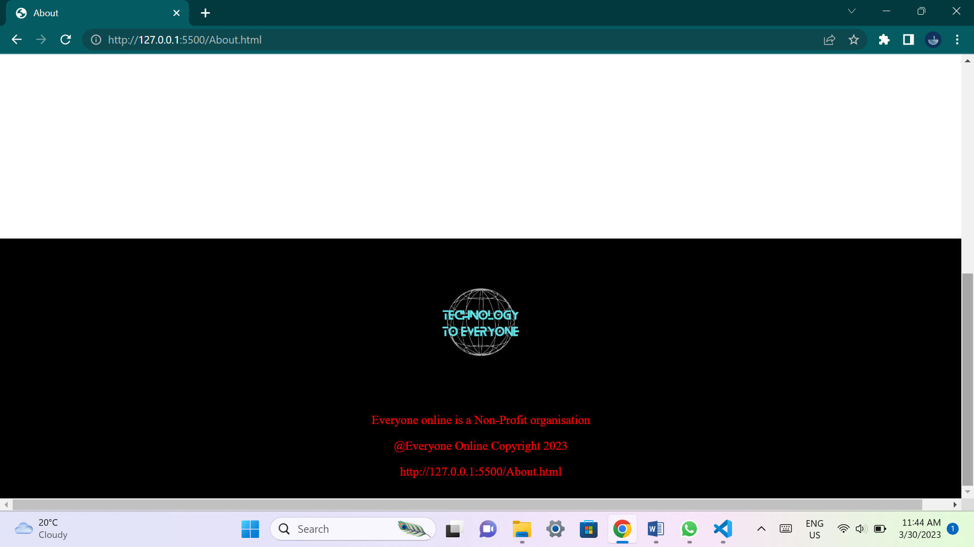

**This page will explain to the user what the organization is about. It will give users an idea about the organization goals and why the organization wants to achieve their goals.**

**List of references:**

* **Rob Amner. 2021. Digital divide narrows as 22 local schools get Wi-Fi, thanks to local tech company. 4 November 2021. [Online]. Available at:** [**https://grocotts.ru.ac.za/2021/11/04/digital-divide-narrows-as-22-local-schools-get-wi-fi-thanks-to-local-tech-company/**](https://grocotts.ru.ac.za/2021/11/04/digital-divide-narrows-as-22-local-schools-get-wi-fi-thanks-to-local-tech-company/) **(Accessed 29 March 2023)**
* **Avnation Organization. 2020. Bridging the digital divide with social activism in AV. 7 August 2020. [Online]. Available at:** [**https://www.avnation.tv/2020/08/07/bridging-the-digital-divide-with-social-activism-in-av/**](https://www.avnation.tv/2020/08/07/bridging-the-digital-divide-with-social-activism-in-av/) **(Accessed 29 March 2023)**
* **Syed Laden. 2021. Digital Bangladesh, digital divide and education sector. 18 April 2021. [Online]. Available at:** [**https://www.newagebd.net/article/135620/digital-bangladesh-digital-divide-and-education-sector**](https://www.newagebd.net/article/135620/digital-bangladesh-digital-divide-and-education-sector) **(Accessed 29 March 2023)**
* **Linda Poon and Sarah Holder. 2020. The ‘New Normal’ for Many Older Adults Is on the Internet. 6 May 2020. [Online]. Available at:** [**https://www.bloomberg.com/news/features/2020-05-06/in-lockdown-seniors-are-becoming-more-tech-savvy**](https://www.bloomberg.com/news/features/2020-05-06/in-lockdown-seniors-are-becoming-more-tech-savvy) **(Accessed 29 March 2023)**
* **Keith Oelrich. 2022. Why We Must Close the Digital Divide. 15 February 2022. [Online]. Available at:** [**https://www.learning.com/blog/closing-the-digital-divide/**](https://www.learning.com/blog/closing-the-digital-divide/) **(Accessed 29 March 2023)**
* **Joshua Bay. 2022. Report: Internet Gap Snubs LA Low-Income Residents & Widens Digital Divide. 24 October 2022. Available at:** [**https://www.the74million.org/article/report-internet-gap-snubs-la-low-income-residents-widens-digital-divide/**](https://www.the74million.org/article/report-internet-gap-snubs-la-low-income-residents-widens-digital-divide/) **(Accessed 29 March 2023)**
* **Ally Tech. 2022. Bridging the Digital Divide: Driving Towards Digital Equity & Inclusion for All. 19 August 2022. Available at:** [**https://ally.tech/bridging-the-digital-divide-driving-towards-digital-equity-inclusion-for-all-fb519aaaca0a**](https://ally.tech/bridging-the-digital-divide-driving-towards-digital-equity-inclusion-for-all-fb519aaaca0a) **(Accessed 29 March 2023)**
* **Theodore D Cosco. 2018. Bridging the digital divide amongst older adults. 23 May 2018. Available at:** [**https://www.ageing.ox.ac.uk/blog/digital-divide**](https://www.ageing.ox.ac.uk/blog/digital-divide) **(Accessed 29 March 2023)**
* **Admin. 2020. THE DIGITAL DIVIDE. 6 October 2020. Available at:** [**https://www.rebdones.com/uncategorized/the-digital-divide/**](https://www.rebdones.com/uncategorized/the-digital-divide/) **(Accessed 29 March 2023)**

**Part 2:**

**Improvements to part 1:**

**New website assets:**

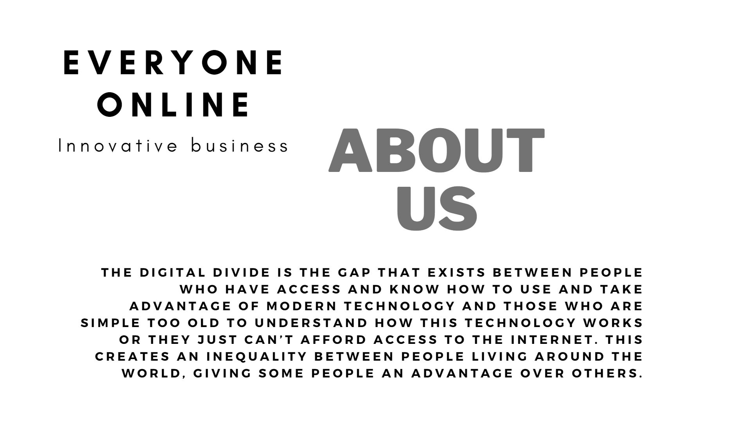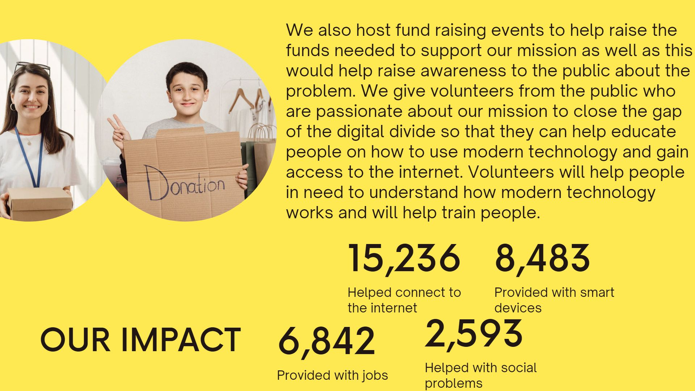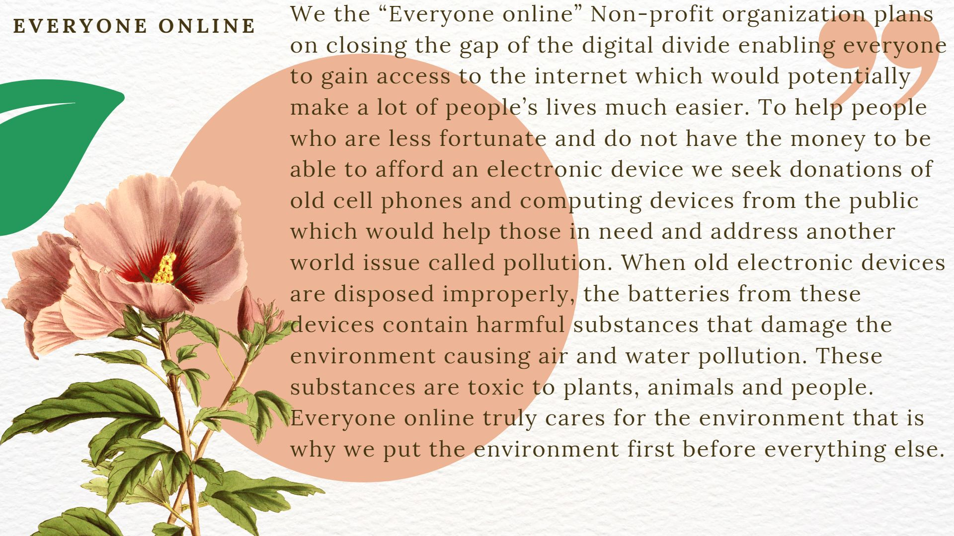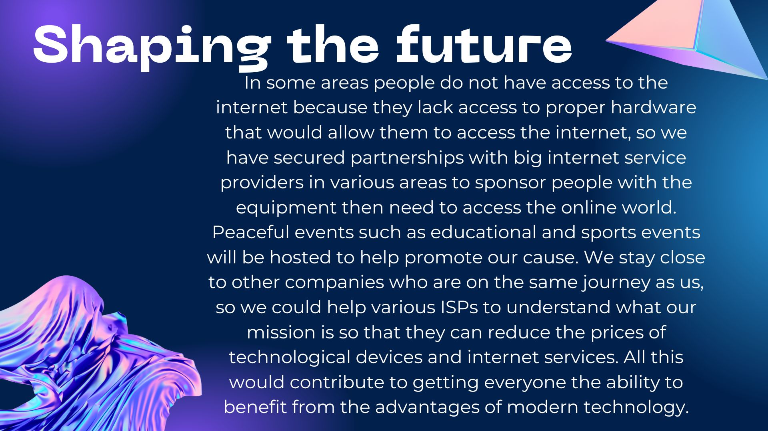

























**All new material was designed using Canva application.**

**Improved webpages and content:**

**Home page:**

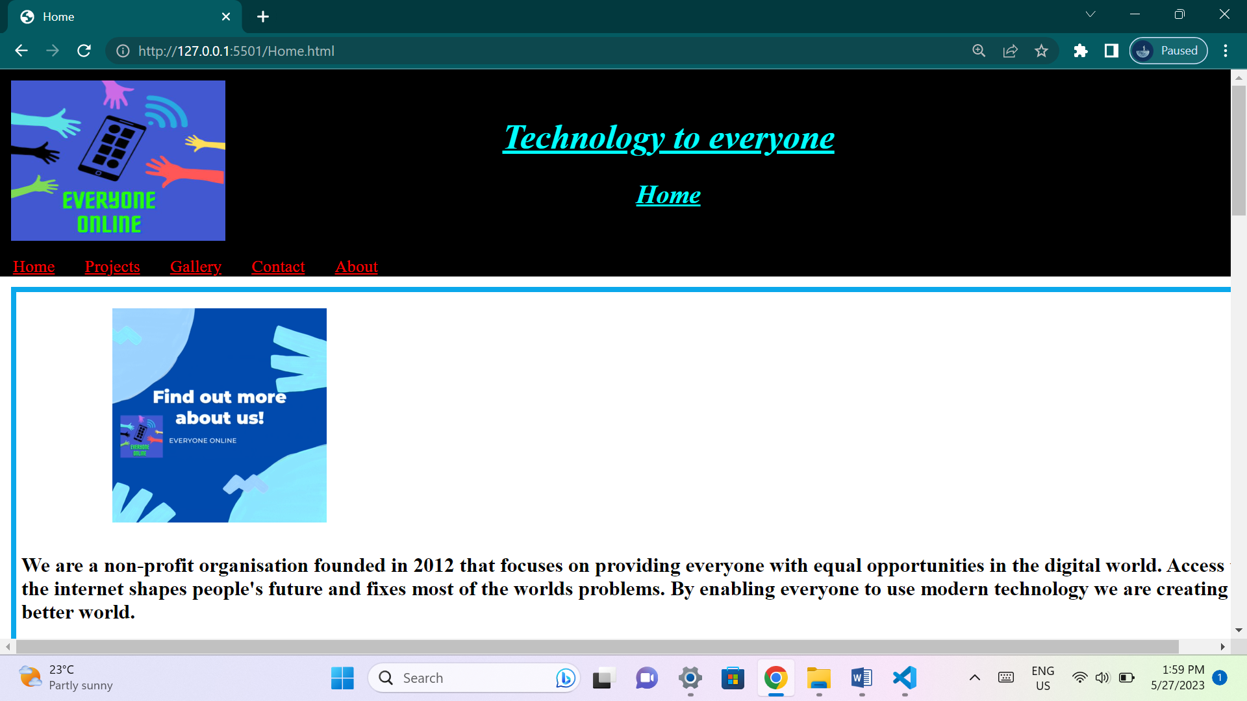

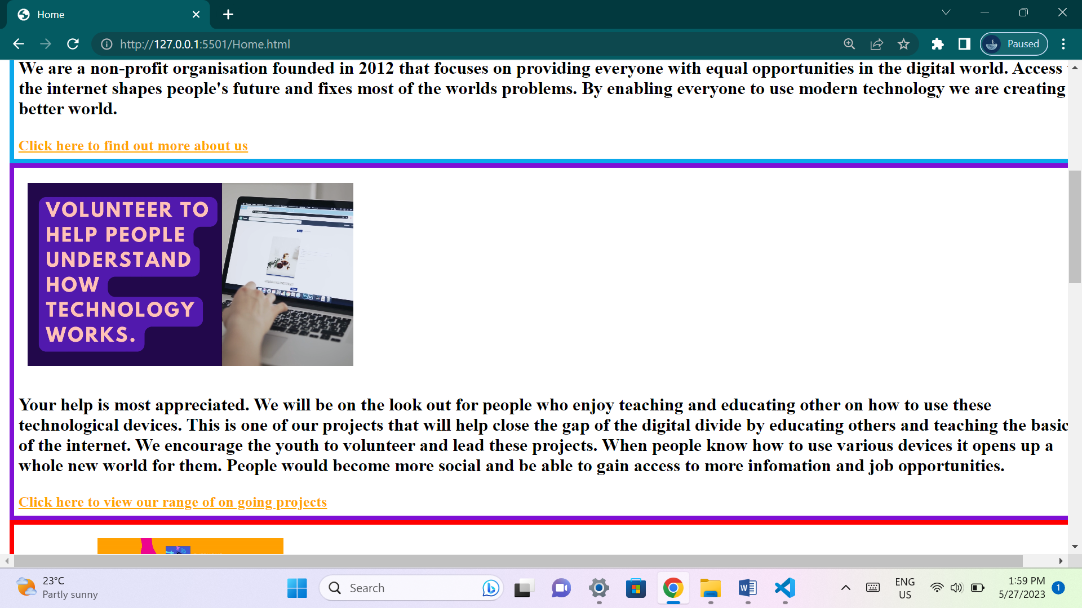

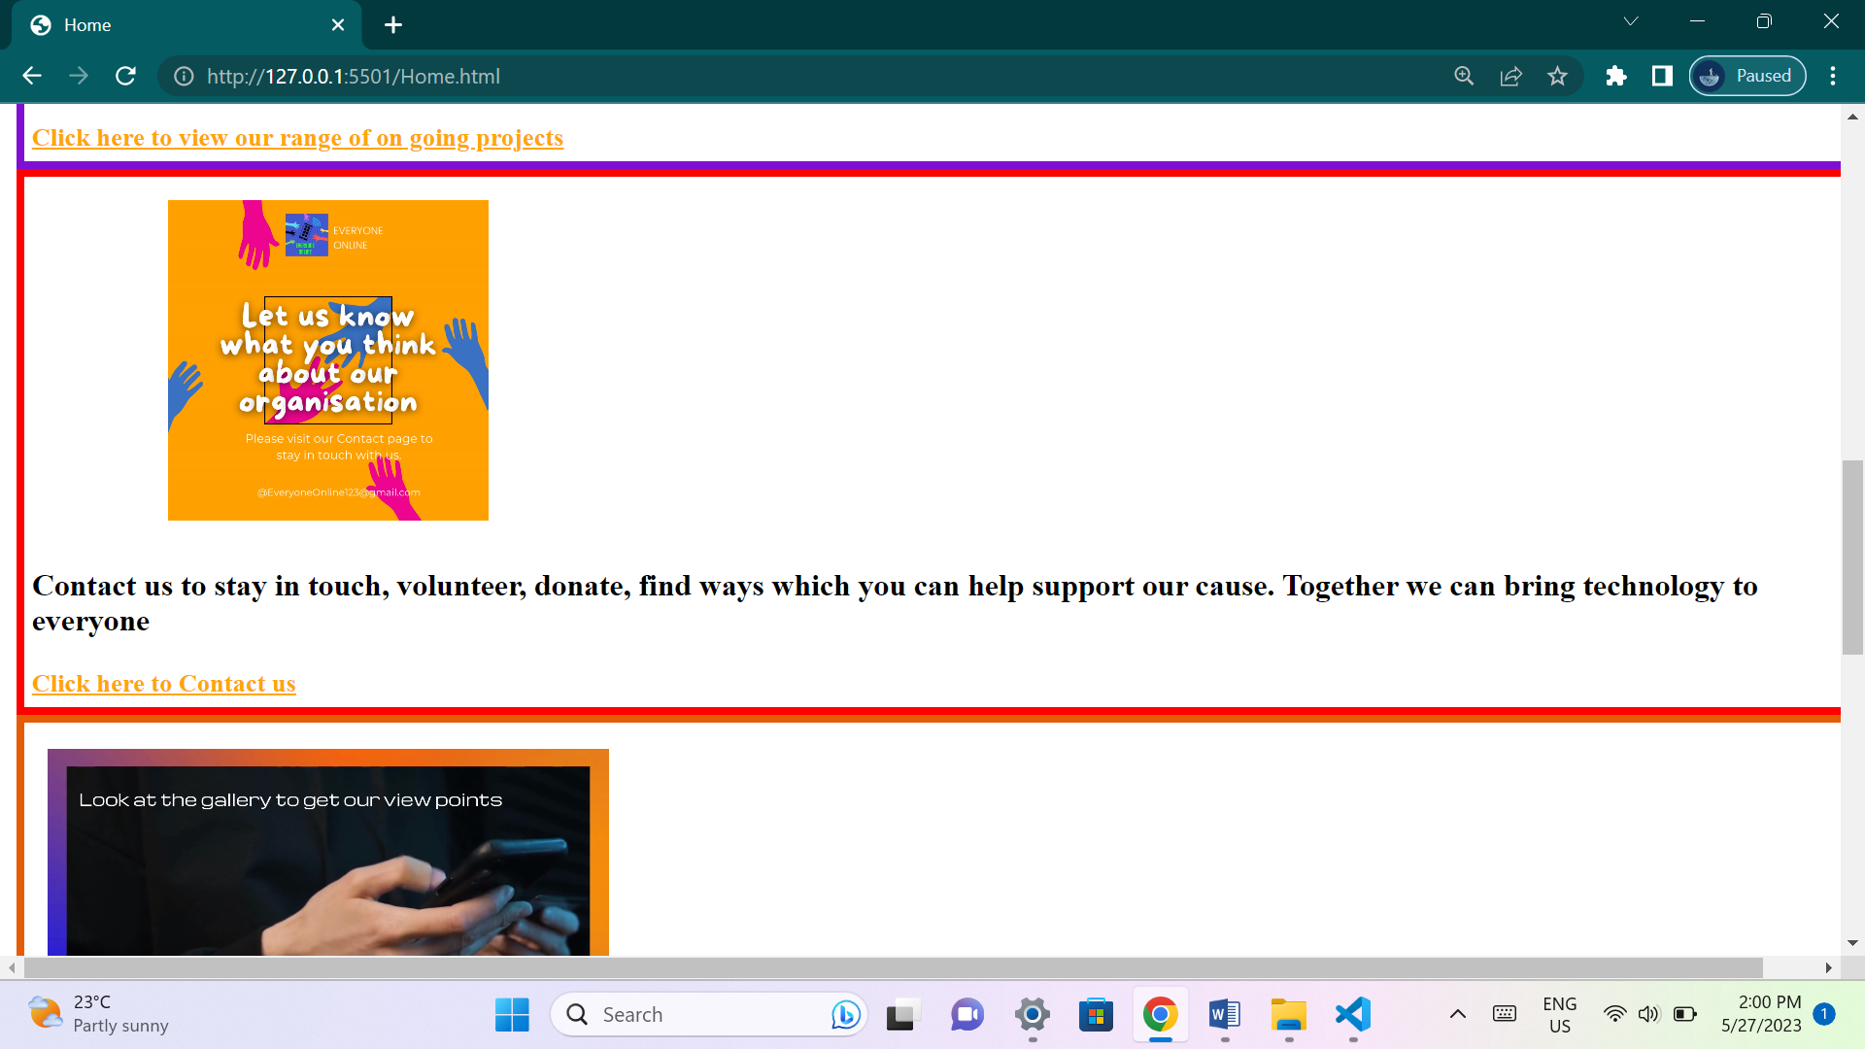

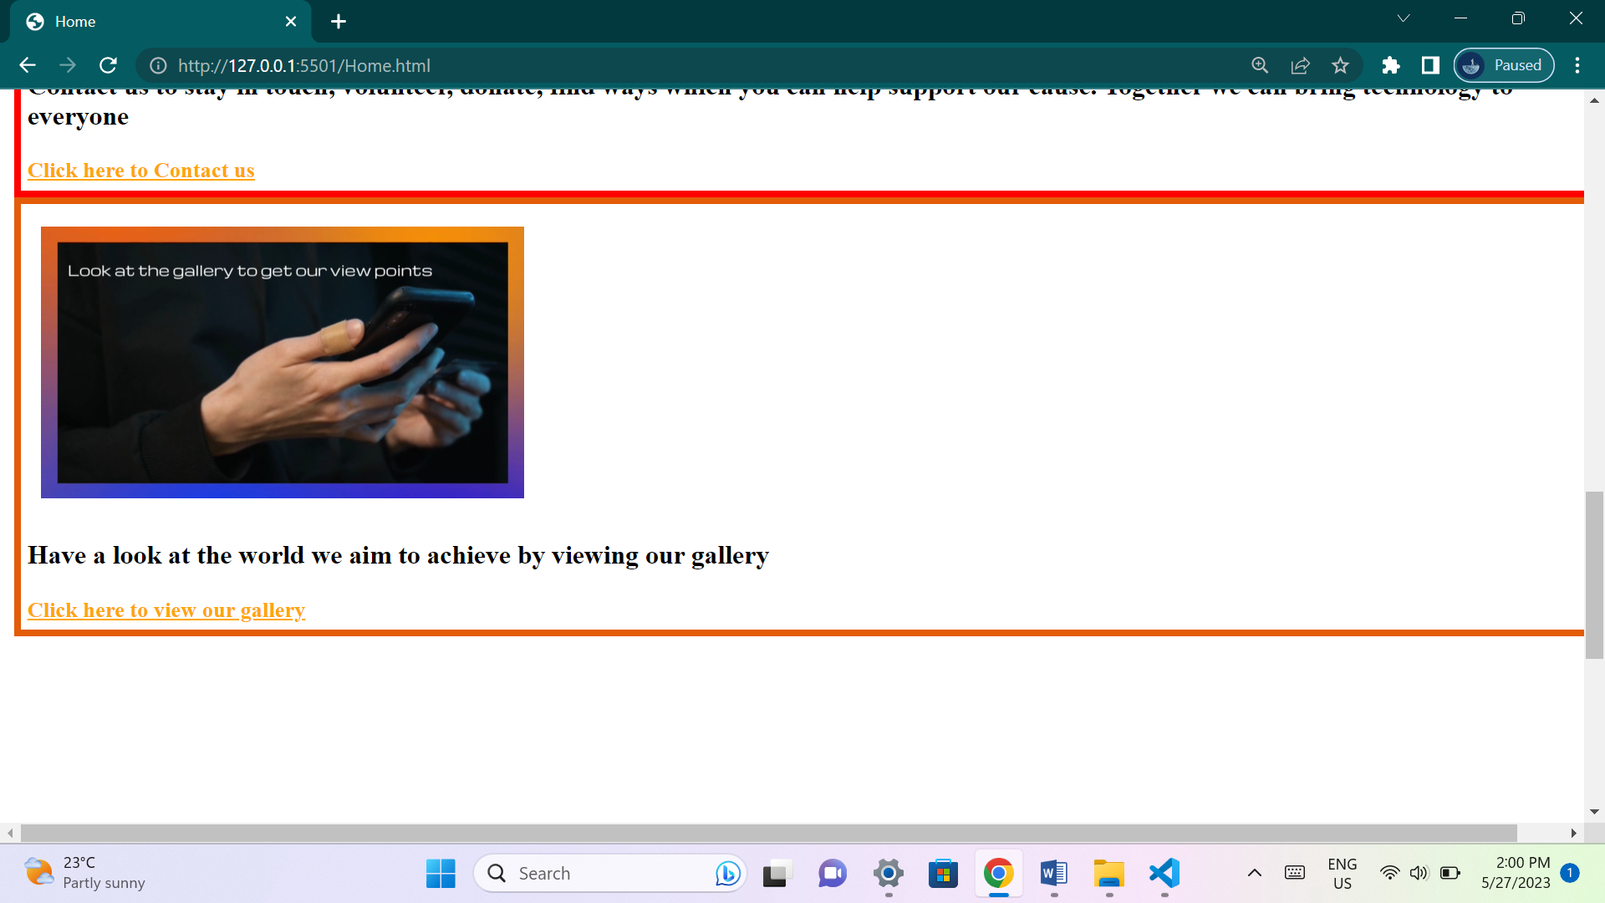

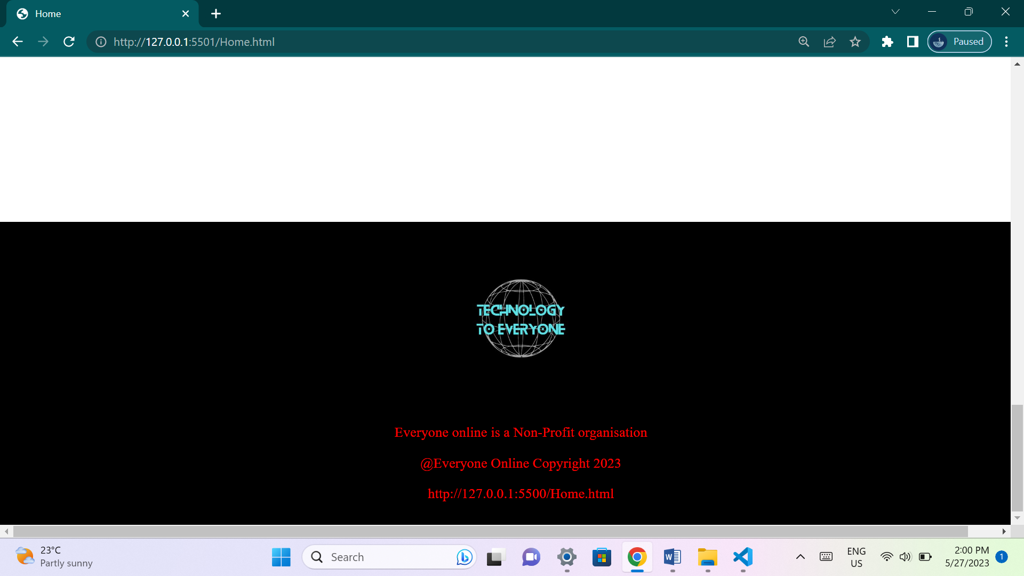

**This page has outline brief details about the organization and its plans. It includes summarized details about all the other web pages as well as links to other pages.**

**Projects page:**

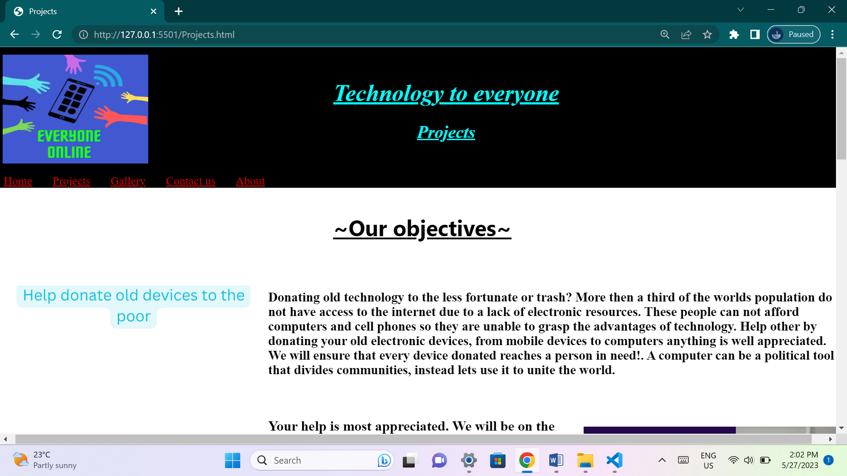

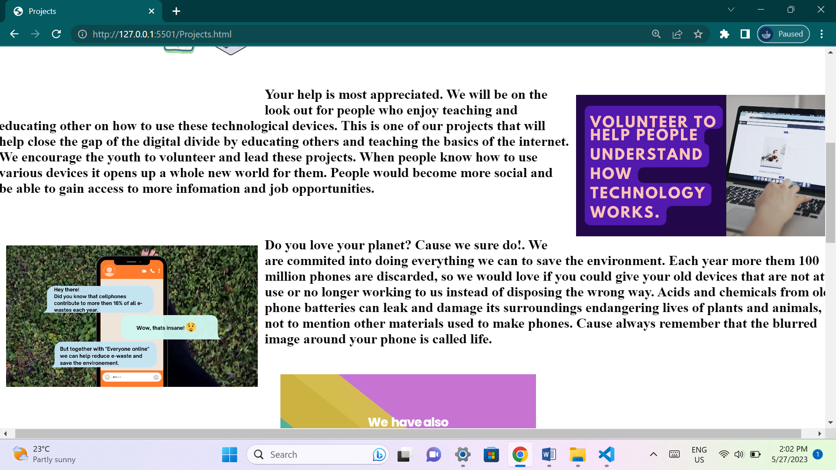

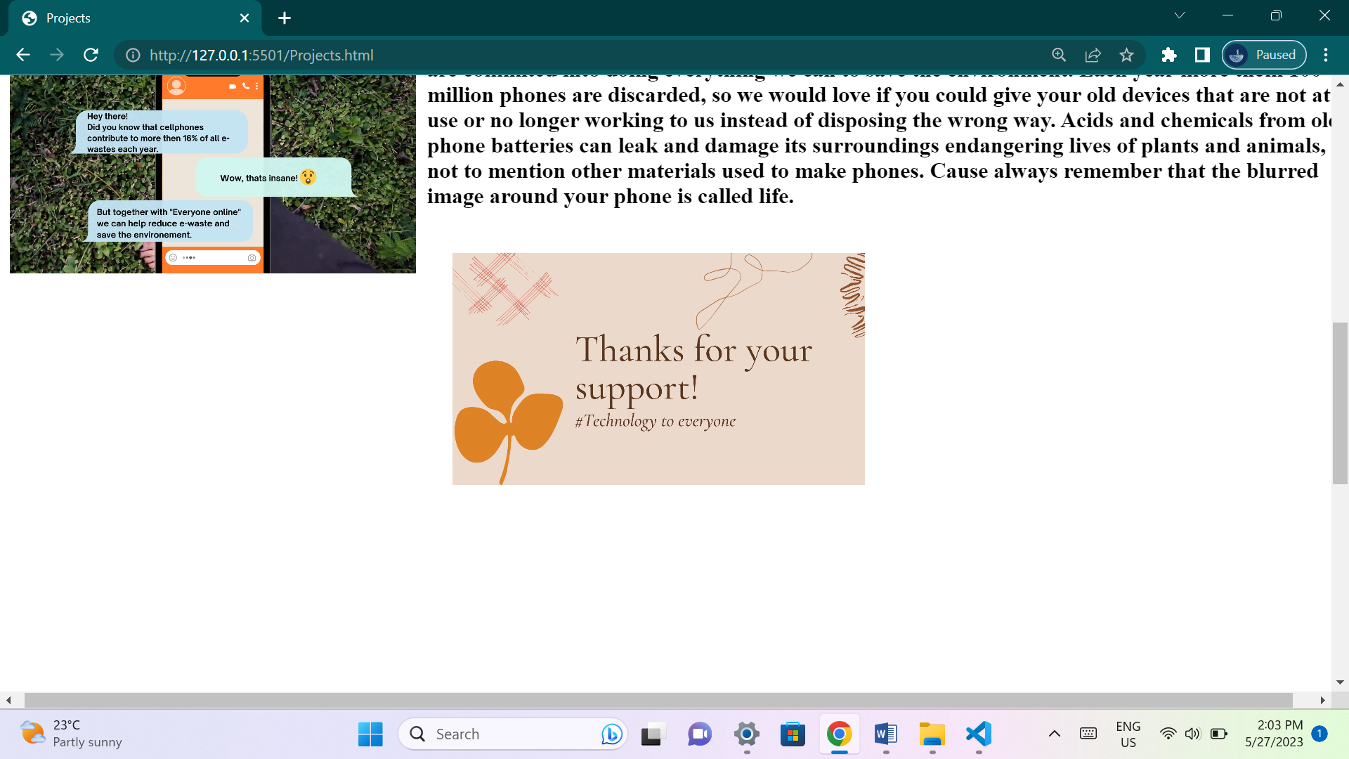

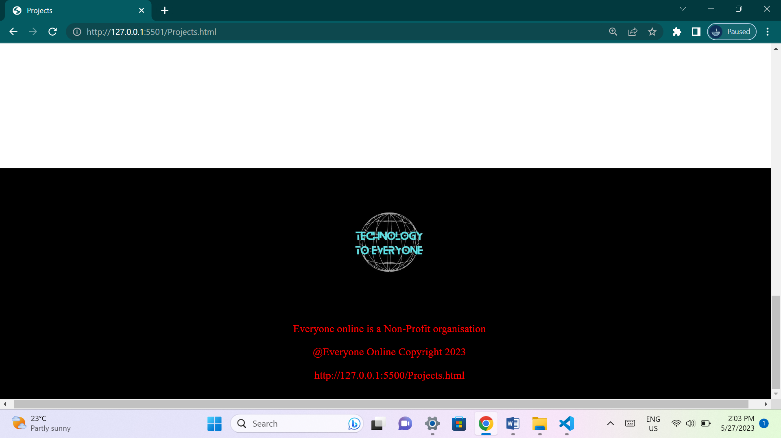

**This page has videos and details about projects that the organization is currently pursuing and wishes to accomplish.**

**Gallery page:**

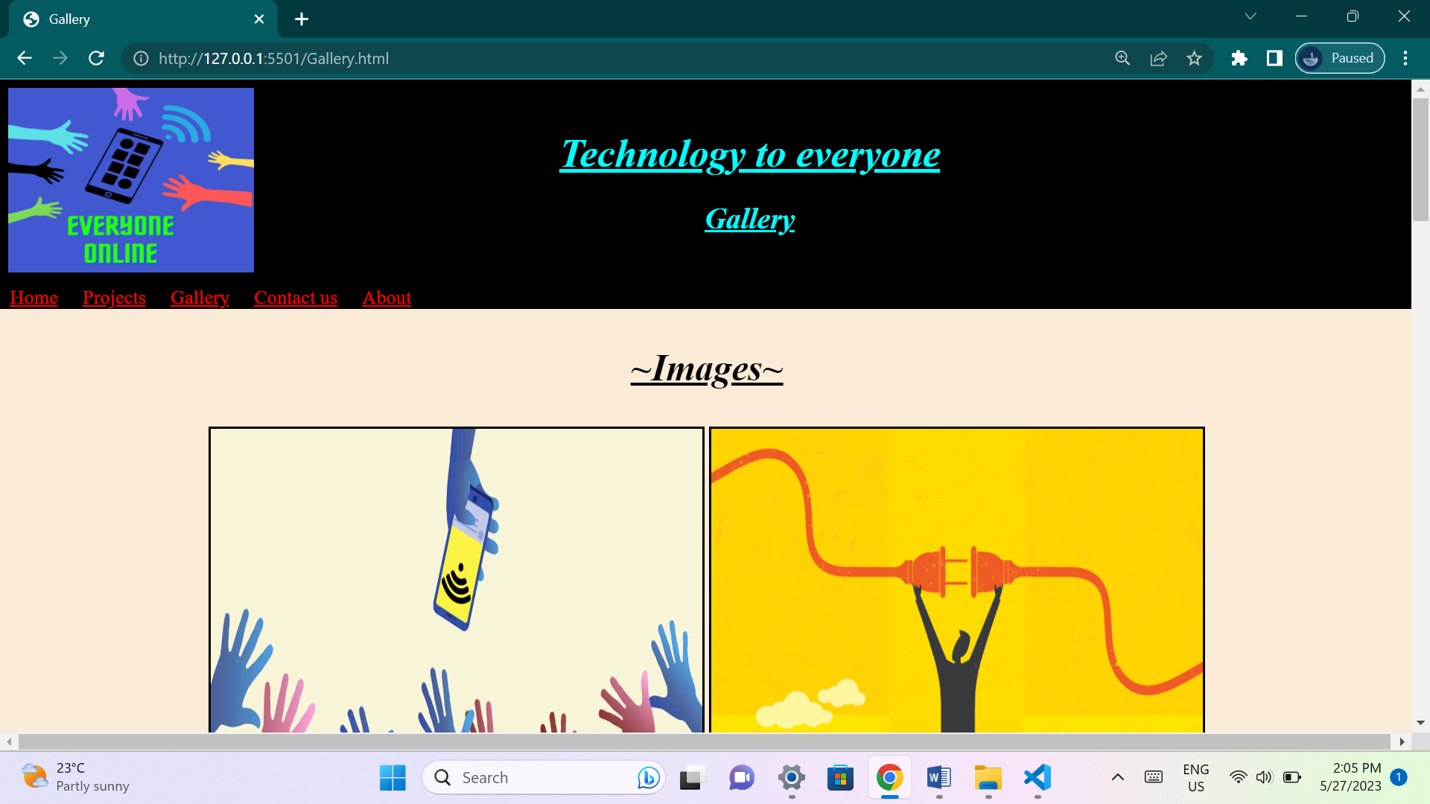

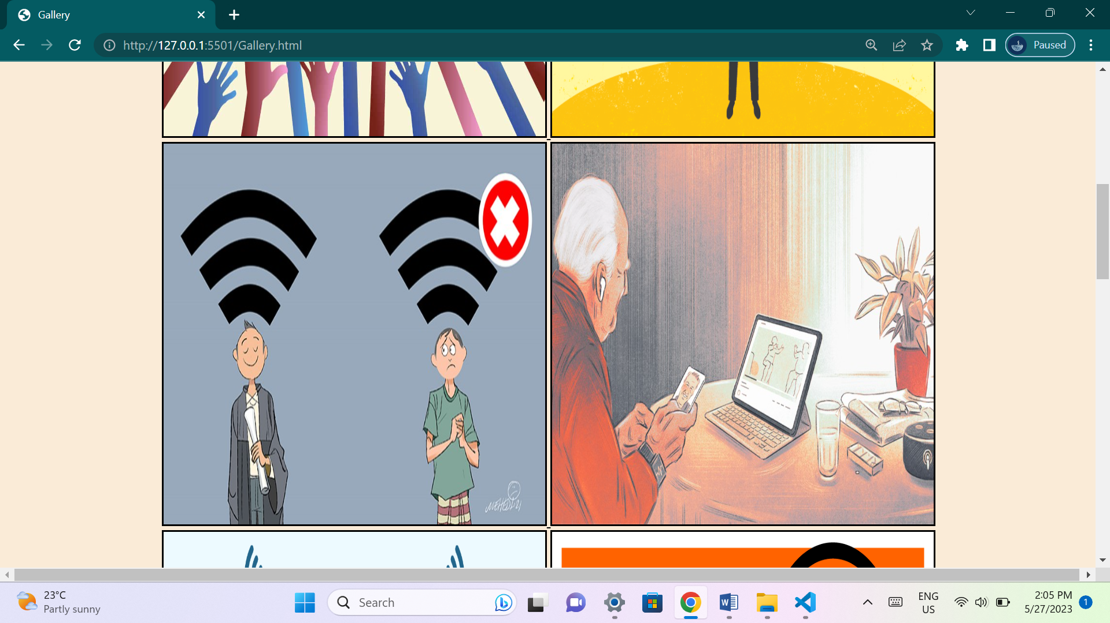

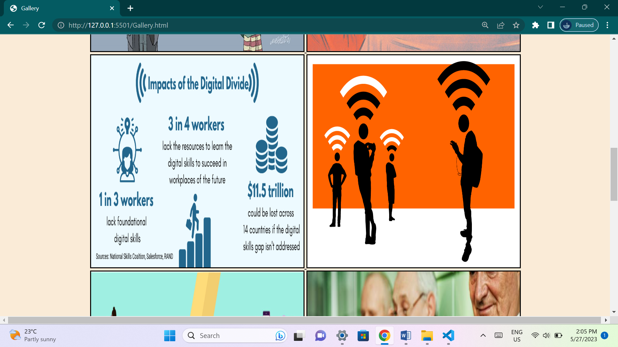

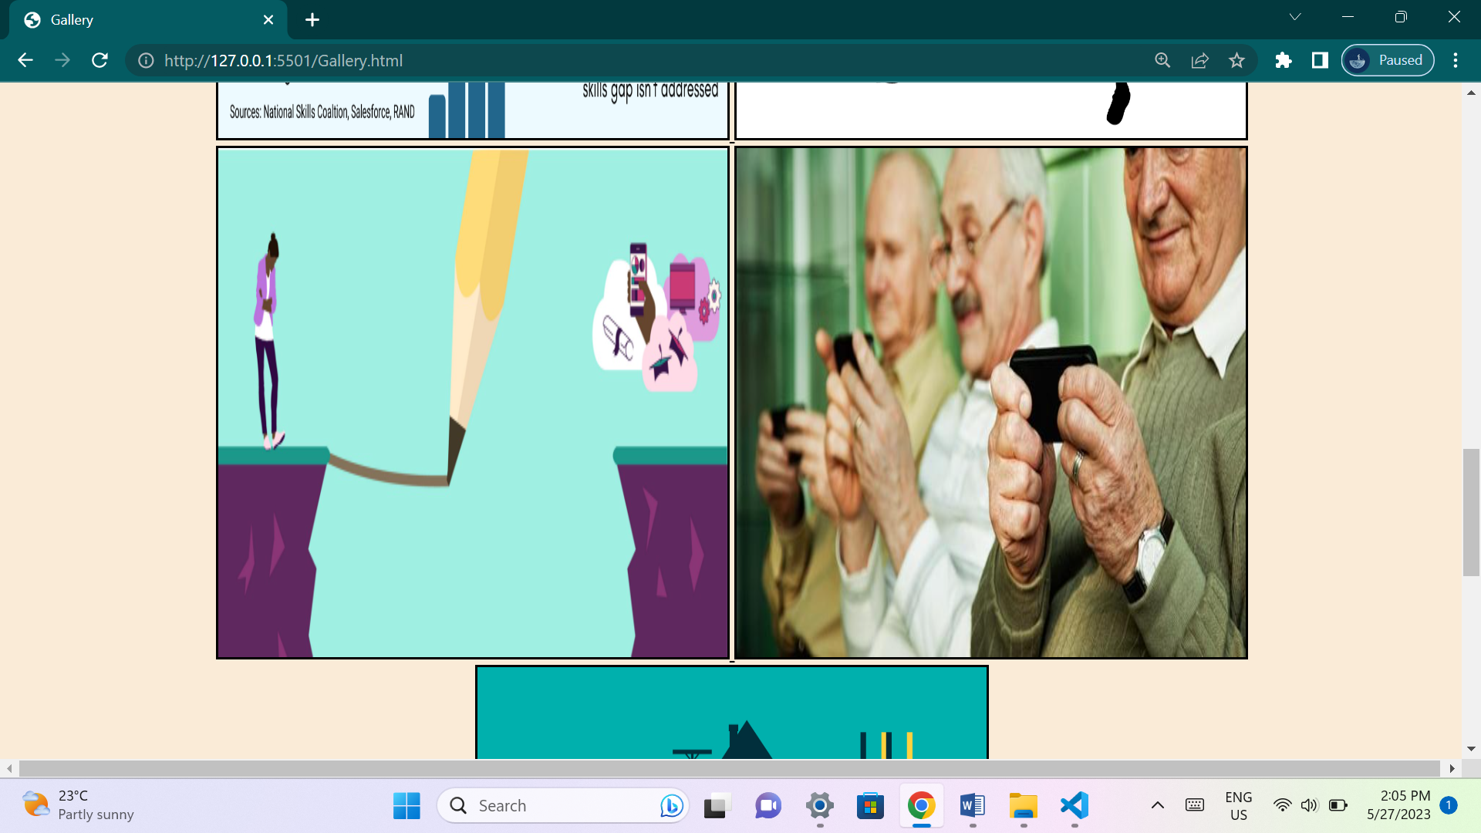

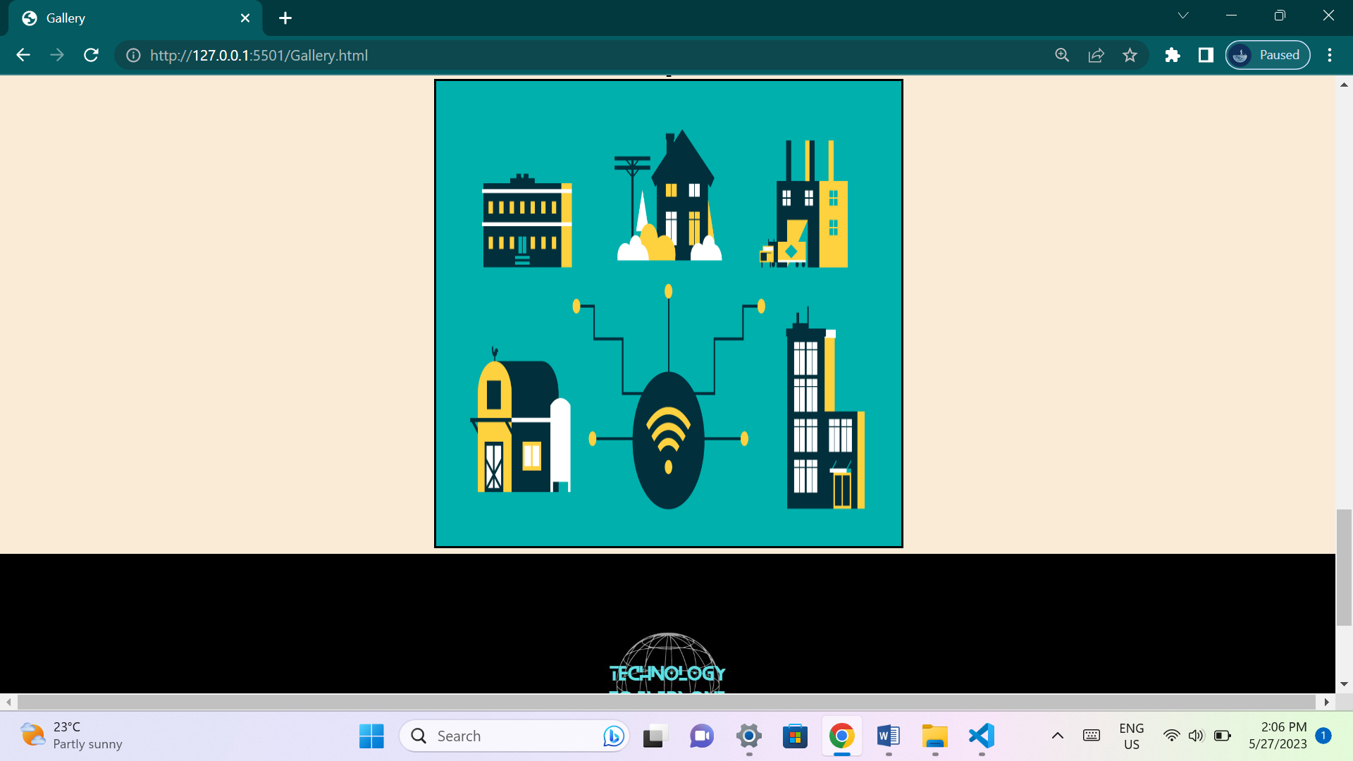

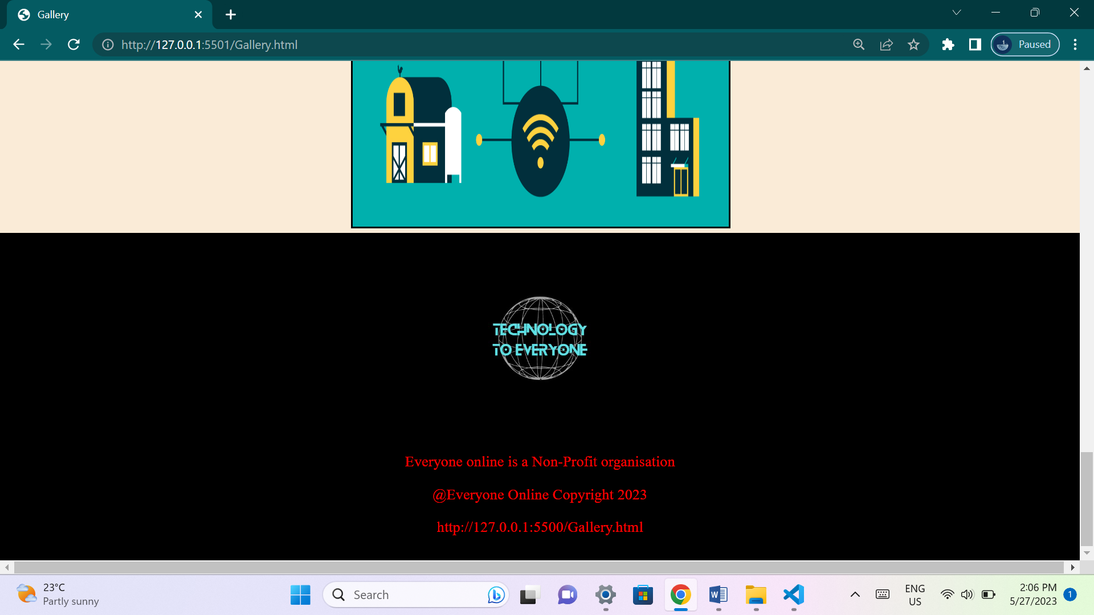

**This page contains multiple images that would help the user understand what the organization wishes to achieve, and its idea's.**

**Contact us page:**

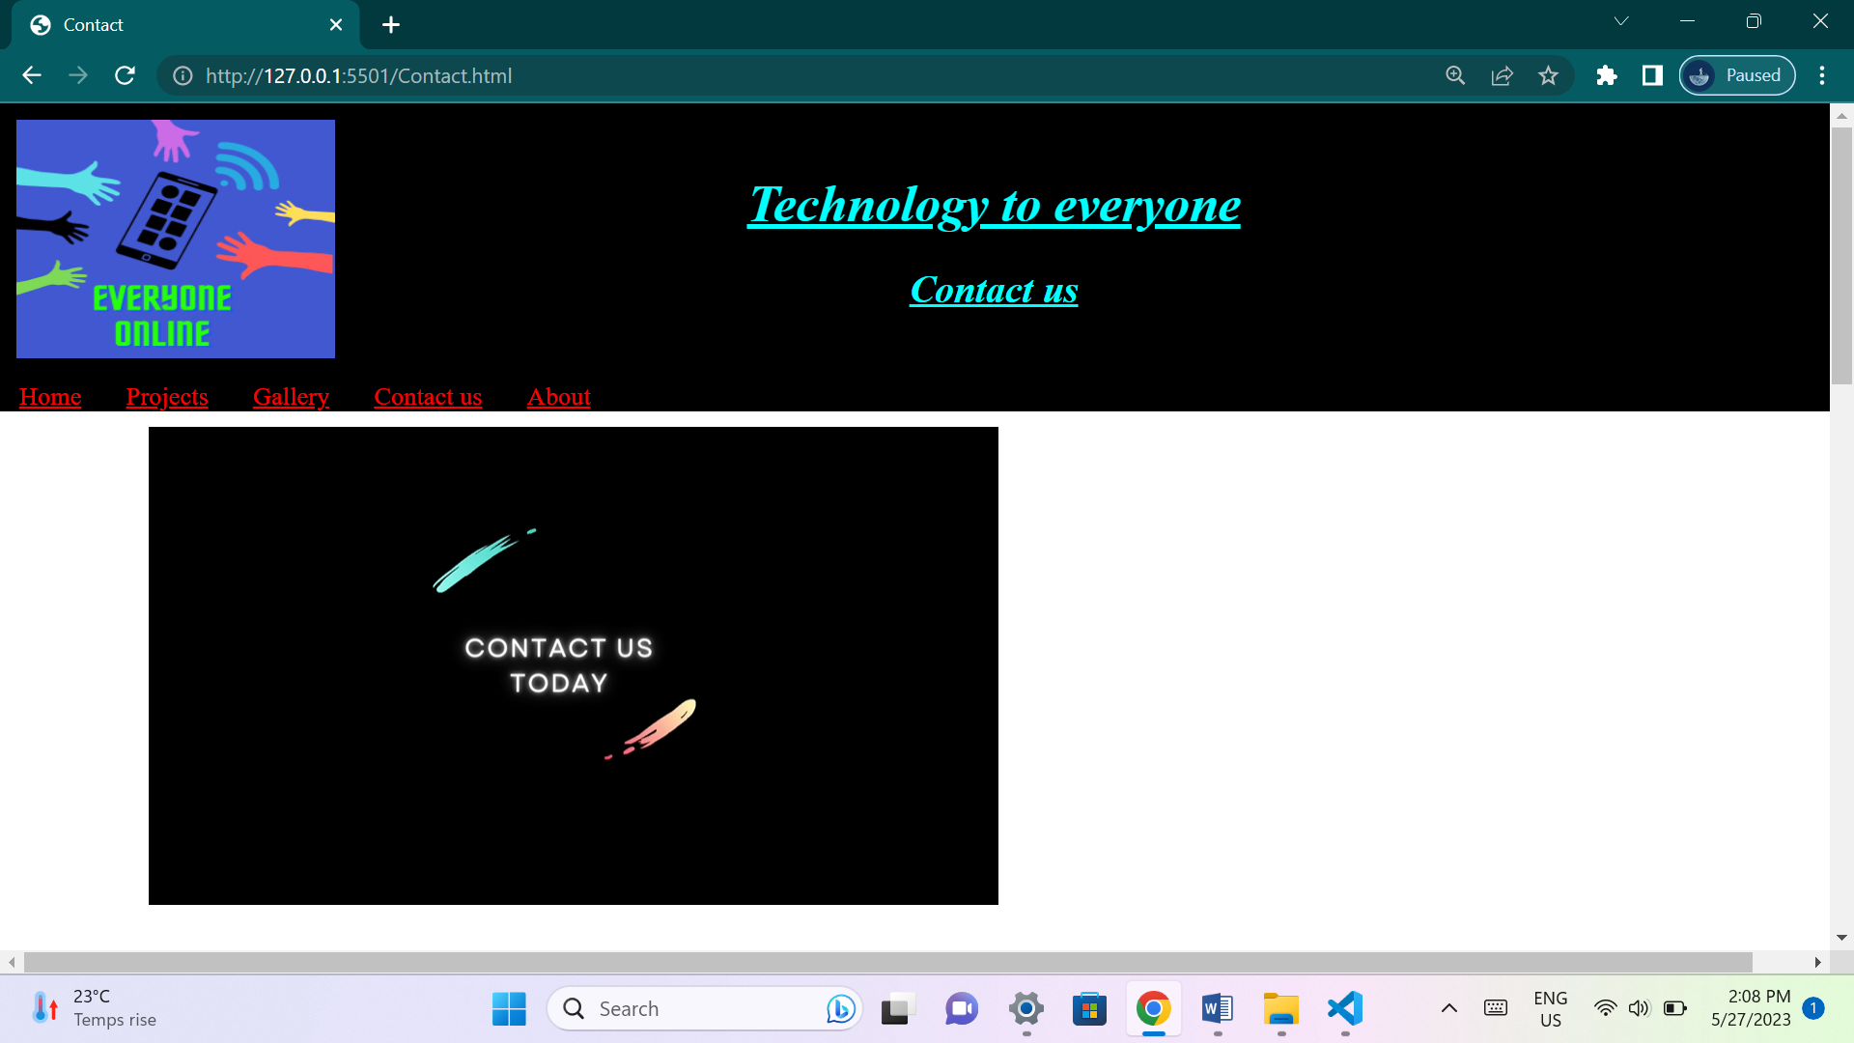

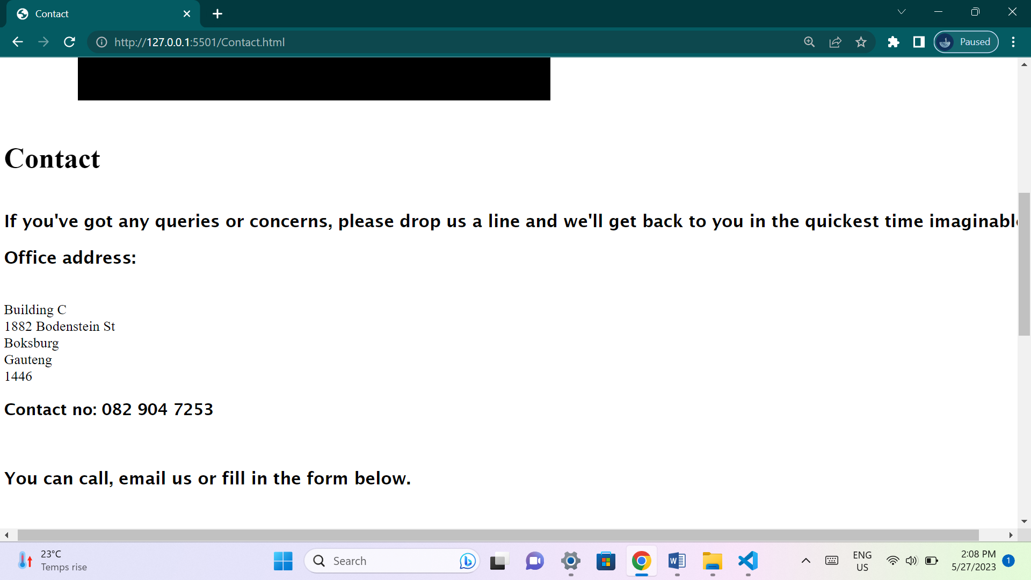

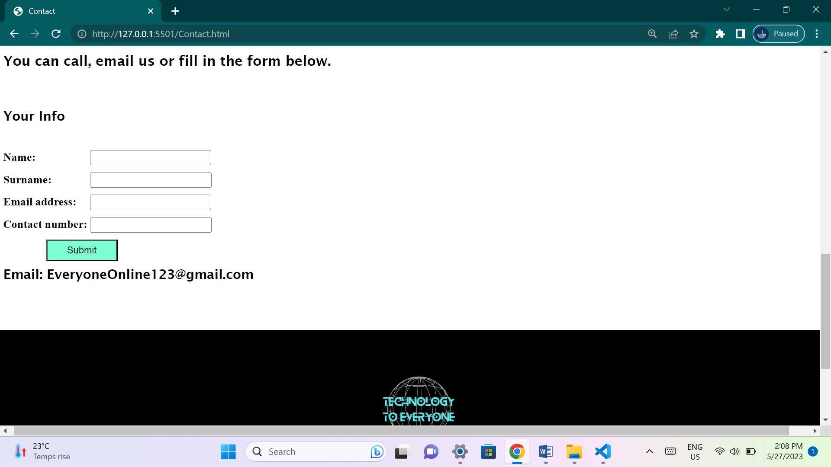

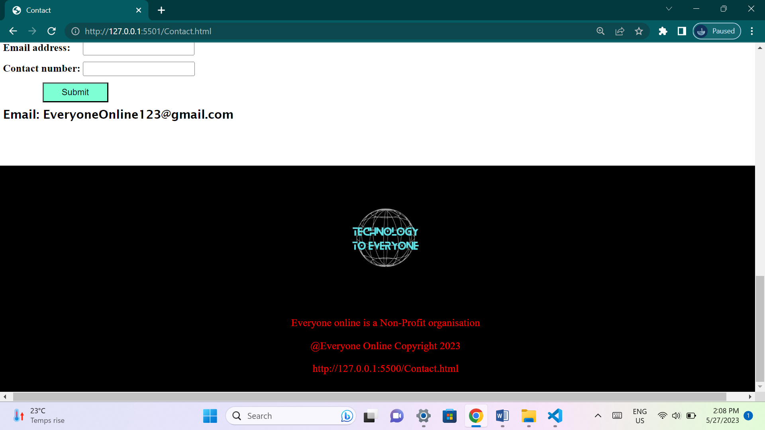

**This page has contact details that will be available to the user if they have any questions or queries dealing with the organization. A page that allows users to stay in touch with the organization.**

**About page:**

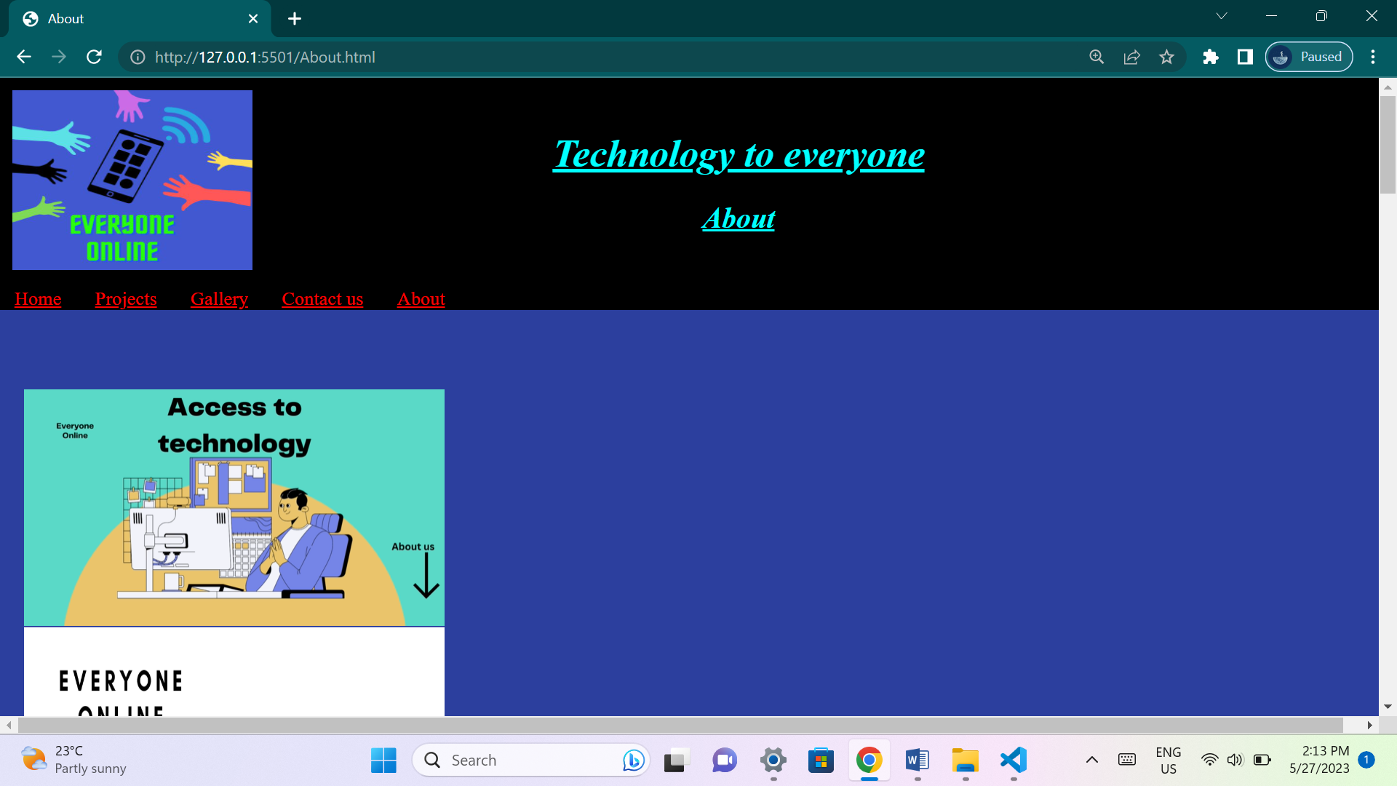

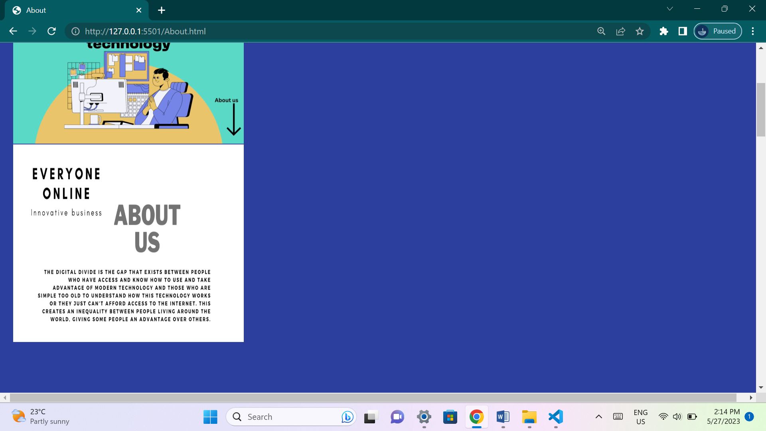

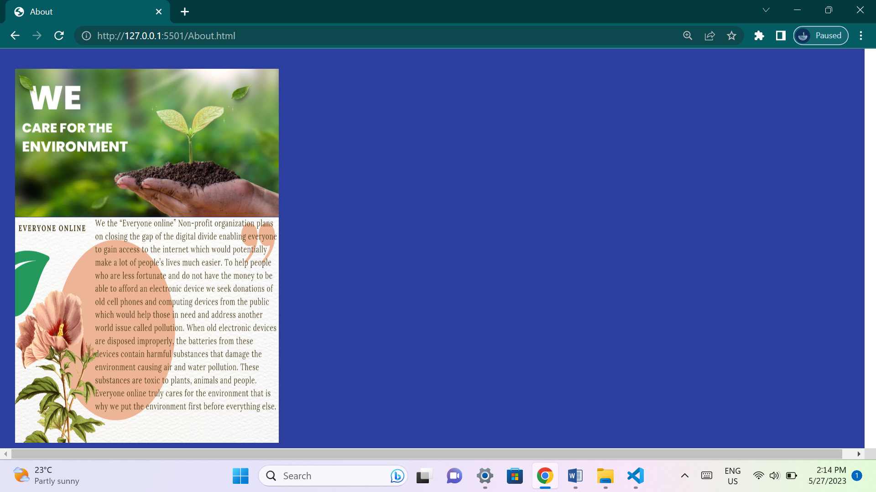

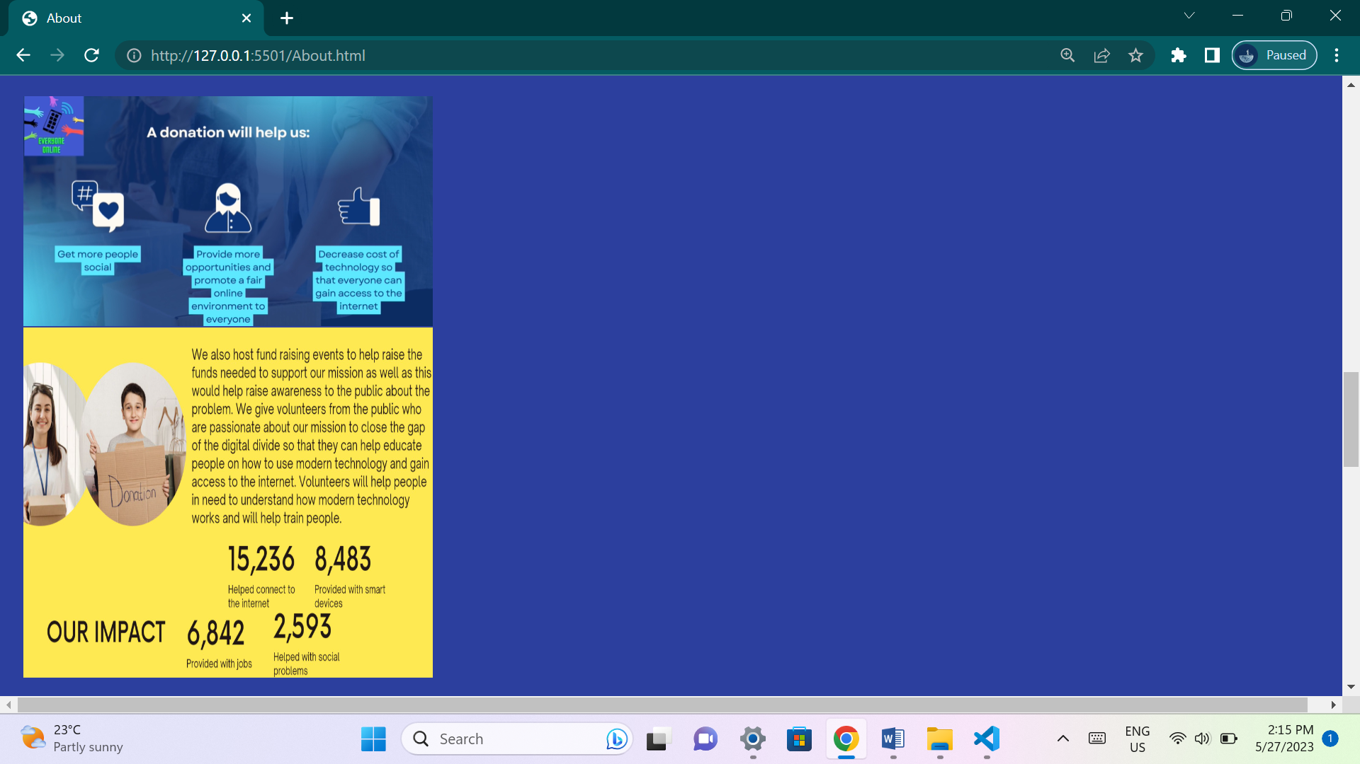

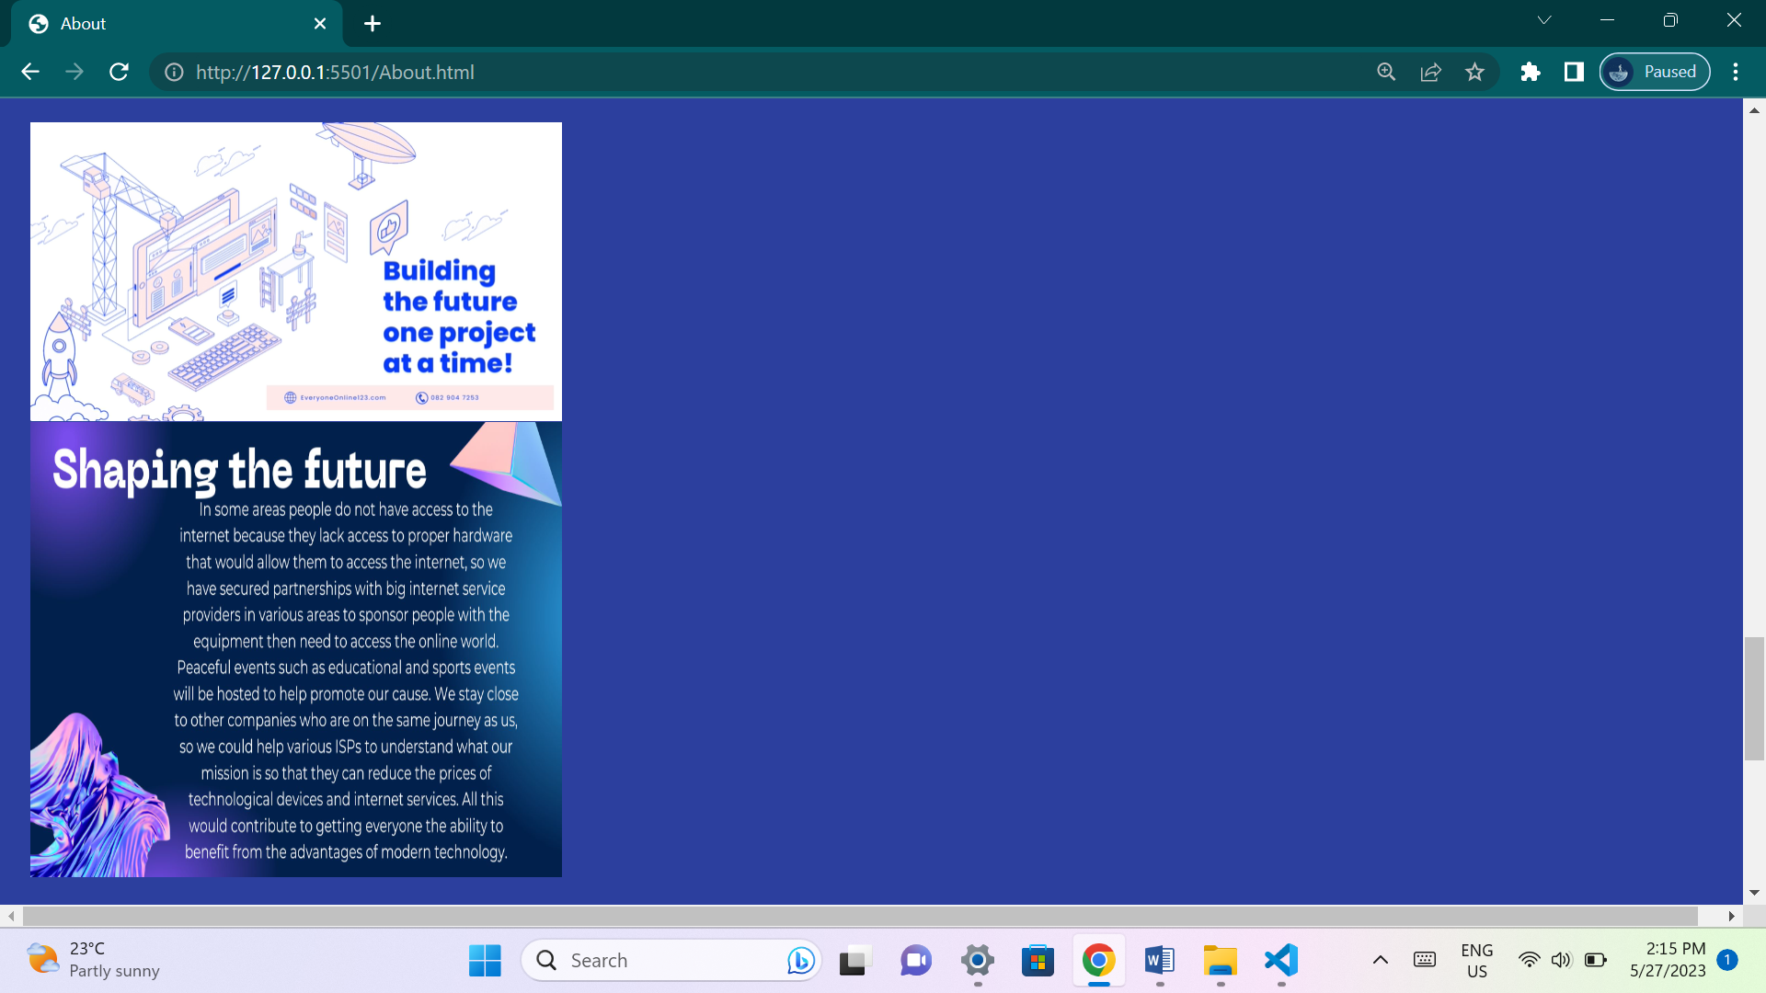

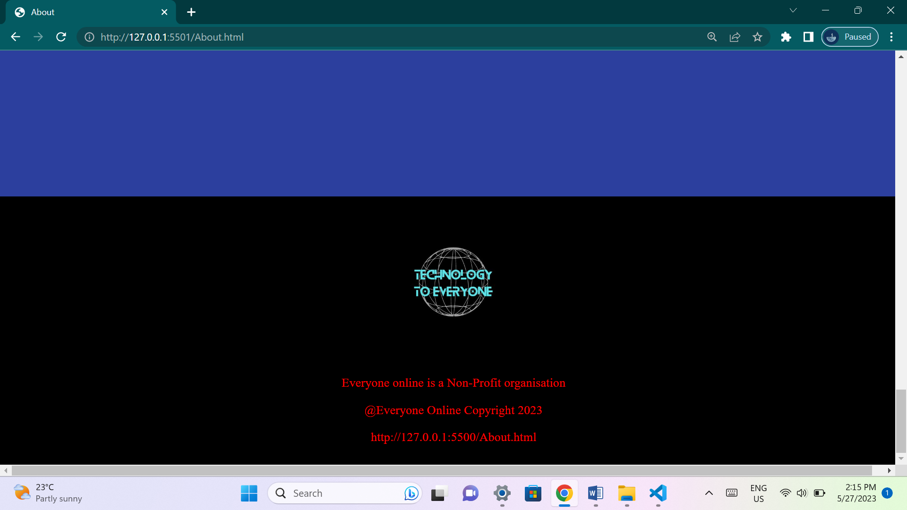

**This page will explain to the user what the organization is about. It will give users an idea about the organization goals and why the organization wants to achieve their goals.**

**Improvements in code:**

**The entire middle screen of all pages has been changed.**

**Added code:**

**Home.html:**

**New code has been added from line 65 to line 85.**

**4 Div tags has been added on lines 65, 70, 76, 82.**

**4 Video tags has been added on lines 66, 72, 78, 83.**

**4 Paragraph tags has been added to lines 68, 74, 79, 84.**

**4 links have been added to lines 69, 75, 80, 85.**

**Home.css:**

**New code has been added from lines 6 to 13, 62 to 66, 68 to 91.**

**Changes to code made on:**

**Line 50, height value changed from 100vh to 300vh.**

**Projects.html:**

**New code has been added from lines 72 to 92.**

**1 H3 heading tag added on line 72.**

**4 Div tags has been added on lines 74, 79, 85, 91.**

**4 Video tags has been added on lines 75, 80, 86, 91.**

**3 Paragraph tags has been added to lines 77, 82, 88.**

**Projects.css:**

**New code has been added from lines 6 to 41, 74 to 101.**

**Changes to code made on:**

**Line 75, terminated padding, height, width elements.**

**Gallery.html:**

**No changes.**

**Gallery.css:**

**New code has been added from lines 7 to 14.**

**Changes to code made on:**

**Line 53, Height value changes from 100vh to 100%.**

**Line 54, Width value changes from 100vw to 100%.**

**Contact.html:**

**New code has been added from lines 65 to 125.**

**2 Heading tags H3 and H4 has been added on lines 67, 68.**

**5 paragraph tags have been added on lines 69, 81, 83, 85, 111.**

**4 inputs have been added on lines 87, 90, 93, 96.**

**1 Button tag has been added to line 99.**

**A script tag with JavaScript has been added to lines 101 to 107.**

**Contact.css:**

**New code has been added to lines 6 to 37, 85 to 115.**

**Changes to code made on:**

**Line 74 to height component value from 100vh to 200vh.**

**About.html:**

**New code has been added from lines 63 to 77.**

**4 Video tags have been added to lines 63, 67, 71, 75.**

**4 Image tags have been added to lines 65, 69, 73, 77.**

**About.css:**

**New code has been added to lines 6 to 13.**

**Changes to code made on:**

**Line 49, height value changed from 100vh to 500vh.**

**Line 50, background-color changed from white to rgb(44, 63, 158).**

**Reference list for new website assets:**

**All new website assets have been designed using the canva application.**

**Part 3:**

**Improvements to part 2:**

**New website assets:**

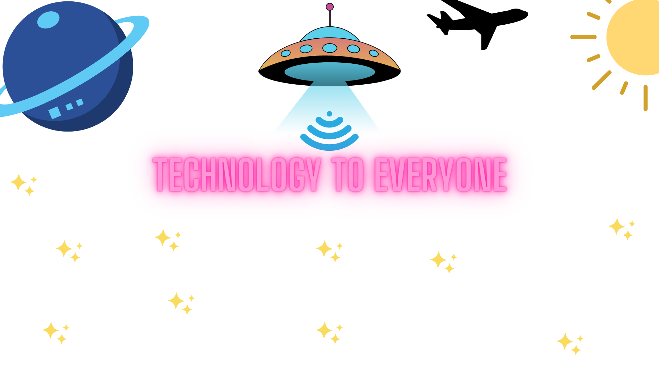

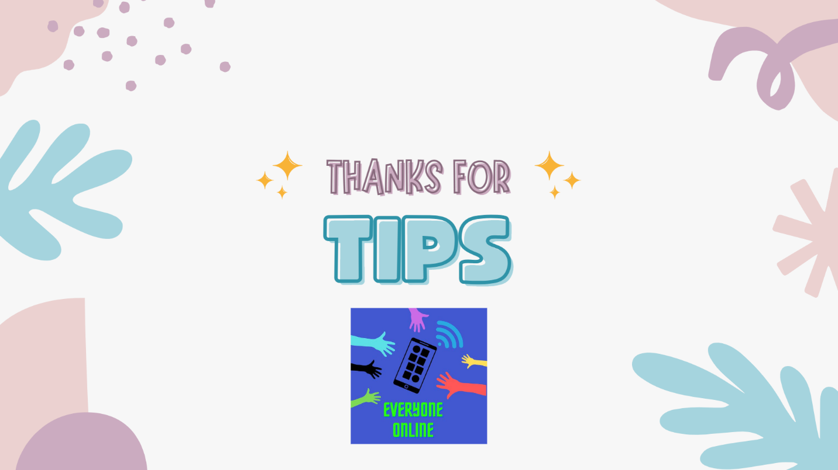

**All create using the canva application.**

**Improved webpages and content:**

**Home page:**

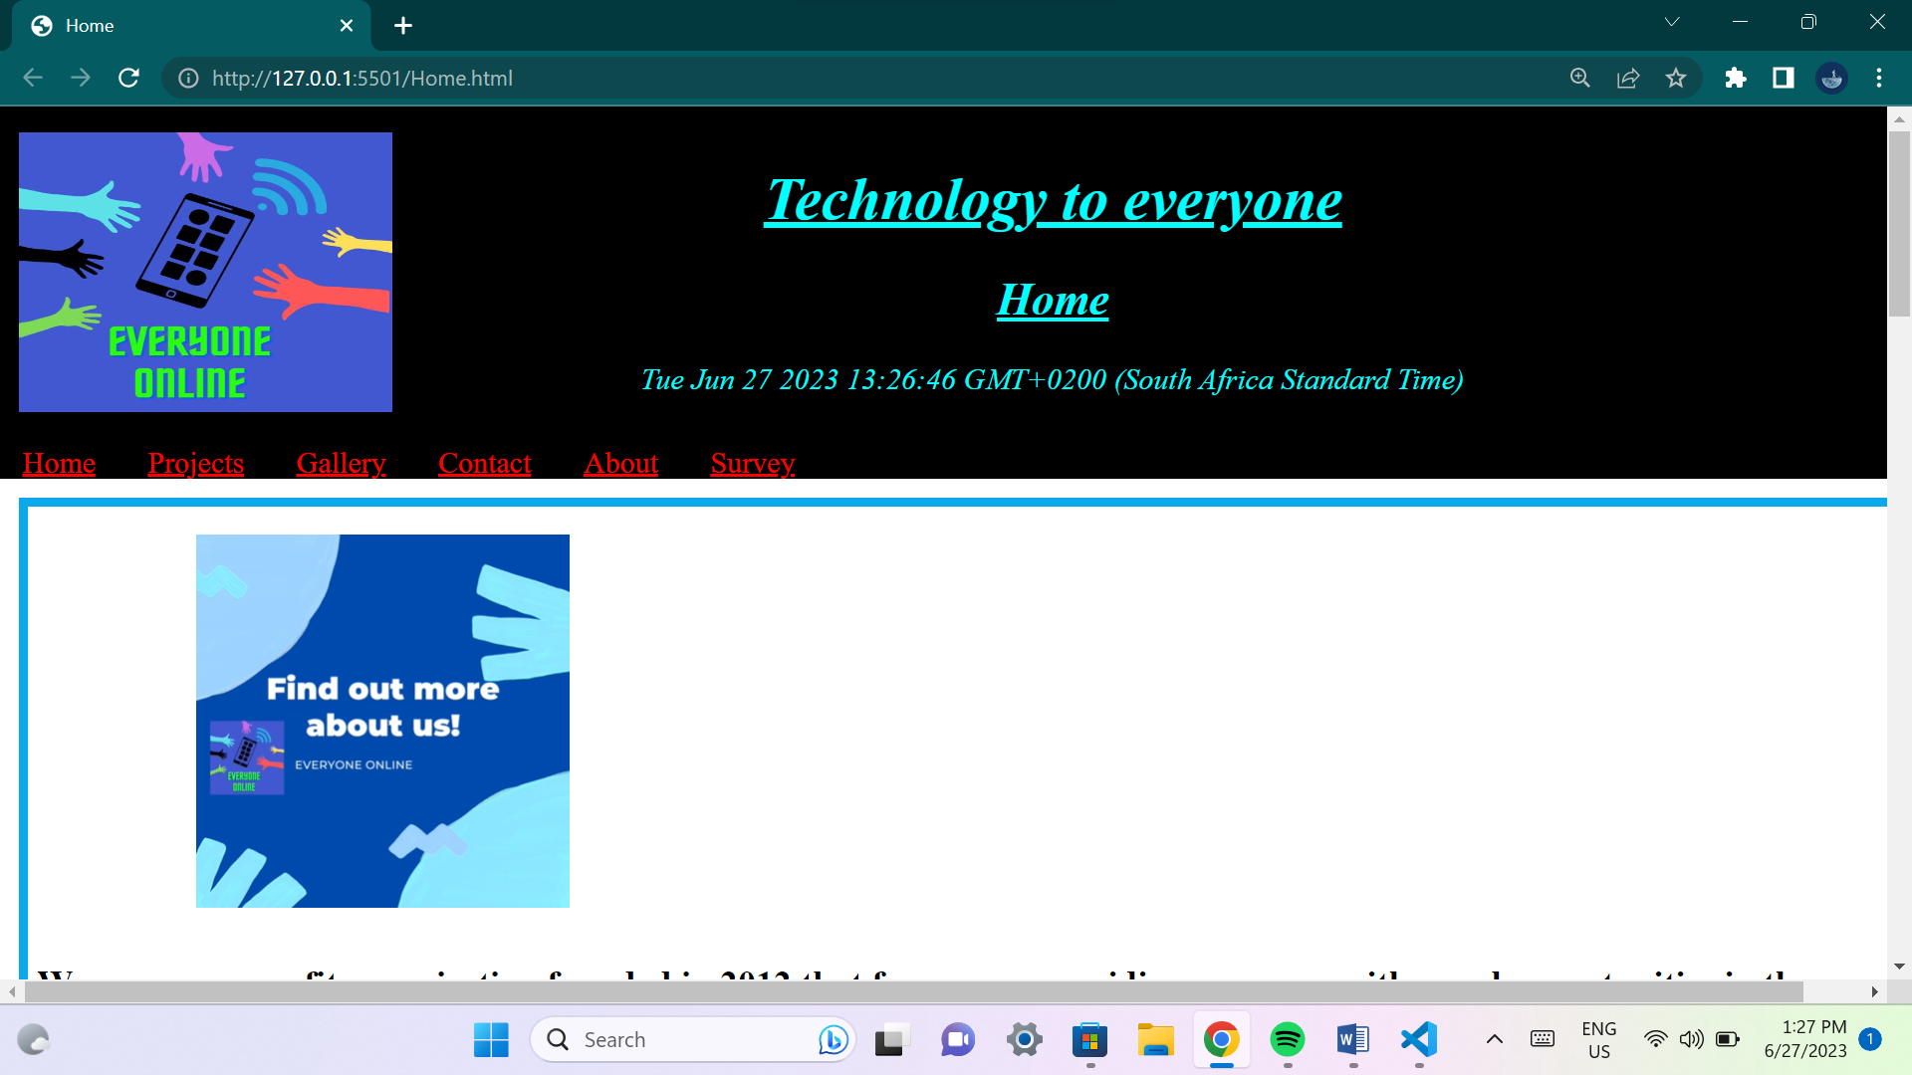

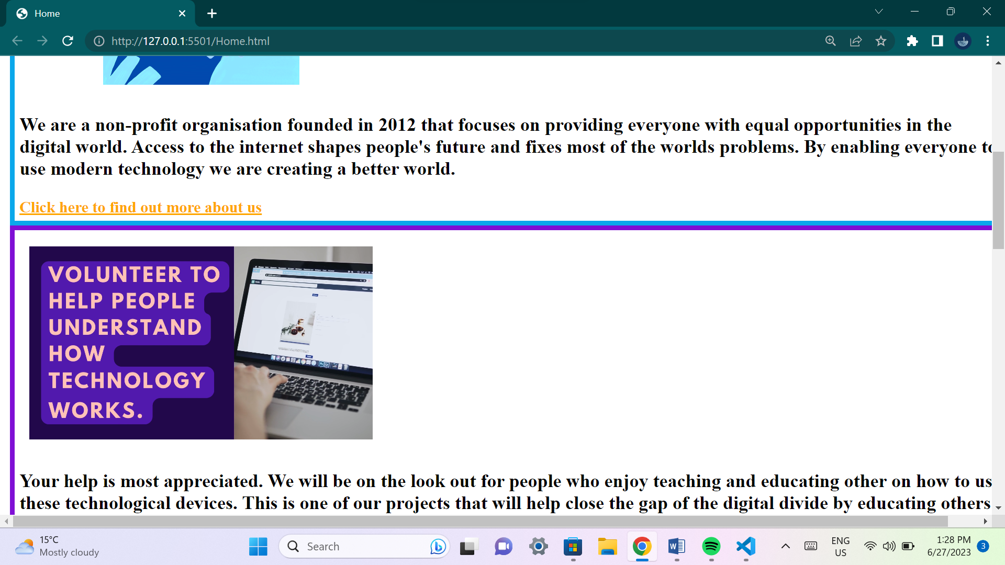

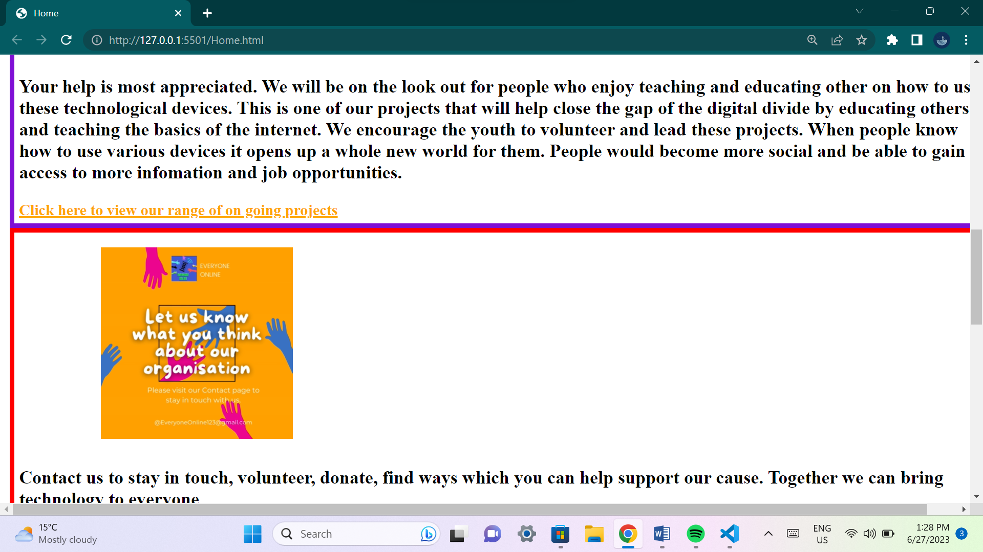

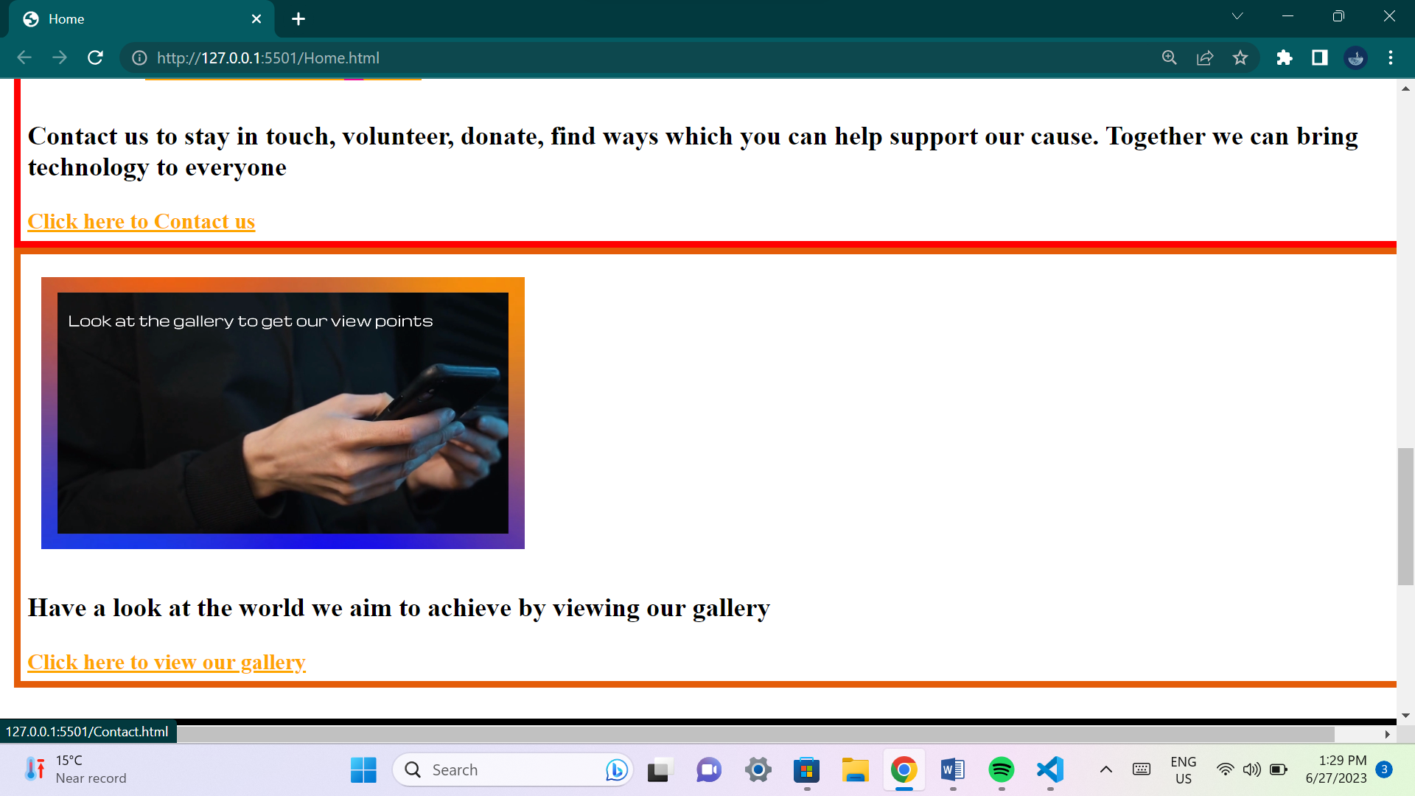

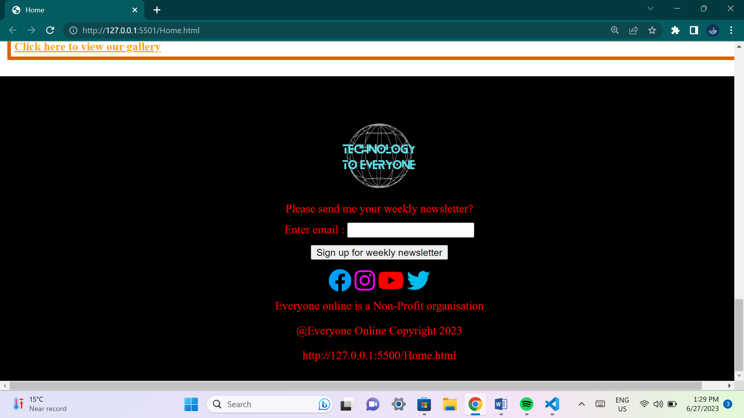

**This page has outline brief details about the organization and its plans. It includes summarized details about all the other web pages as well as links to other pages.**

**Projects page:**

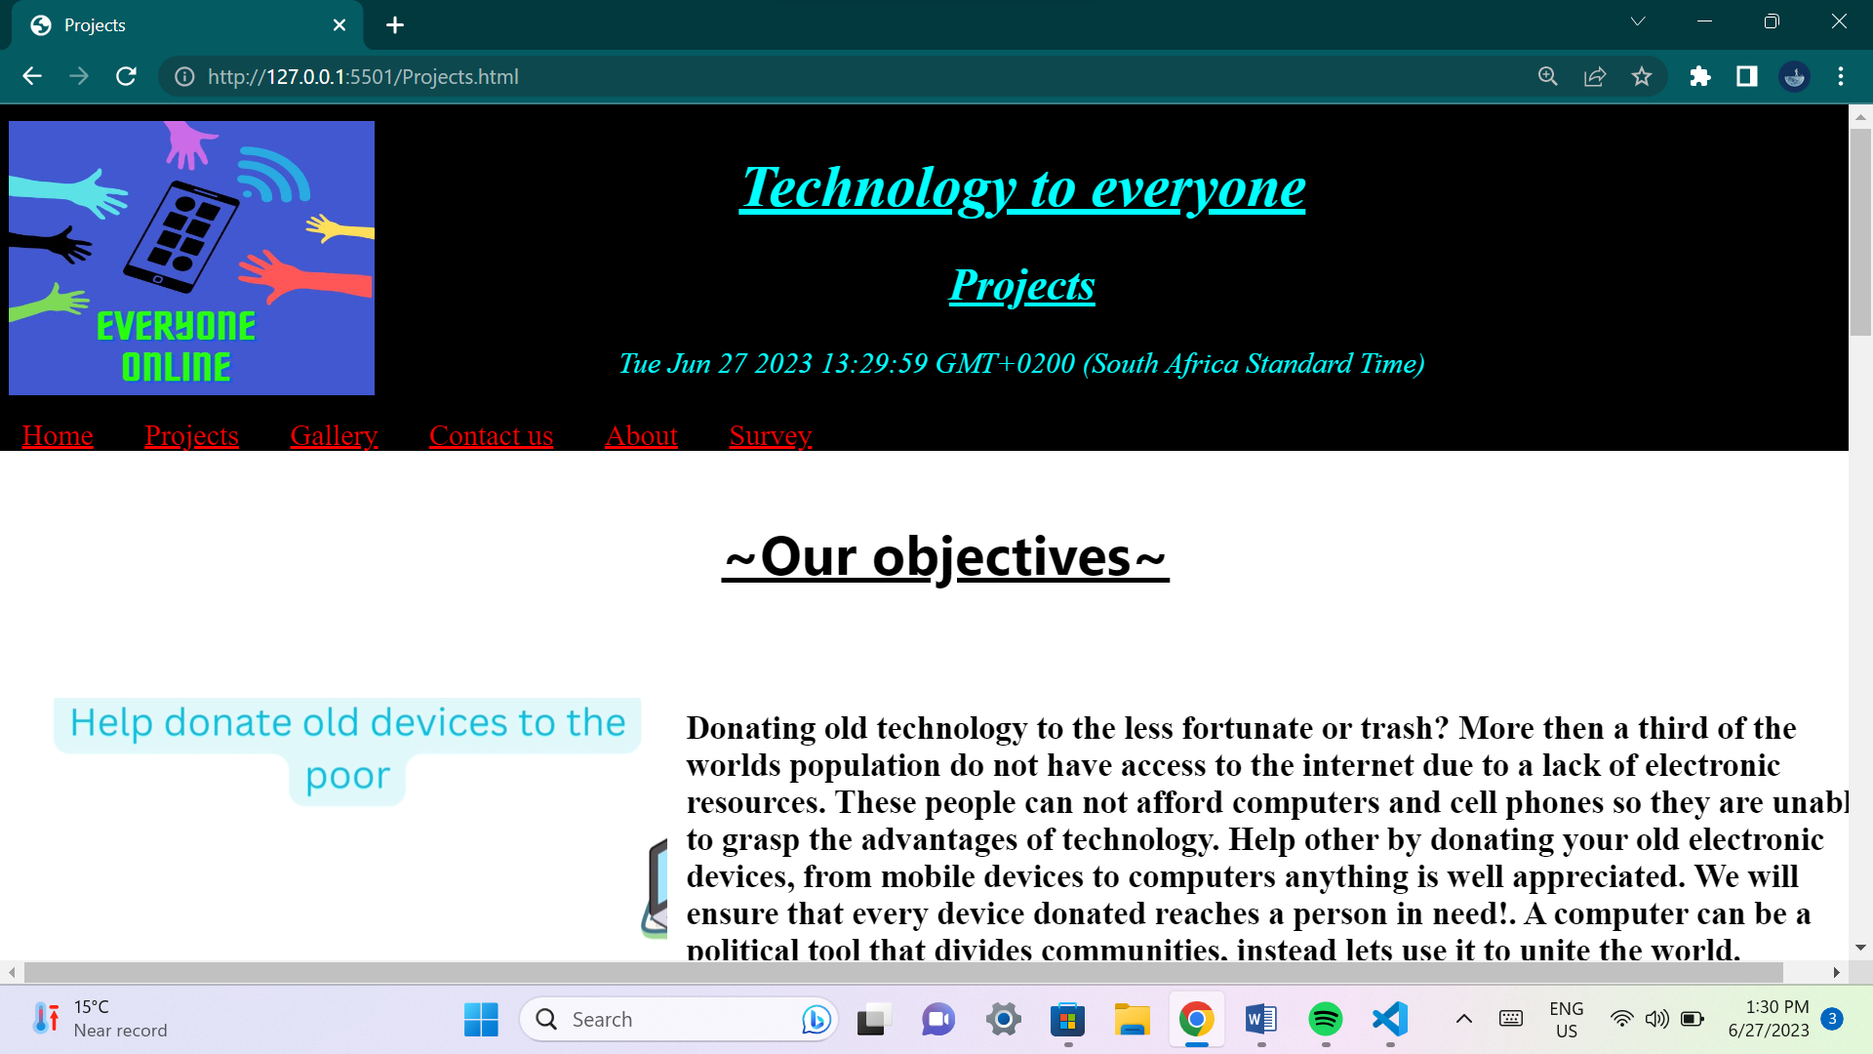

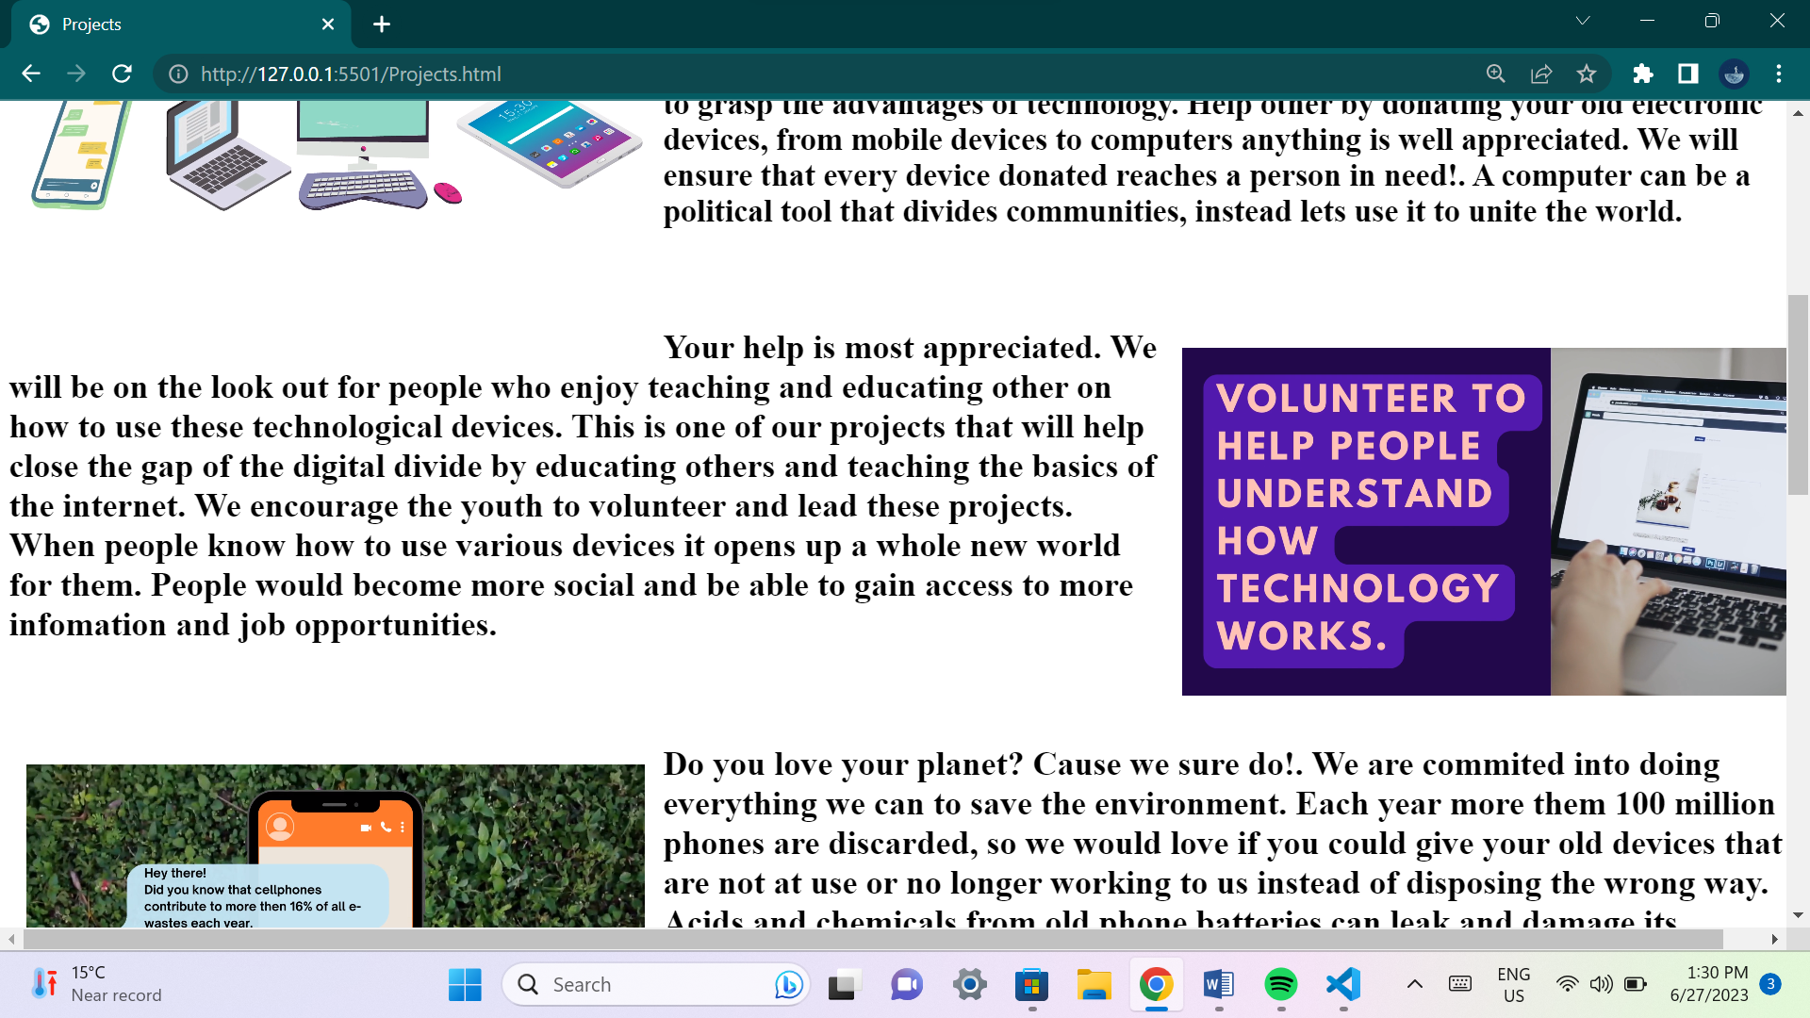

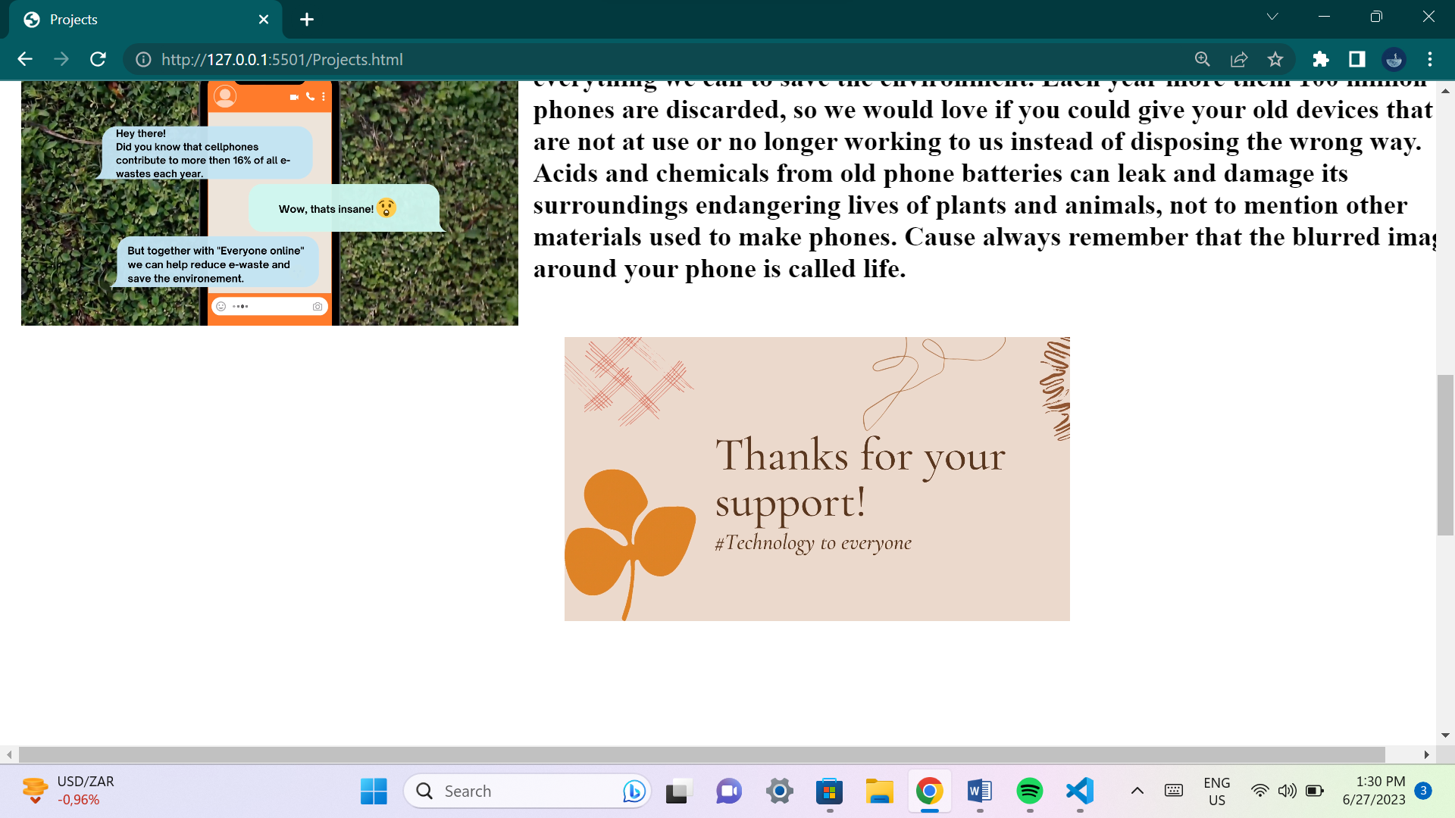

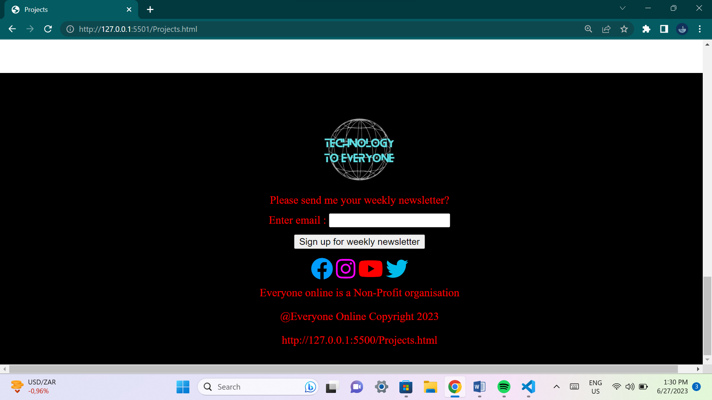

**This page has videos and details about projects that the organization is currently pursuing and wishes to accomplish.**

**Gallery page:**

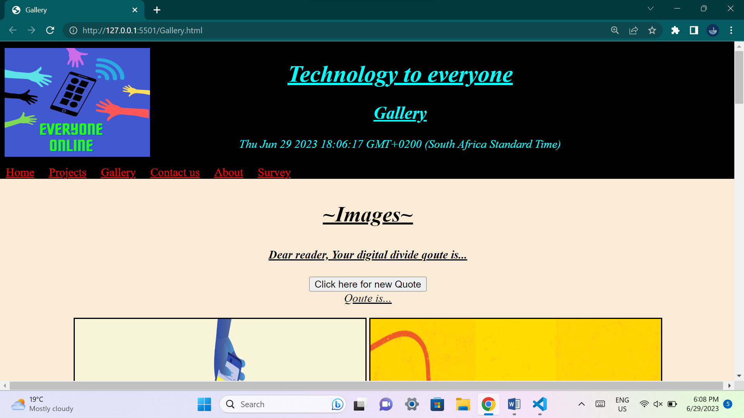

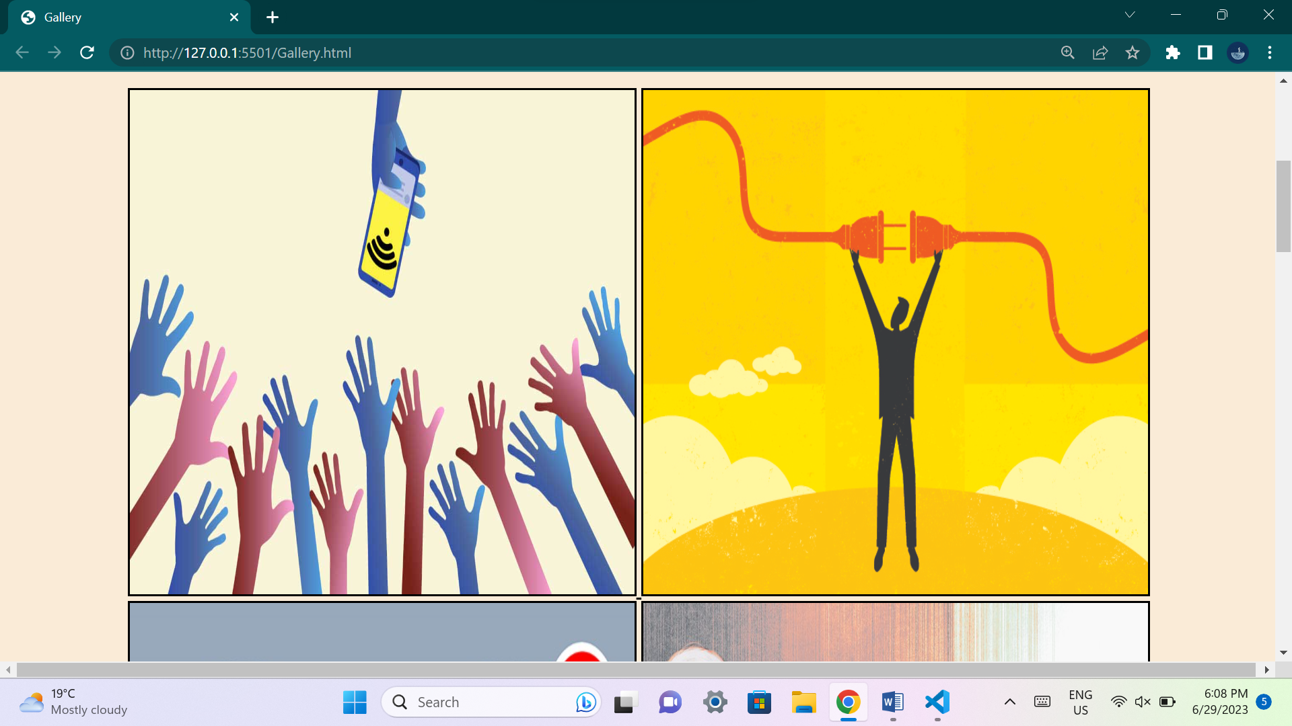

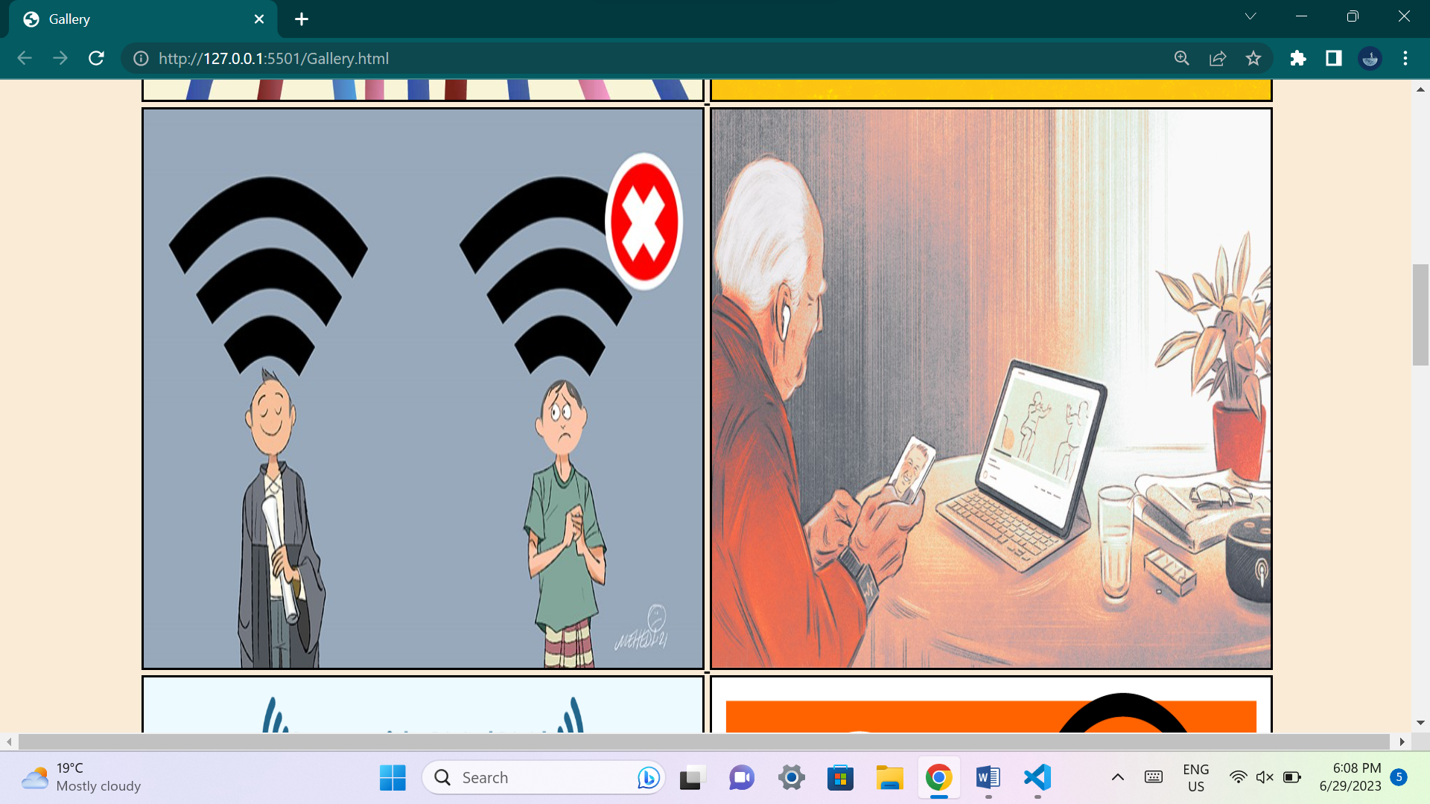

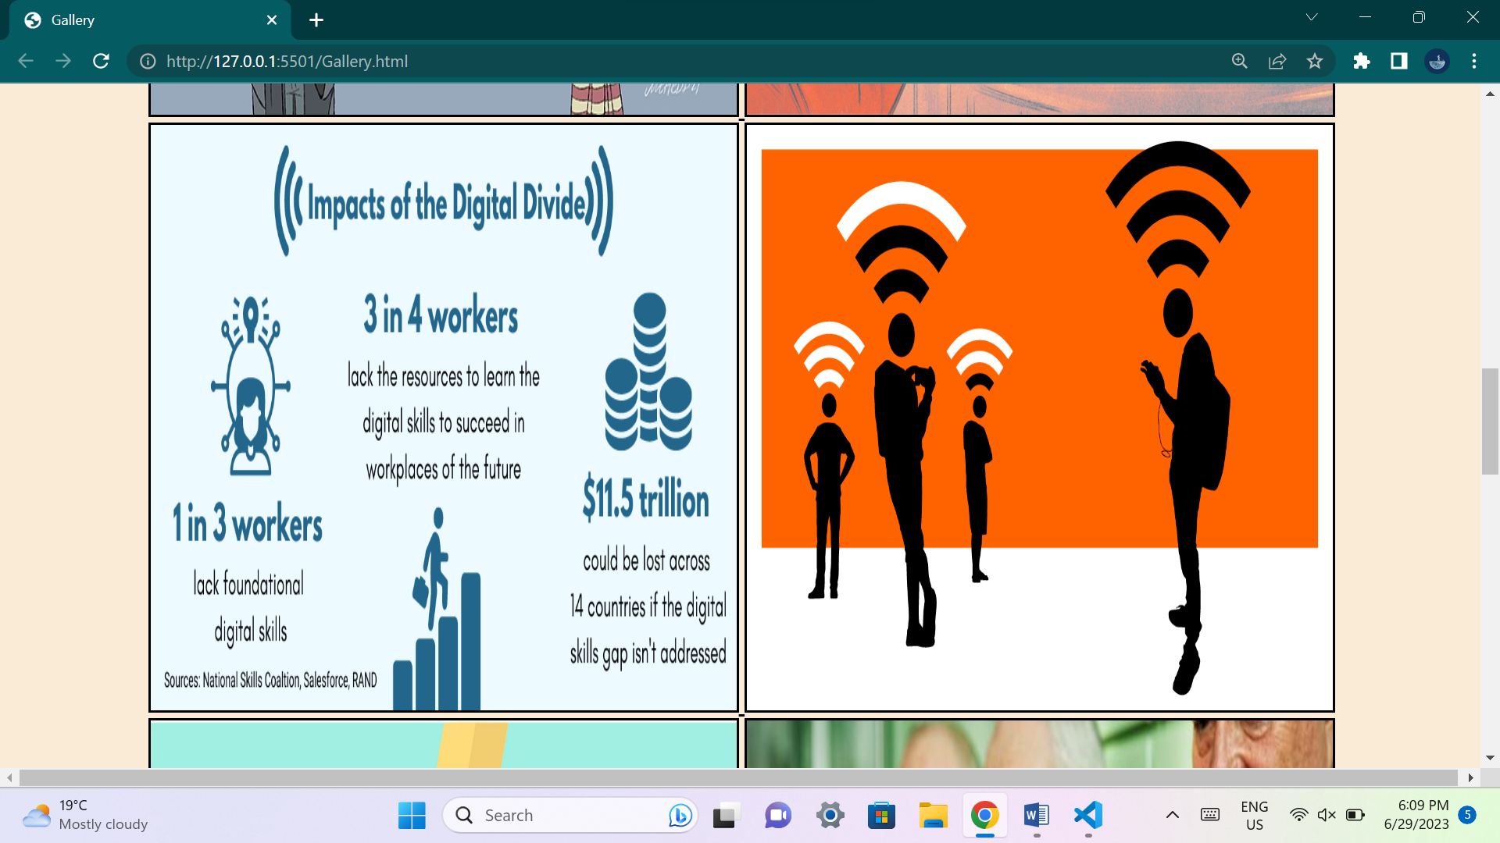

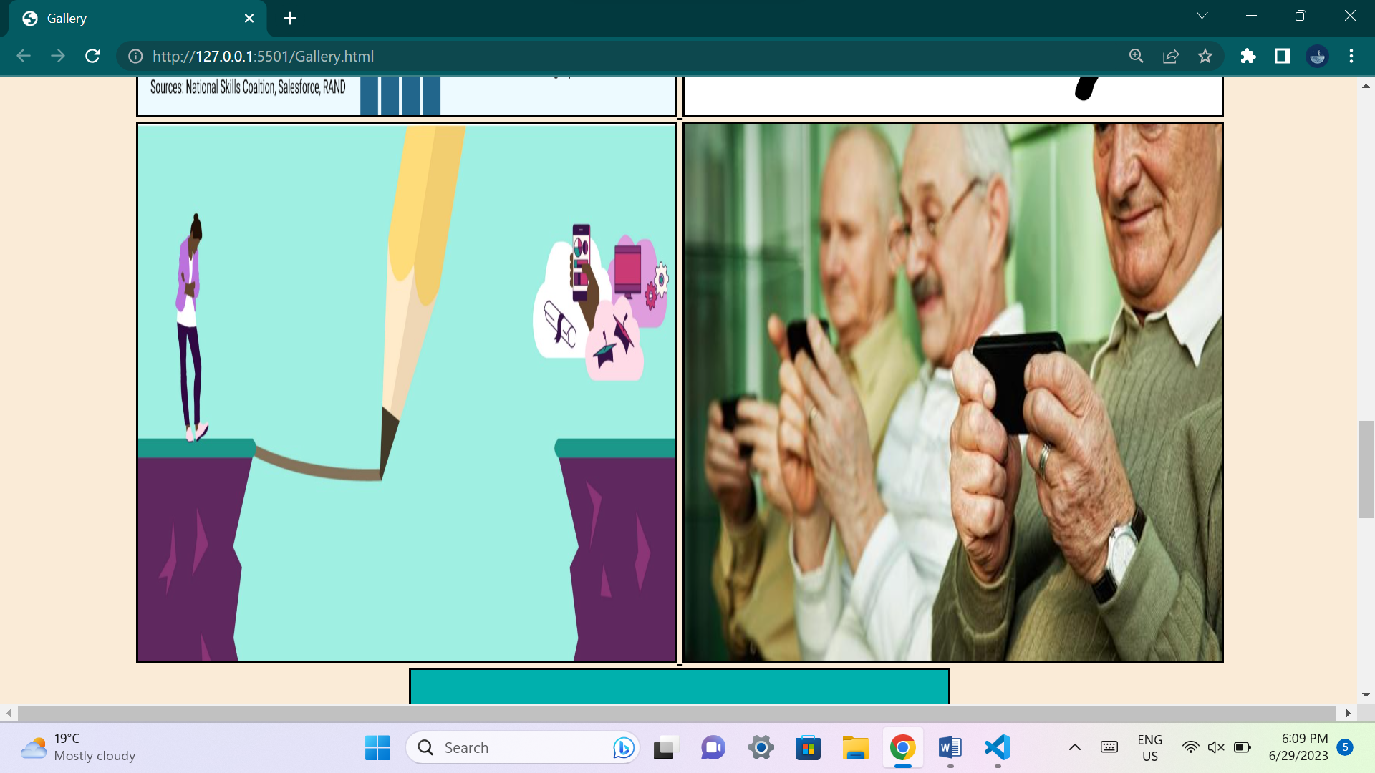

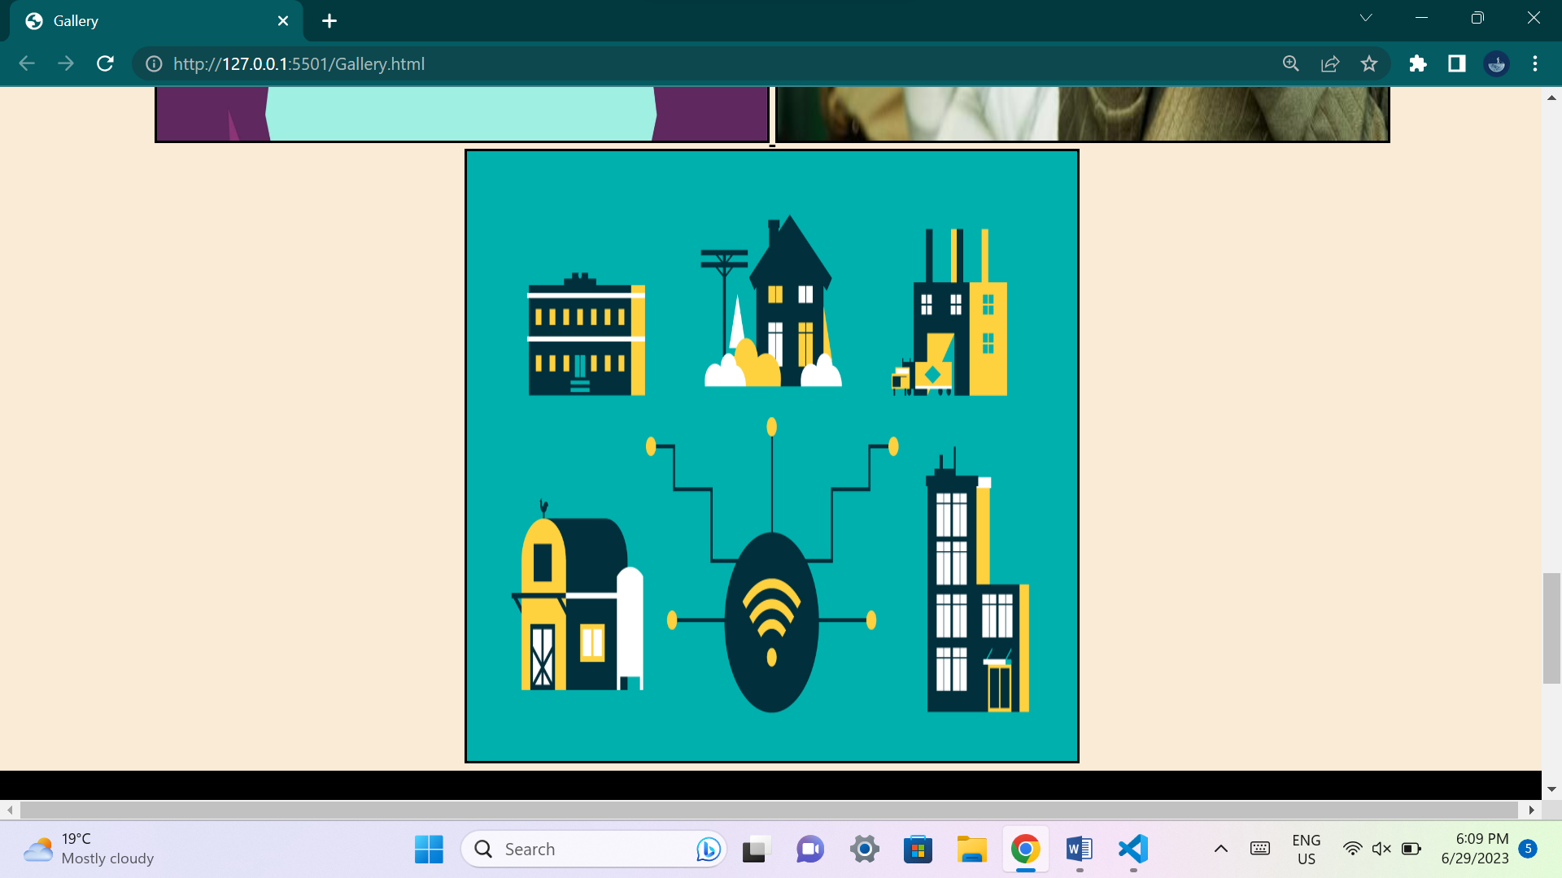

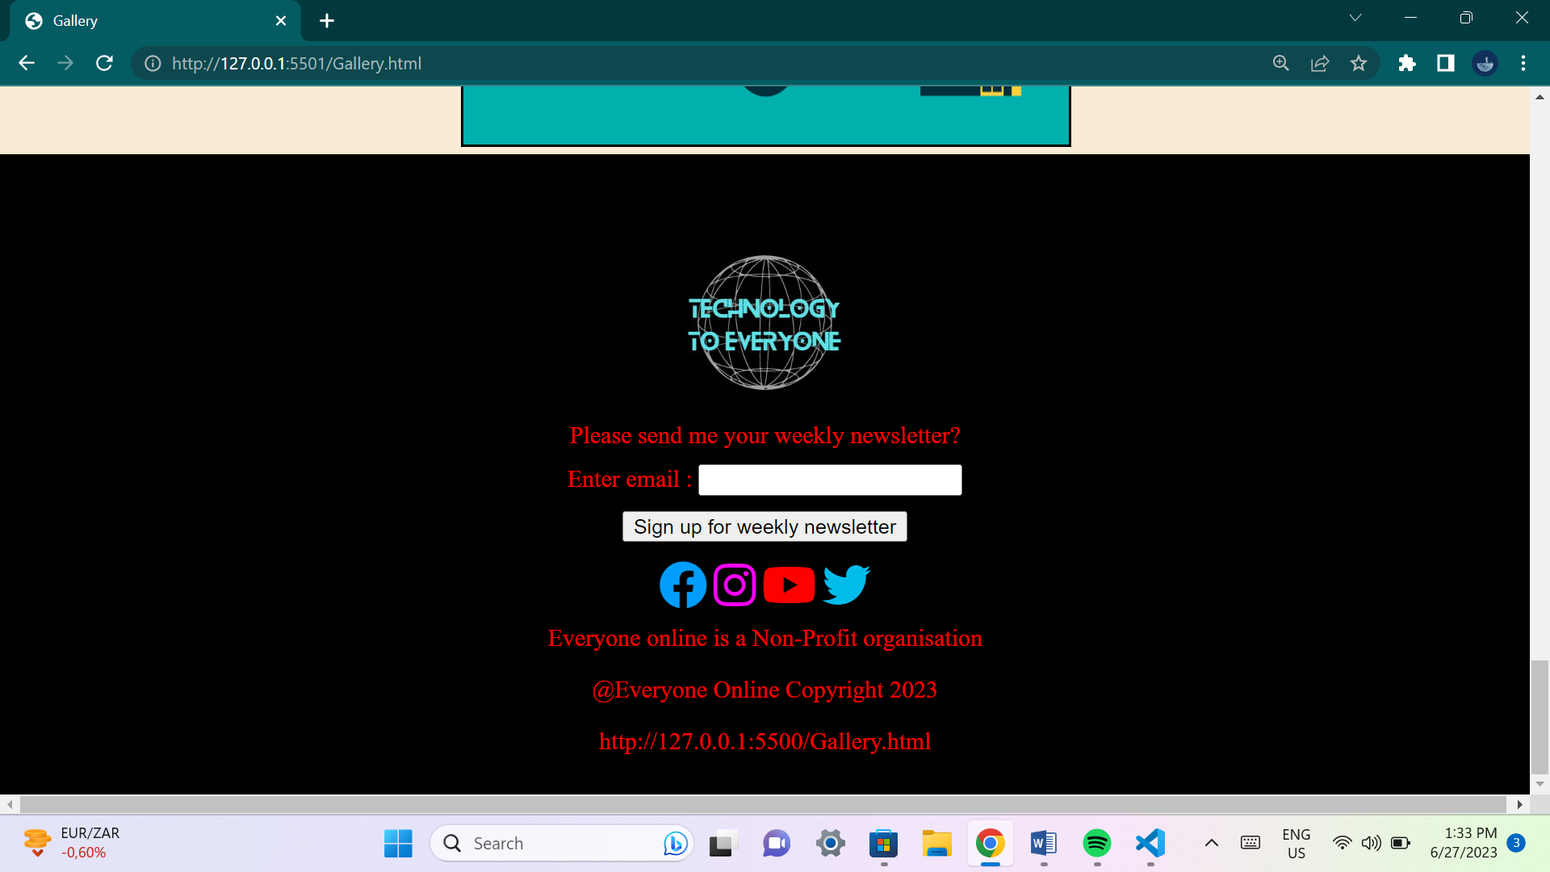

**This page contains multiple images that would help the user understand what the organization wishes to achieve, and its idea's.**

**Contact us page:**

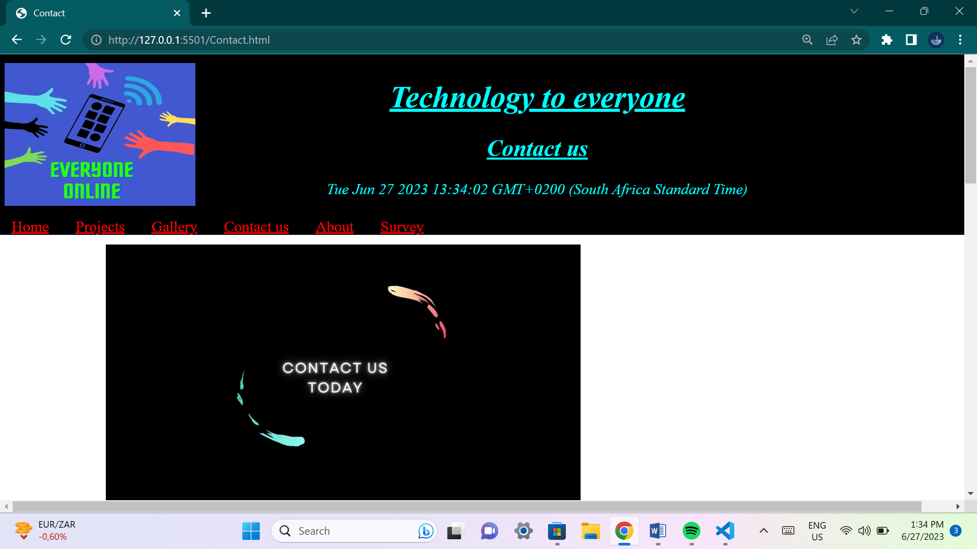

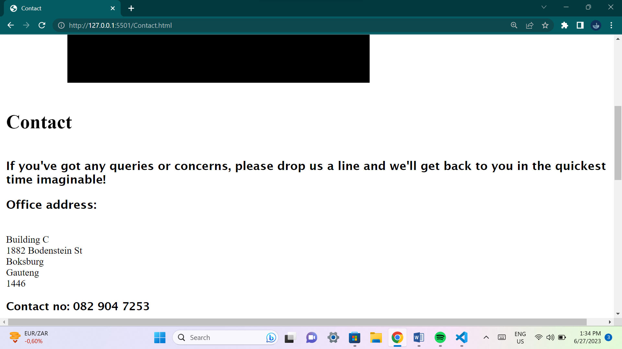

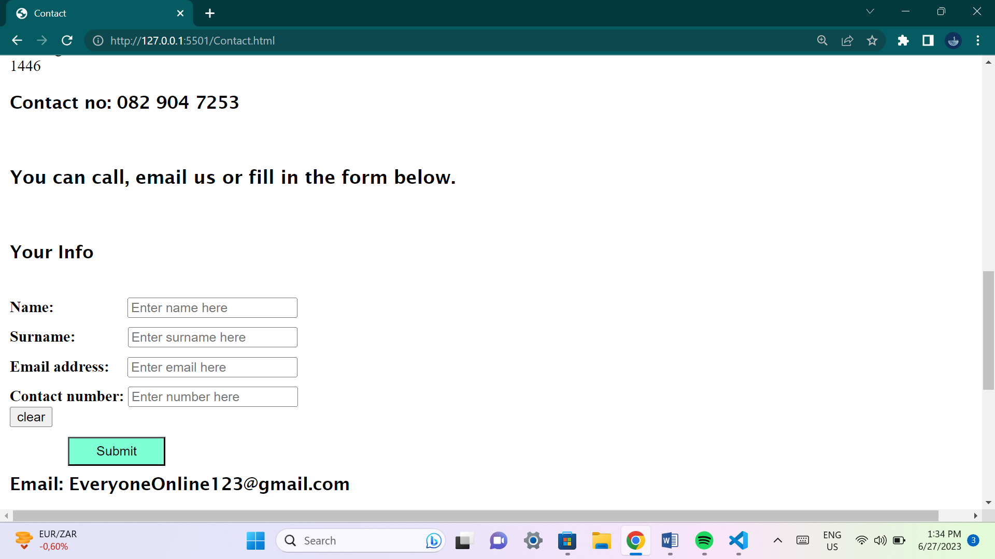

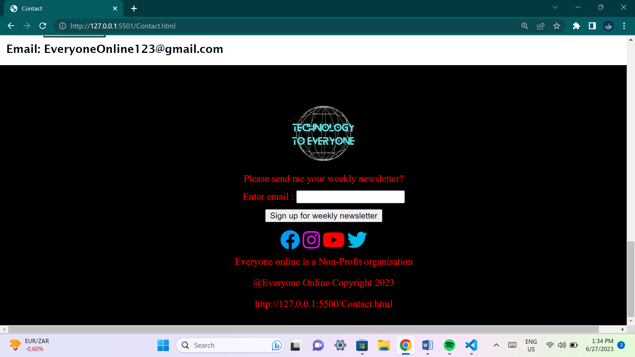

**This page has contact details that will be available to the user if they have any questions or queries dealing with the organization. A page that allows users to stay in touch with the organization.**

**About page:**

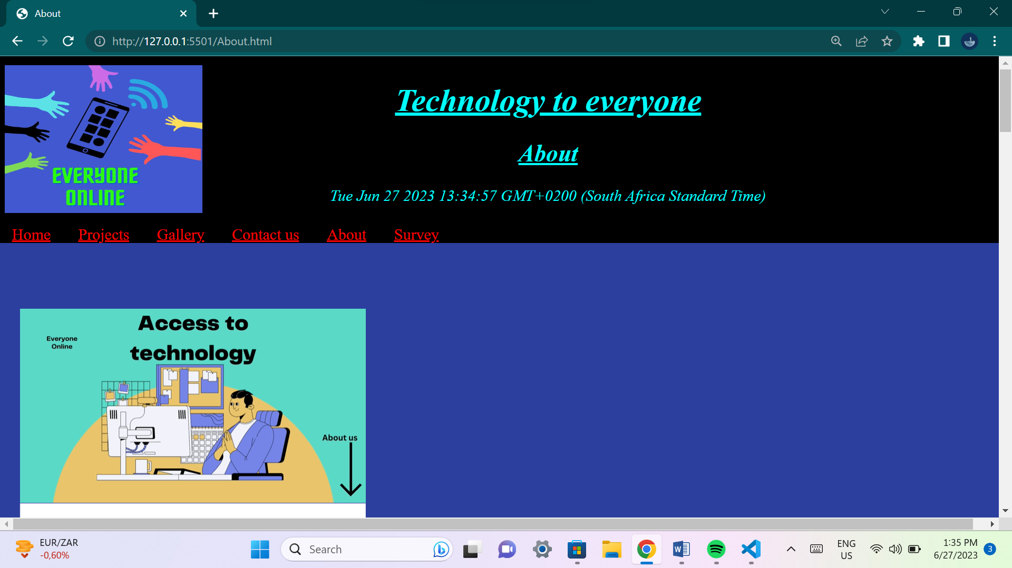

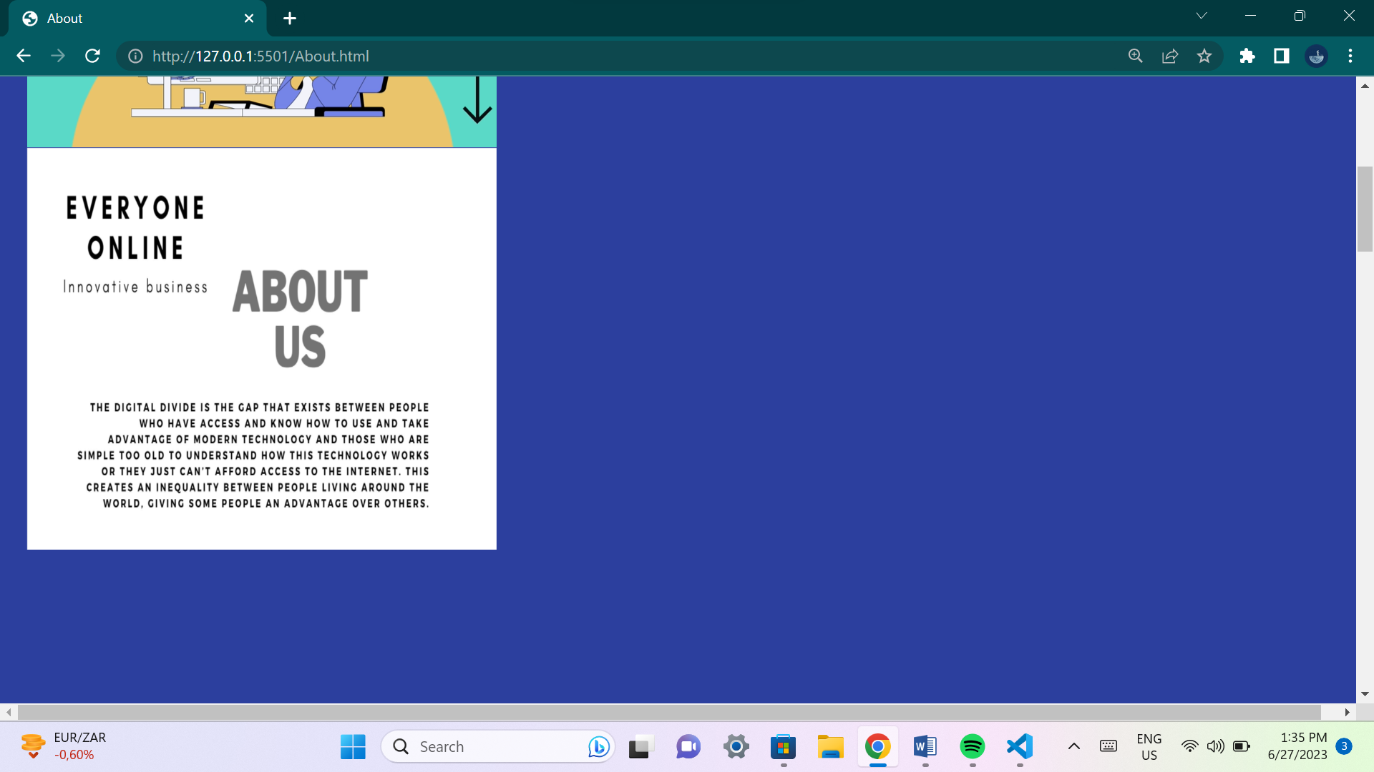

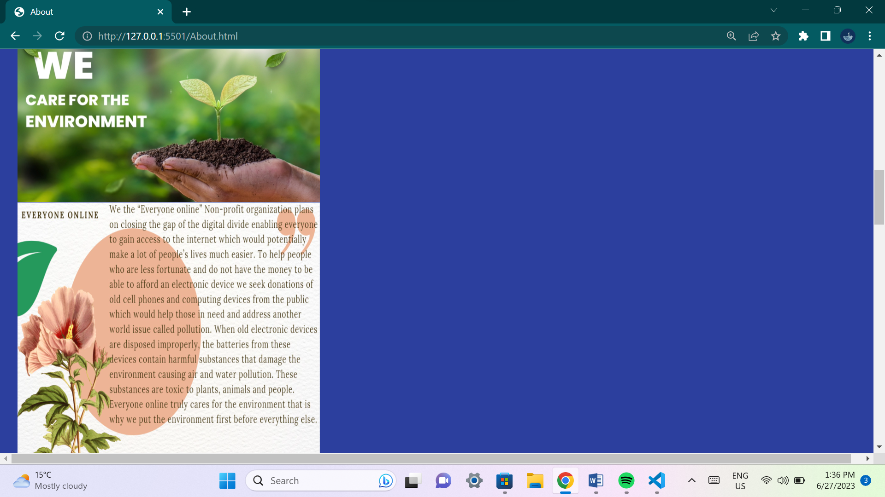

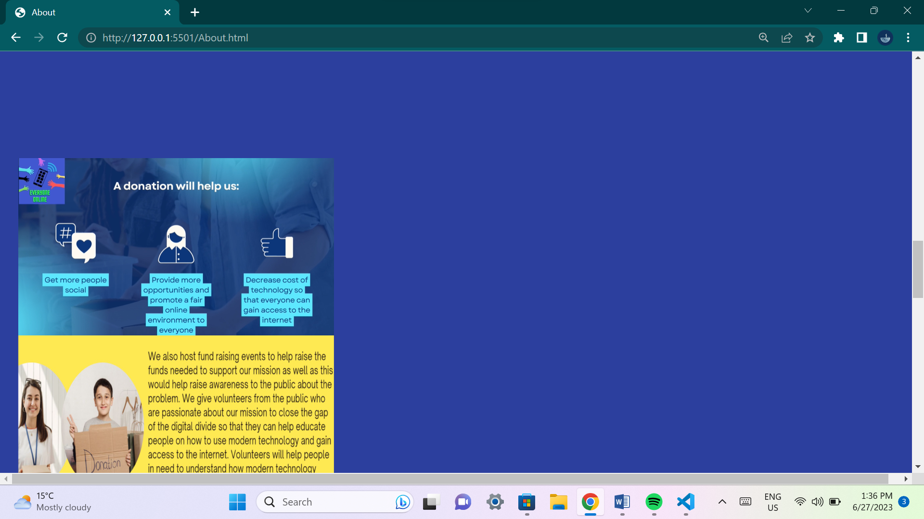

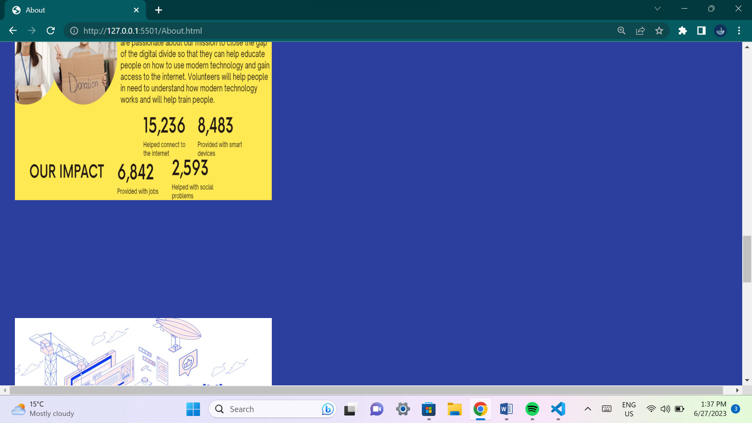

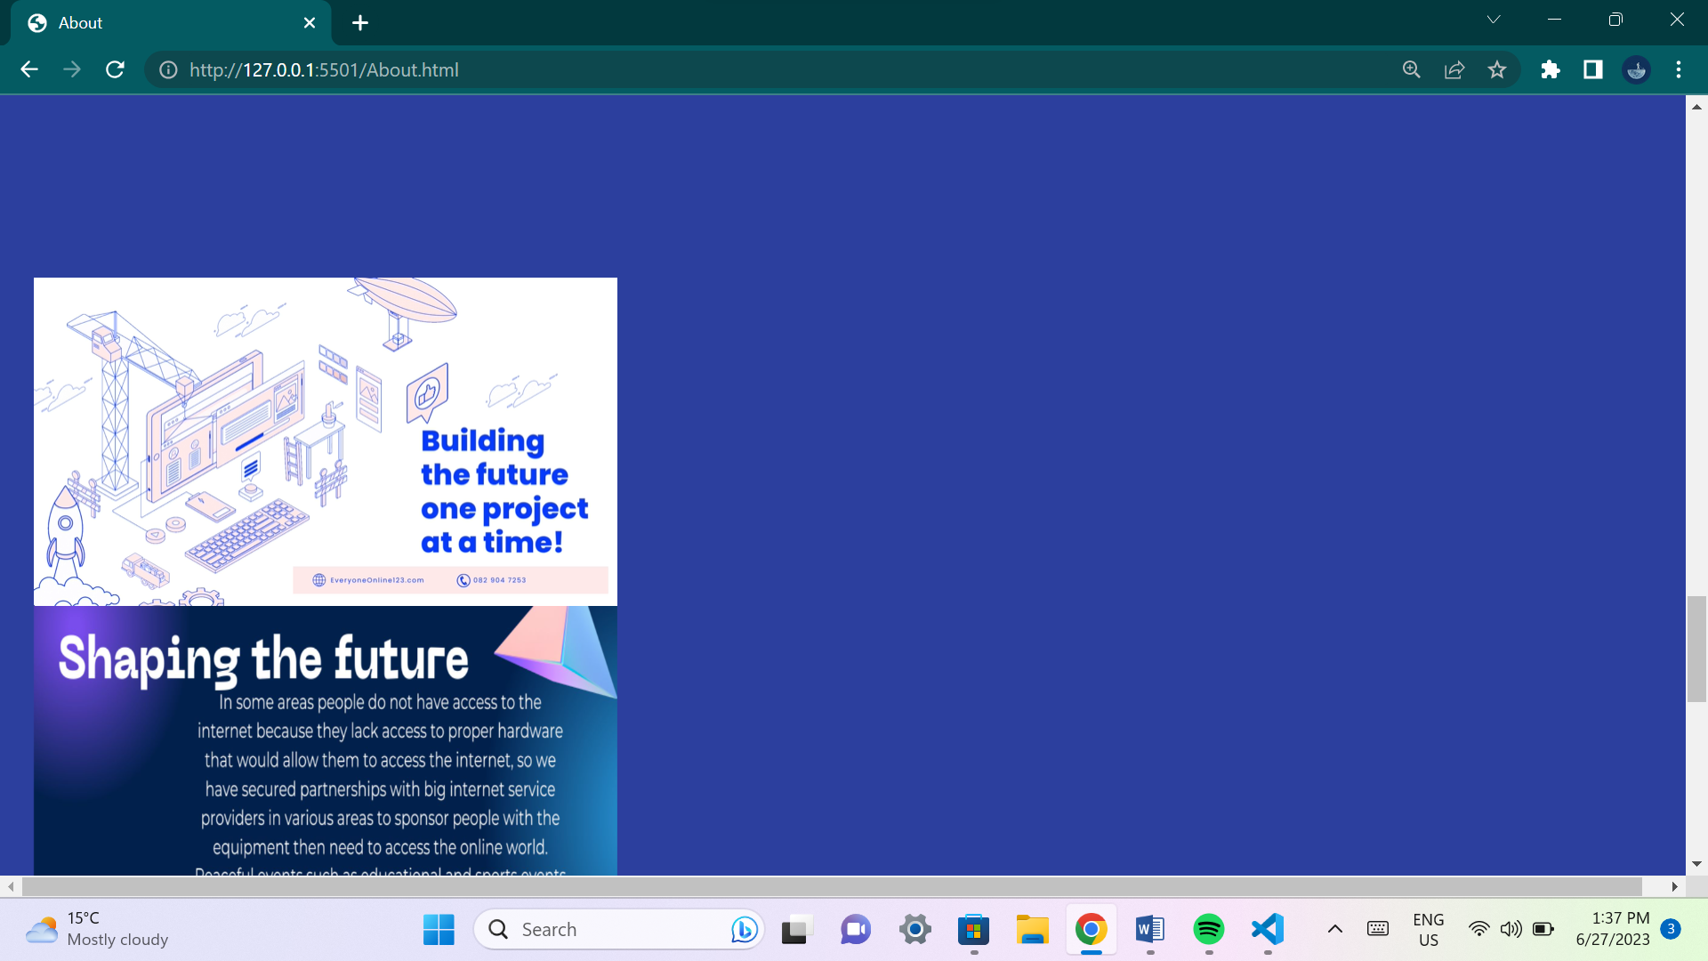

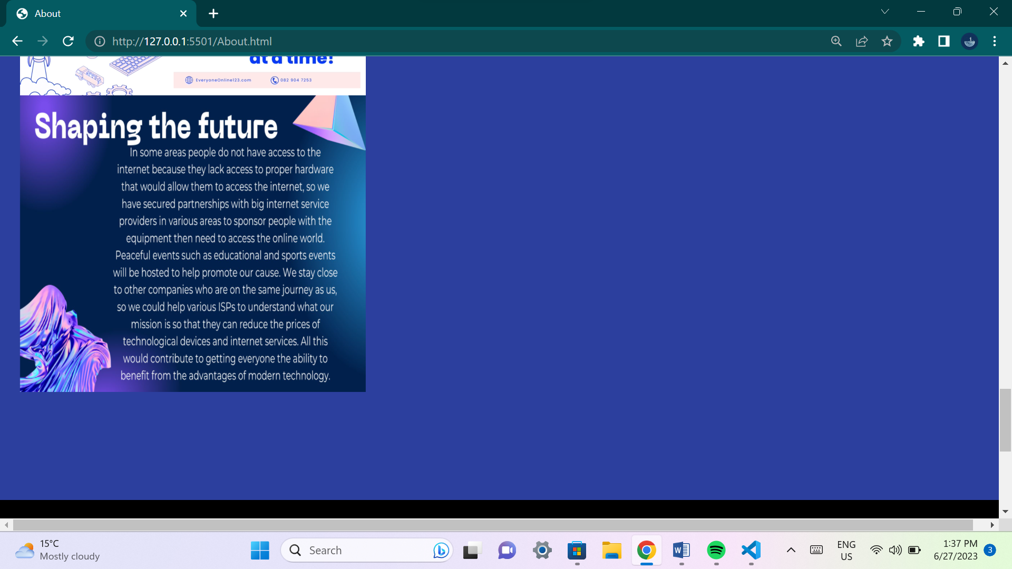

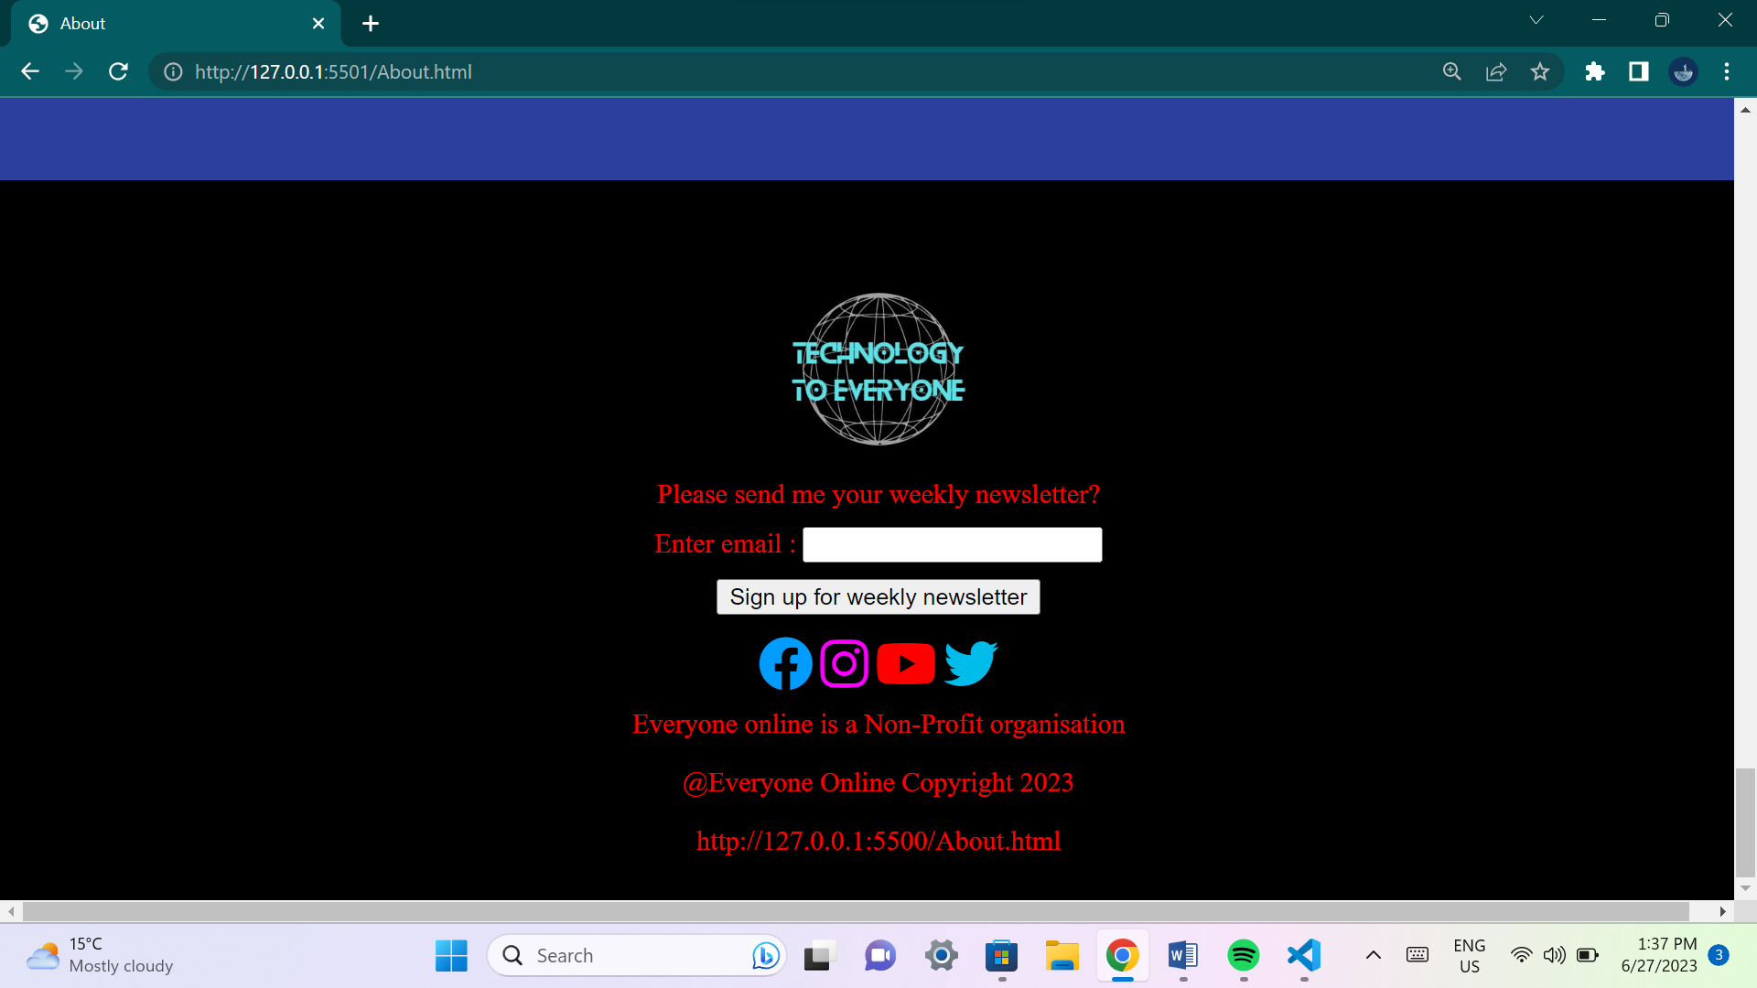

**This page will explain to the user what the organization is about. It will give users an idea about the organization goals and why the organization wants to achieve their goals.**

**Survey page:**

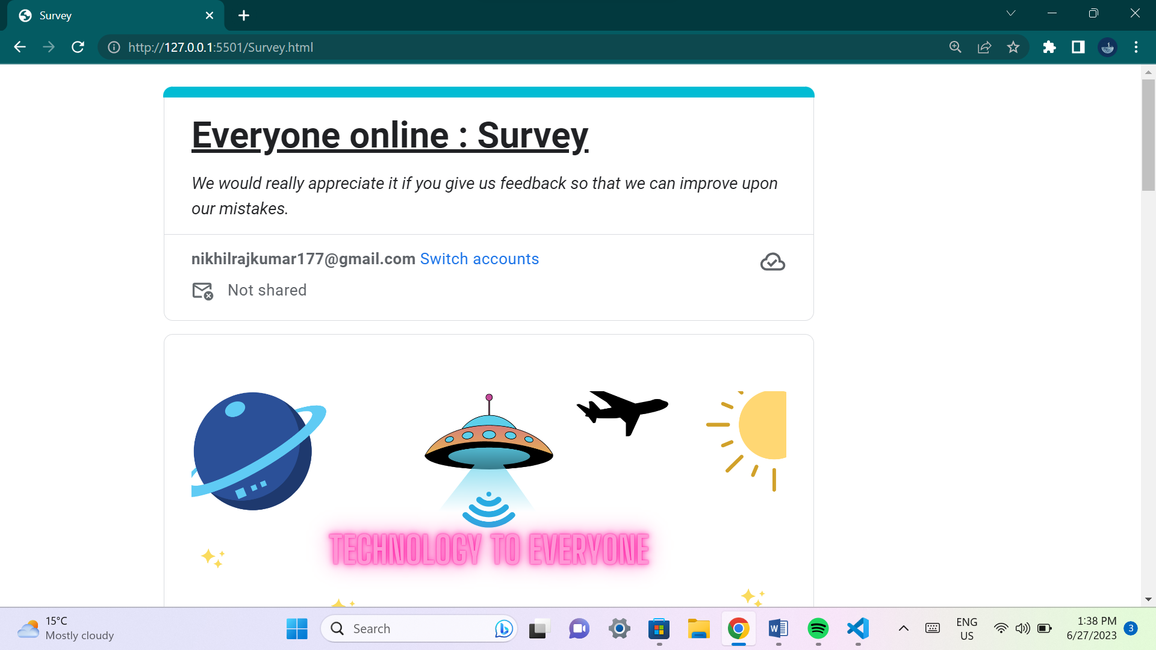

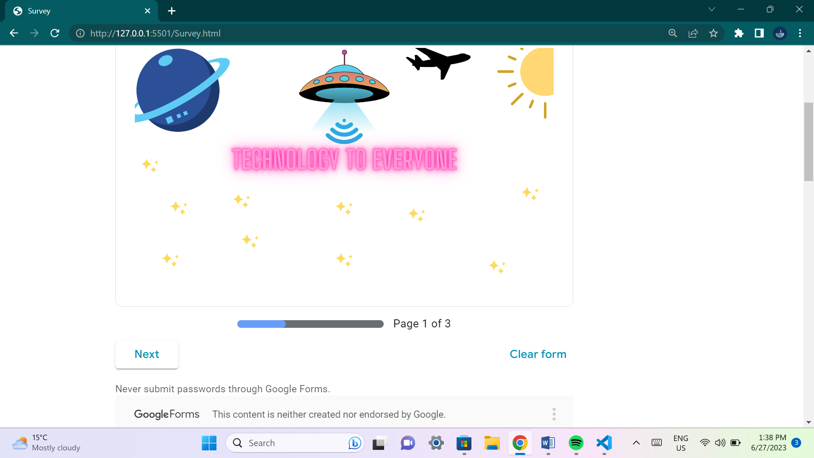

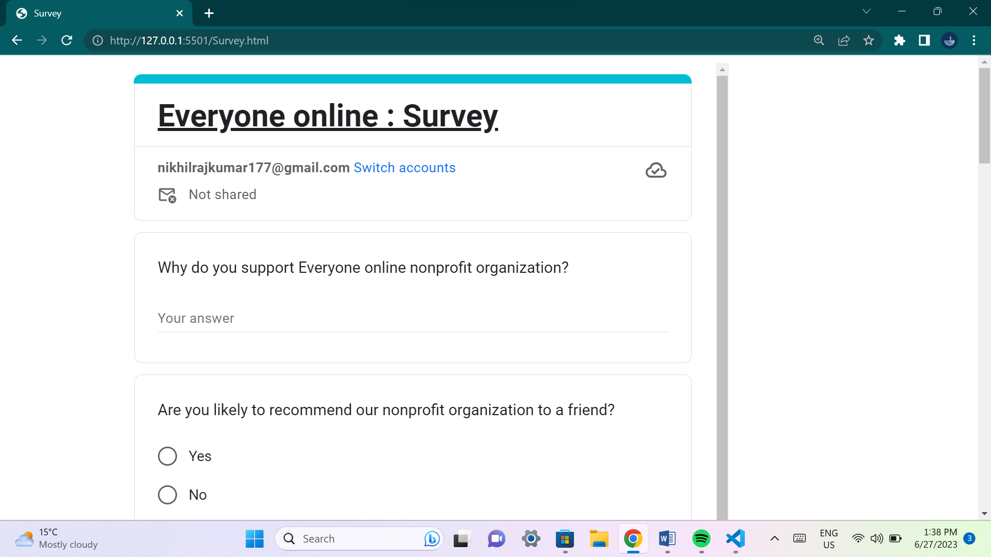

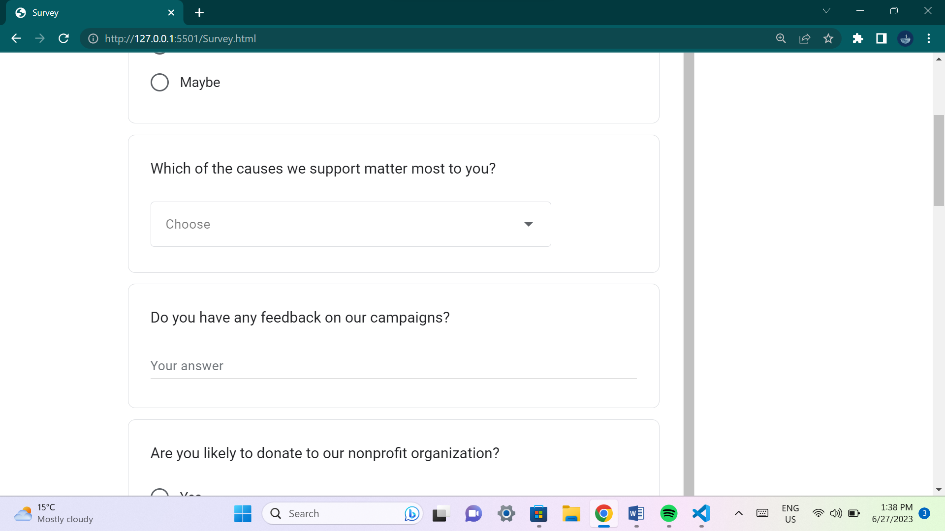

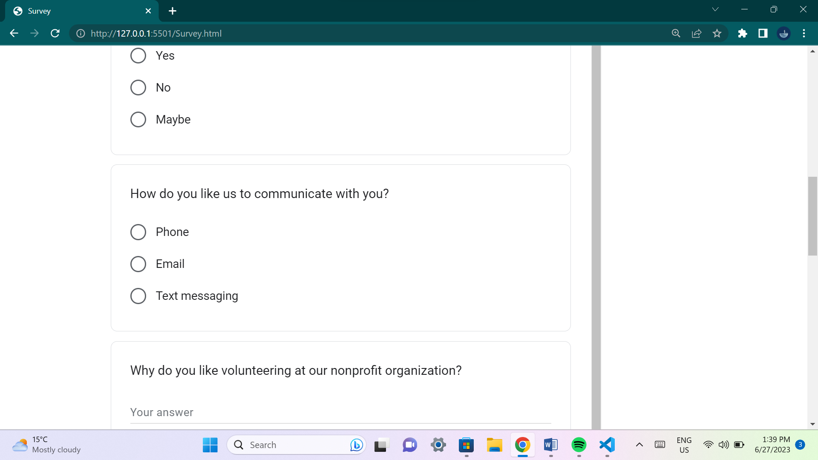

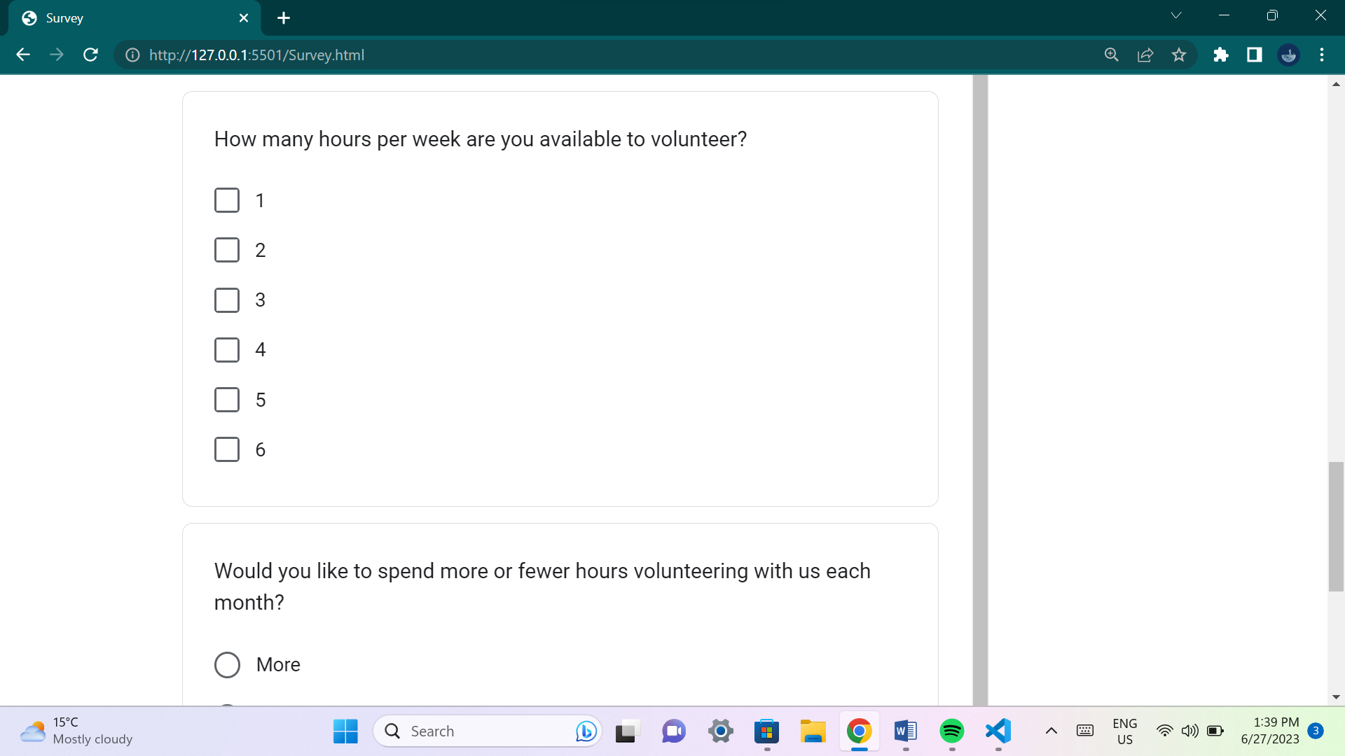

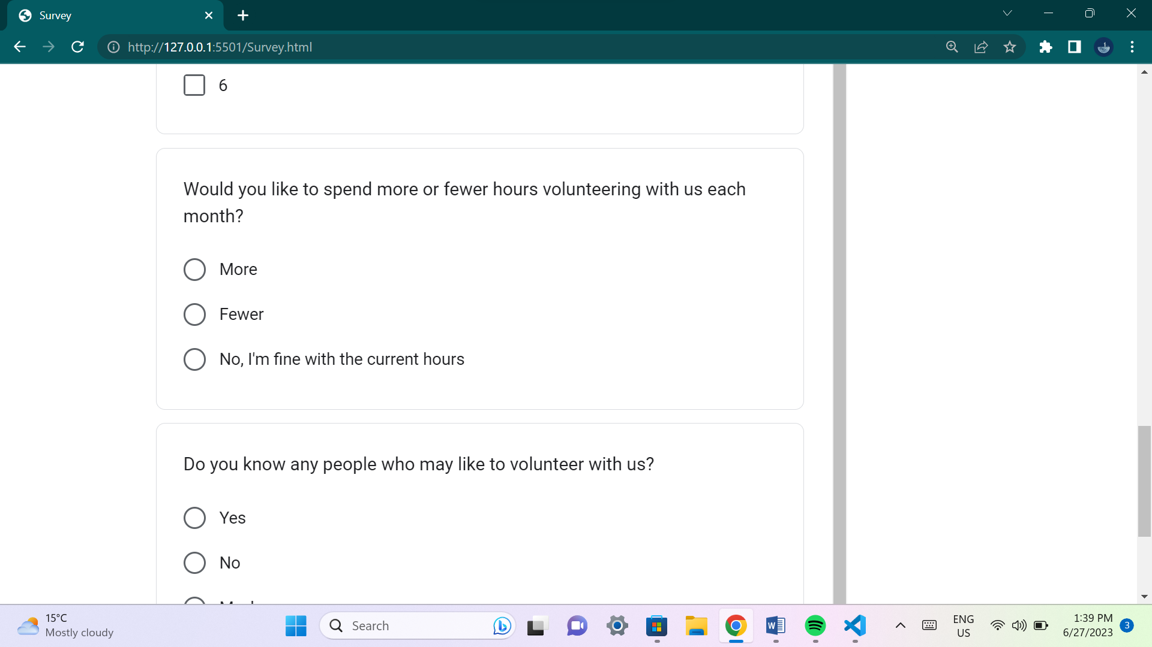

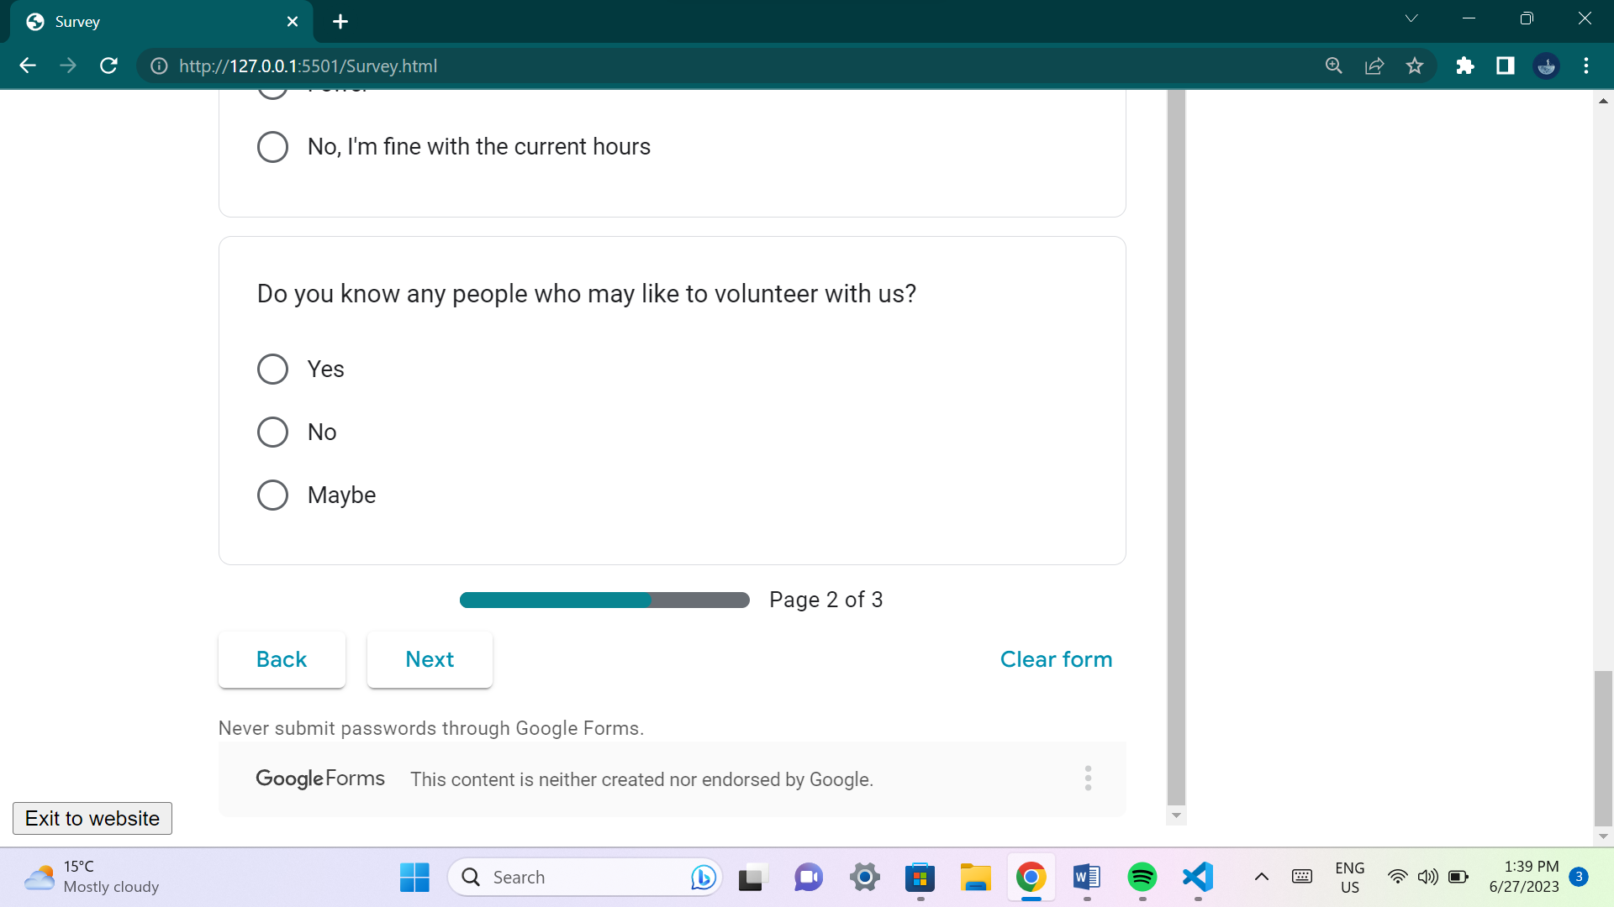

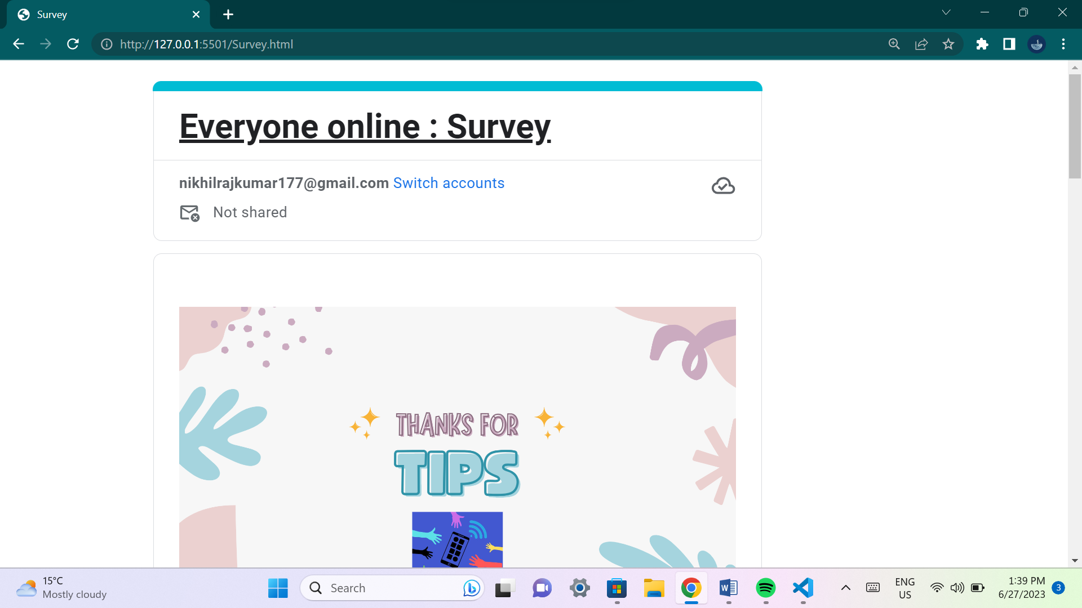

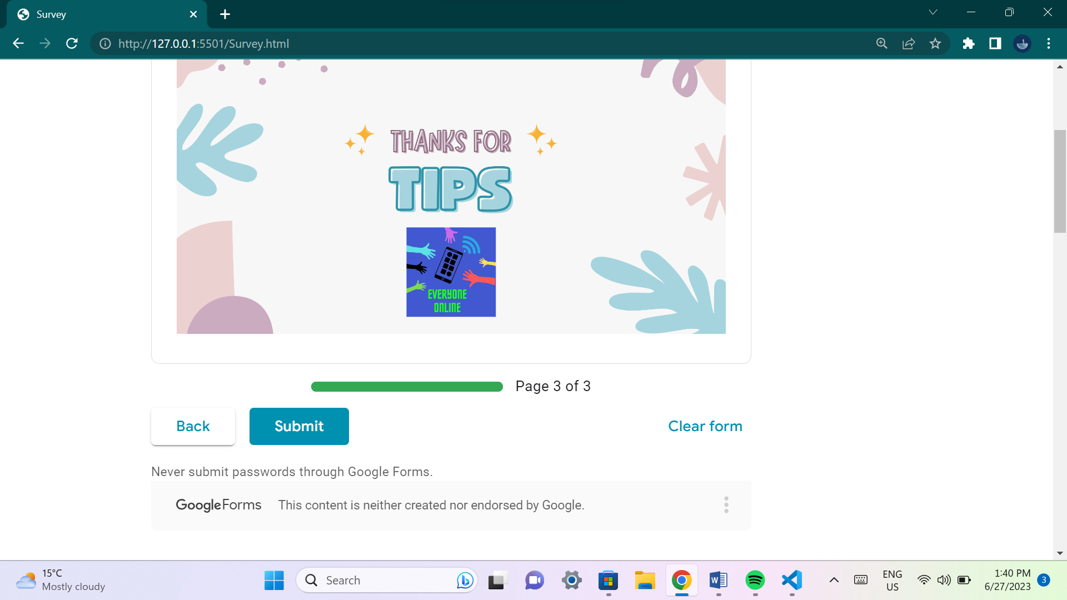

**This page contains a survey that customers of our services can let us know how well our organization is doing and what we should change and improve in our organization. We will use the data obtained from this survey to improve our services.**

**Functionality:**

**A survey screen using google forms was added. A back button was also added in that html file to return back to the website from the survey screen.**

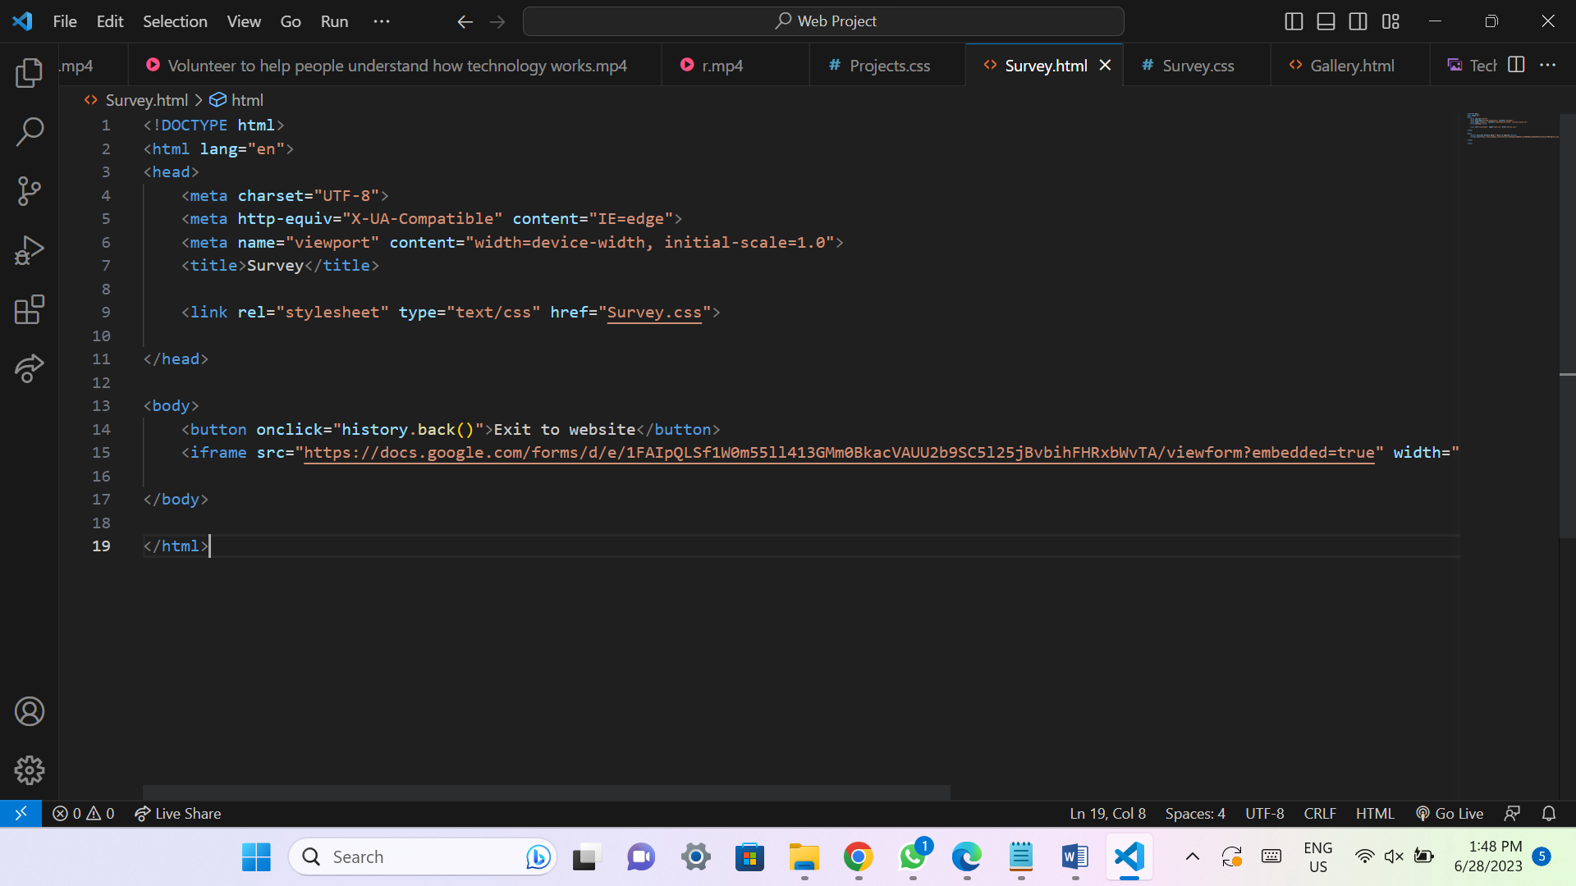

**A Date stamp on all of the headers of all the webpages was added using javascript.**

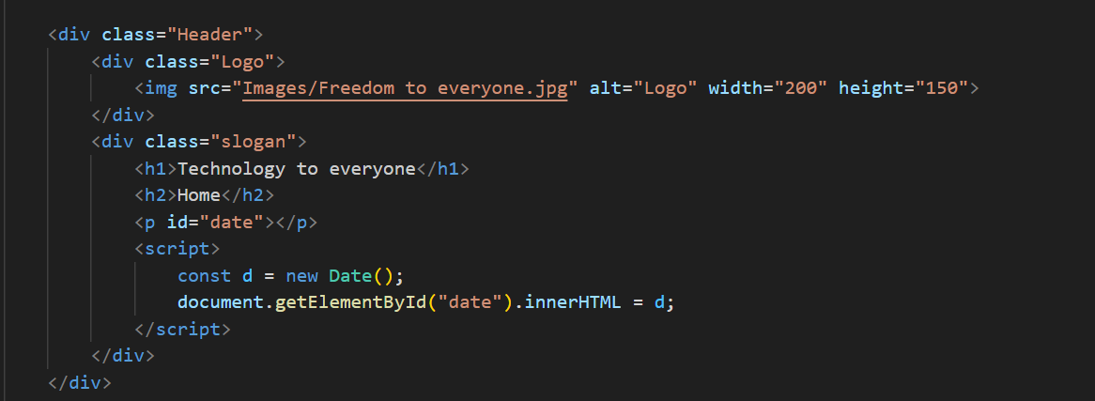

**Social media icons with links were added to the footers of all webpages. The links are used to promote the organization. Links go to social media platforms Facebook, Instagram, YouTube and Twitter.**

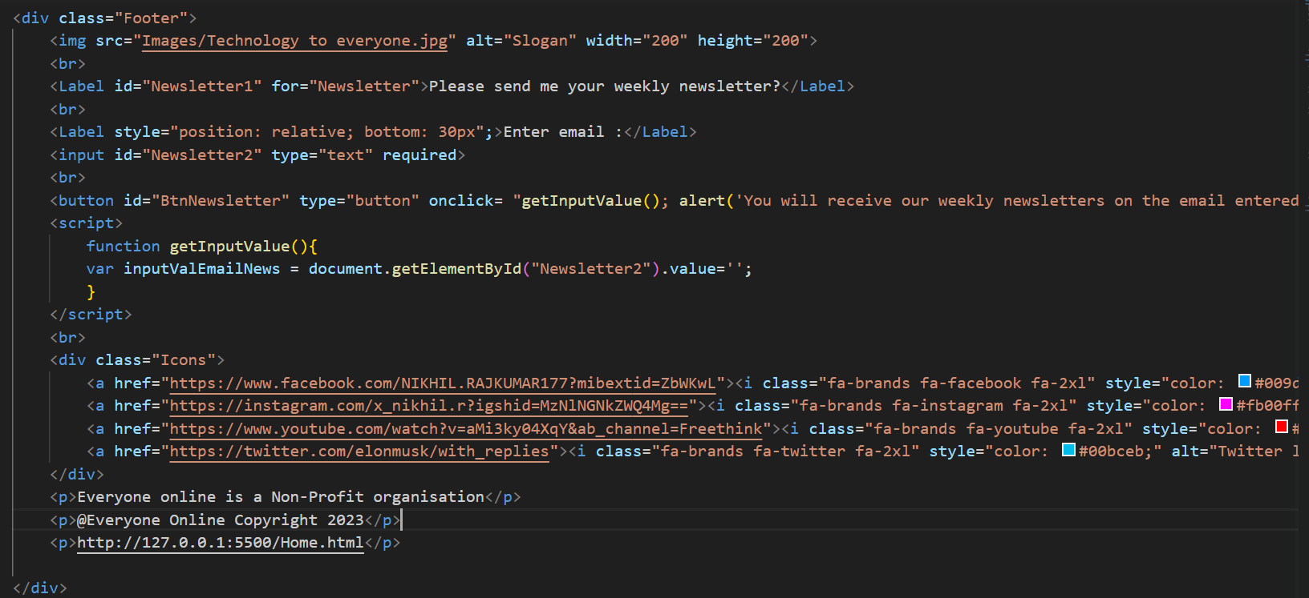

**Receive newsletter function added to the footer of all webpages. Here there is an input and submit button which will submit your email entered in the input and display an alert “You will receive our weekly newsletters on the email entered in below!”, while clearing the input.**



**Information entered in contact screens are validated. There are 4 inputs and 1 submit button. If an input is left blank and the submit button is pressed then there will be an error displayed prompting the user to fill in the inputs. If all inputs are filled and the submit button is pressed then an alert will be displayed “Your details have been successfully entered in, you will be contacted shortly”. The contact.html page is linked to a new page called Contact.js.**

**A function to validate the form has been used. The form values are fetched and previous errors are then cleared. All input fields are validated to check for blanks. If there are no blanks, then the alert is displayed. Addeventlistener calls the code to validate the form.**

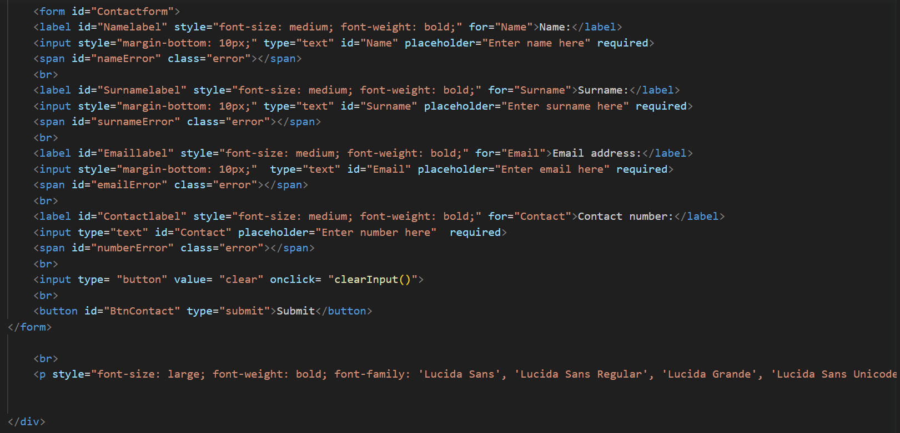

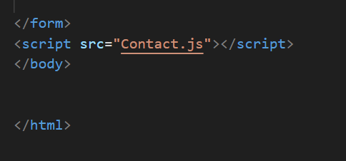

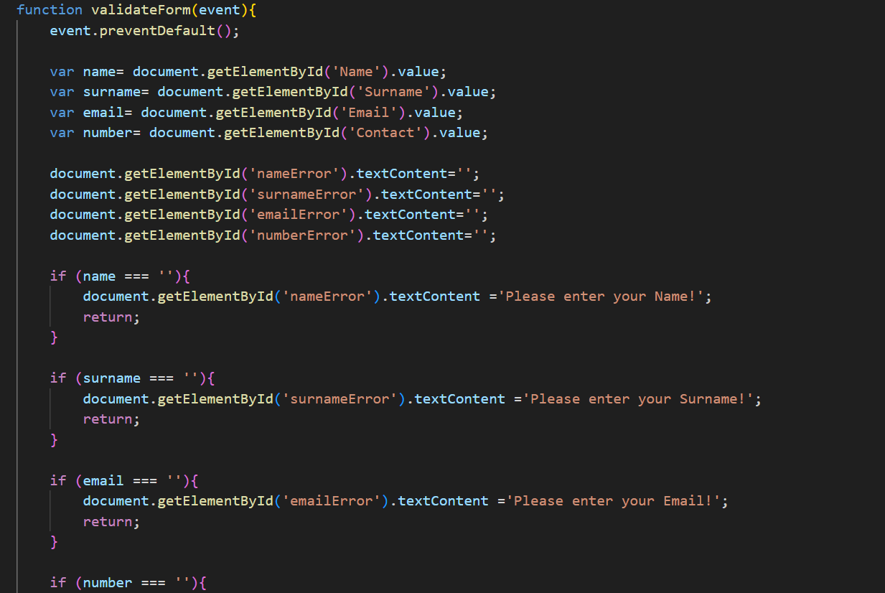

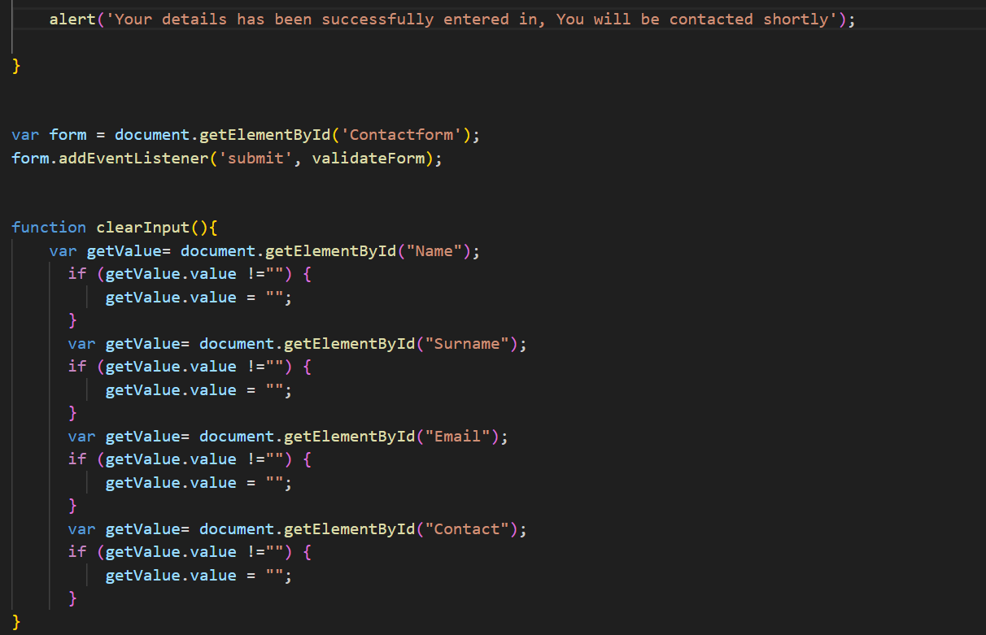

**On the contact page form there is also a clear button that clears all input fields.**

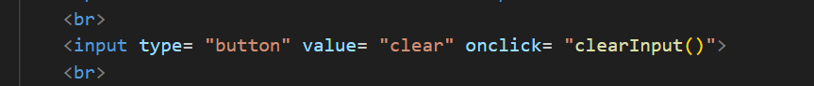

**Mail to function added on contact screen.**



**Quote feature added to Gallery.html. The quote features display random quotes dealing with the digital divide by famous people in the industry when the button is pressed on the Gallery.html page. Gallery.html is now linked to the new file create called Gallery.js. A new container is created in Gallery.html and has 2 elements, button and output label. In Gallery.js new code added to create 2 variables, and create an array that stores quotes. An addeventlistener function is used and the math.random method is used.**

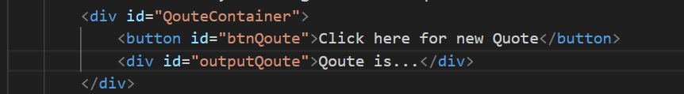

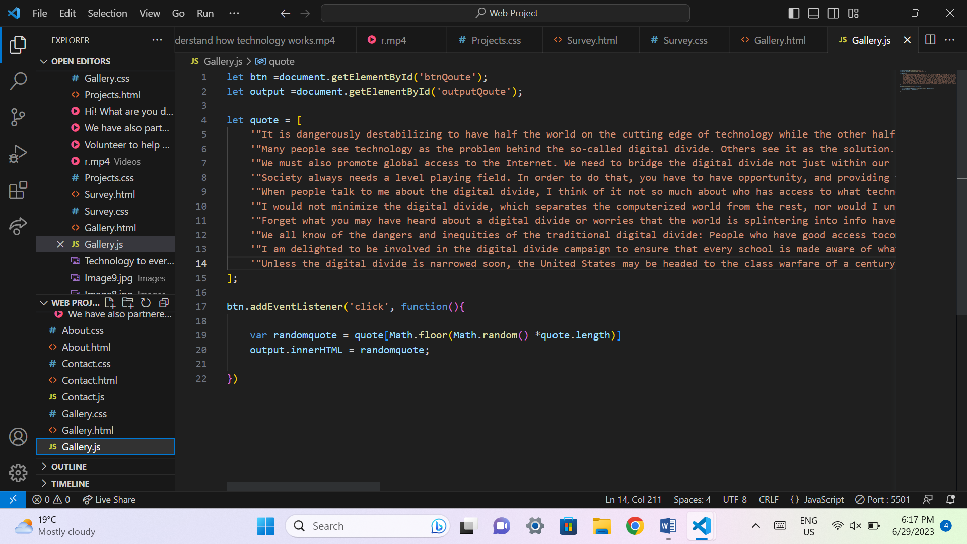

**SEO:**

* **All video’s and images have alt tags to help users identify a specific visual resource used in the website.**
* **All elements have a corresponding Identification tag and is named to make it unique to avoid confusion.**
* **All links on websites work, including links containing navigation to other internal webpages on the website and social media promoting links.**
* **Social media links available at the footer of the website of all pages to promote the organization. These contain the platforms Facebook, Instagram, YouTube and twitter.**
* **Website works efficiently with all browsers. It is browser friendly.**
* **There is no spelling errors or errors with information and data displayed by the website.**
* **Headings and text are clear and can be read by users.**
* **All buttons and elements are well functional and do not contain any errors.**
* **Website is runs smoothly and error free on windows devices (Computers).**
* **Website is responsive to all devices and is mobile friendly.**
* **Website is fast and efficient.**
* **Website provides quality content.**

**Improvements in code:**

**Home.html:**

**Line 11, added script tag to link FontAwesome so social media icons can be used.**

**Line 50-54, added a date stamp by opening a script tag used on the header.**

**Line 66, added a new navigation link to a new webpage called “Survey”.**

**Line 103-113, added a label, input and button for receive newsletter feature. Script tag was also opened to get value from input.**

**Line 115-113, added Social media icon links.**

**Home.css:**

**New code added to lines 93-106.**

**Projects.html:**

**Line 12, added script tag to link FontAwesome so social media icons can be used.**

**Line 56-60, added a date stamp by opening a script tag used on the header.**

**Line 72, added a new navigation link to a new webpage called “Survey”.**

**Line 109-119, added a label, input and button for receive newsletter feature. Script tag was also opened to get value from input.**

**Line 121-126, added Social media icon links.**

**Projects.css:**

**New code added to lines 110-123.**

**Gallery.html:**

**Line 10, added script tag to link FontAwesome so social media icons can be used.**

**Line 53-57, added a date stamp by opening a script tag used on the header.**

**Line 69, added a new navigation link to a new webpage called “Survey”.**

**Line 77-81, added 2 labels and a button used to create random quote feature.**

**Line 115-125, added a label, input and button for receive newsletter feature. Script tag was also opened to get value from input.**

**Line 127-132, added Social media icon links**

**Line 137, Added script tag to link Gallery.html to Gallery.js.**

**Gallery.css:**

**New code added to lines 69-82.**

**Gallery.js:**

**This is a file create and is linked to Gallery.html.**

**New code added from lines 1-22 used for the random quote feature.**

**Contact.html:**

**Line 12, added script tag to link FontAwesome so social media icons can be used.**

**Line 40, contains the mail to function.**

**Line 42, Contains a script tag that links the Contact.html to Contact.js.**

**Line 99, 103, 107, 111, added a span error tags.**

**Line 112, added a button.**

**Line 51-55, added a date stamp by opening a script tag used on the header.**

**Line 67, added a new navigation link to a new webpage called “Survey”.**

**Line 128-138, added a label, input and button for receive newsletter feature. Script tag was also opened to get value from input.**

**Line 140-145, added Social media icon links**

**Line 164, added a script tag that links Contact.html to Contact.js.**

**Contact.css:**

**New code added to lines 117-130.**

**Contact.js:**

**This is a new .Js file created and is linked to Contact.html.**

**New code is added to lines 1-60 used to validate the inputs and display an alert on Contact.html.**

**About.html:**

**Line 12, added script tag to link FontAwesome so social media icons can be used.**

**Line 47-51, added a date stamp by opening a script tag used on the header.**

**Line 63, added a new navigation link to a new webpage called “Survey”.**

**Line 91-101, added a label, input and button for receive newsletter feature. Script tag was also opened to get value from input.**

**Line 103-108, added Social media icon links**

**About.css:**

**New code added to lines 61-74.**

**Survey.html:**

**This is a new html page that was create to have the survey on it.**

**Line 8, added code that links Survey.html to Survey.css.**

**Line 14, added a button to go back to previous webpage. This button gets you back to the website page you were previously on from the Survey.html.**

**Line 15, added code that contains the google forms code using the iframe tag.**

**Survey.css:**

**This is a new Css file created and is linked to Survey.html.**

**Line 1-8, added code to decorate the button element found in the Survey.html page.**

**Reference list for new website assets part 3:**

**The canva application was used to create 2 new images.**

**Font Awesome website was used to create social media icons.**

**Google forms was used to create the survey form.**

**Anonymous. (n.d, n.d n.d). *Digital Divide Quotes*. Retrieved from AZ Quotes:** [**https://www.azquotes.com/quotes/topics/digital-divide.html**](https://www.azquotes.com/quotes/topics/digital-divide.html) **(Accessed on: 29 June 2023)**